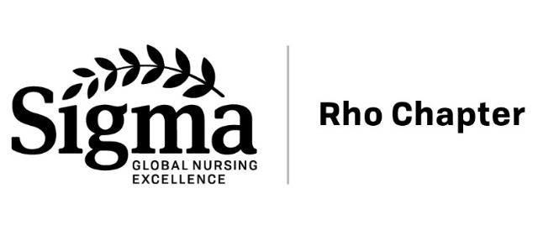
RHO CHAPTER AWARDS

Excellence in Nursing Nomination Form

Nominee Information
Name of Nominee_______________________________
Phone (mobile, home, or office)_________________________________
Email ________________________________________

Award Category (check one)
____Research ____Education ____Nursing Practice
____Leadership ____Rising Star ____Distinguished Service
____Friend of Nursing ____Mentorship ____Student Leadership**
____Institutional/Organizational Excellence
**Award for current UM nursing students

Supporting Materials
Be sure to address the criteria for your award category in your comments and materials. The Awards Committee selects awardees based on the criteria for each award. Award criteria are found on the Rho Chapter website: https://nursing.umich.edu/about/nursing-michigan/sigma-rho-chapter/awards
1. Attach a summary of the Nominee’s contributions and accomplishments
2. Additional supporting materials to be submitted with this nomination form include:
- The nominee’s curriculum vita
- Supporting statements from peers and community leaders or other documentation regarding award criteria
3. Have you informed the candidate of the nomination? (notification is optional):
____Yes, notified ____No, not notified

Nomination Submitted by:
Name ______________________________________
Phone (work) _______________________ (mobile)________________________
Email ____________________________________________________________________

Submissions must be received by February 28
Please submit your nomination materials in a single, complete packet:
By Mail: OR By Email:
Mary DeBardeleben (Rho Administrative Assistant) marydp@med.umich.edu
Professional Development & Education
300 N. Ingalls, Suite 6B17
Ann Arbor MI 48109-5436

Questions? Contact the Awards Chair--Visit this URL for name & contact information:
https://nursing.umich.edu/about/nursing-michigan/sigma-rho-chapter/officers-committees

