a
UNIVERSITY OF MICHIGAN SCHOOL OF NURSING
Department of Systems, Populations and Leadership (SPL)
Chair's State of the Department Report
Summer 2026 | AY 2025-2026 Review and AY 2026-2027 Priorities
FINAL Version 3.5 | August 27, 2026
Since 2022, the SPL Chair has prepared an annual report to document departmental activity, summarize the current state of the department, and frame priorities for the year ahead. This fifth report reviews AY 2025-2026, identifies operational and strategic priorities for AY 2026-2027, and outlines opportunities for scholarship, education, clinical practice, service, and collaboration. It is intended to support informed discussion, shared governance, and collective planning across SPL and the U-M School of Nursing (UMSN).
SPL faculty are encouraged to review the report, discuss its priorities, and provide constructive feedback to the Chair, Vice Chair, Department Advisory Council (DAC), UMSN Ombud’s Office, or the UMSN Office of the Dean. The report is designed to evolve as final data, tables, figures, and updates are incorporated.
Ivo D. Dinov, PhD
Chair, Department of Systems, Populations and Leadership
Henry P. Tappan Collegiate Professor

We gratefully acknowledge the contributions of the following SPL faculty and staff: Michelle Aebersold, PhD, RN, MSBA, CHSE, FSSH, FAAN; John Knight, DNP, RN, CSSMBB, PMP; Deanna Marriott, PhD; Barbara Medvec, DNP, RN, NEA-BC; William Barast, BA (and others).

Contents
Executive Summary 4
AY 2025-2026 highlights 4
Principal challenges and opportunities 4
AY 2026-2027 Priorities 5
PART I: AY 2025-2026 in Review 6
1. Purpose and Department Context 6
2. SPL Scholarship and Practice Foci 6
E.P.I.C. values 6
3. Faculty Composition, Recruitment, and Transitions 6
Recent faculty recruitment 8
Faculty transitions 10
4. Department Advisory Council and Faculty Engagement 10
May 2026 SPL writing retreat 10
Other DAC activity 12
5. Faculty Personnel Actions and Recognitions 12
Reappointments and promotions 12
Selected faculty recognitions 12
Collective accomplishments 13
Office of Global Affairs 13
6. Culture, Safety, Ethics, and Reporting 14
Emergency and public-safety resources 14
Employee reporting responsibilities 14
7. Leadership, Analytics and Innovation (LAI) Graduate Program 14
Program evaluation 15
8. SPL Web and Digital Resources 16
9. UMSN AI in Health Initiative 16
Educational applications 17
Practice and decision-support applications 17
Research and scholarly applications 17
UMSN AI in Health Team 18
10. Faculty Scholarly Interests, Productivity, and Connectivity 20
Composite academic productivity 20
Text mining of publications and grants 22
Faculty connectivity 25
Aggregate productivity statistics 31
PART II: AY 2026-2027 Priorities 34
11. Operating Context and Department Priorities 34
Core department priorities for AY 2026-2027 34
Collaboration and mentoring 34
12. LAI Redesign and Executive Nursing Curriculum 34
Conceptual AI and health-analytics content 34
13. AI Content in Faculty Development and Teaching 35
PART III: Mid-Term Strategic Vision and Opportunities 36
14. SPL Strategic Vision and Look to Michigan Alignment 36
15. SPL Cultural Identity and Fall 2026 Retreat 36
16. Look to Michigan Faculty Expansion Program (FEP) 37
17. SPL Intramural Partnership Pathways (IPP) 37
IPP objectives 37
18. Strategic Initiative Fund (SIF) 37
19. UMSN Preparedness for the AI-Enabled Future 38
Near-term principles for AI work 38
REFERENCES 39
Selected Public References and Resources 39
Notes and Appendices 40
Supplementary Appendix to SPL-2026 Annual Report: Faculty Accolades 40
Supplementary Appendix to SPL-2026 Annual Report: New SPL Faculty Since 2023 41

Executive Summary
The 2026 SPL State of the Department Report summarizes AY 2025-2026 achievements and challenges and identifies priorities for AY 2026-2027. SPL advances the School of Nursing mission through interdisciplinary scholarship, teaching, clinical and professional practice, and service focused on health systems, population health, and leadership. The department continues to strengthen collaboration across faculty tracks while responding to changes in student enrollment, program design, research funding, technology, and the broader higher-education environment.

AY 2025-2026 highlights
- Scholarship and practice: SPL faculty sustained broad research, educational, clinical, and professional activity across systems, population health, leadership, data science, health informatics, implementation science, simulation, quality and safety, and AI in health.
- Faculty development and community: Structured mentoring, peer support, writing activities, and the May 2026 writing retreat created additional opportunities for scholarly progress and collegial connection.
- Academic programs: SPL continued to support undergraduate and graduate education while reviewing the Leadership, Analytics and Innovation (LAI) MSN program and its future executive-nursing curriculum.
- AI in health: The UMSN AI in Health Initiative continued to build AI training capacity, explore responsible applications in education, practice, and research, and develop or test AI-supported learning and analytical resources.
- External standing: In the 2026 U.S. News & World Report graduate rankings, UMSN was ranked No. 6 for the MSN and No. 4 for the DNP.
- Faculty recognitions: Over 30 high-impact awards and faculty recognitions received in AY 2025-2026.
- Leadership transition: Allison R. Webel, PhD, RN, FAAN, became UMSN's 10th Dean on July 1, 2026.

Principal challenges and opportunities
- Maintain educational quality while supporting growth in undergraduate, professional, and graduate programs.
- Recruit, onboard, mentor, and retain excellent faculty while aligning workload, resources, and administrative support with departmental priorities.
- Improve faculty participation in departmental events and shared governance while sustaining a respectful, transparent, and constructive culture.
- Redesign the LAI/executive nursing curriculum using a deliberate governance, market, learning-outcomes, and resource-assessment process.
- Use AI and advanced analytics responsibly, with attention to evidence, privacy, security, bias, transparency, human oversight, and measurable educational, clinical, and scholarly value.
- Pursue interdisciplinary opportunities such as the Look to Michigan Faculty Expansion Program, Strategic Initiative Fund, Impact Institutes, and other intramural/extramural mechanisms when they align with SPL priorities and sustainable capacity.

AY 2026-2027 Priorities
Priority | Primary emphasis
Educational excellence | Support program development and growth; strengthen learning design, evaluation, student support, and curricular coherence.
Faculty success | Recruitment, onboarding, mentoring, retention, promotion, scholarly support, and equitable workload planning.
LAI redesign | Define the future executive-nursing value proposition, graduate curriculum, delivery model, outcomes, and approval pathway.
Collaborative scholarship | Increase cross-track and cross-unit team science, interprofessional writing, grant development, and translational partnerships.
Responsible AI | Develop evidence-based, human-centered uses of AI in education, research, operations, and health care.
Fiscal stewardship | Prioritize essential work, assess return and impact, and align new commitments with sustainable resources.

PART I: AY 2025-2026 in Review

1. Purpose and Department Context
The annual State of the SPL Department Report documents departmental activity, provides a common factual baseline for discussion, and identifies priorities and opportunities. This report covers the 2025-2026 academic year and looks ahead to 2026-2027 and the department's mid-term strategic direction.
The Department of Systems, Populations and Leadership brings together faculty from nursing and related disciplines to address complex health challenges. Faculty expertise includes nursing science, population health, epidemiology, health services research, implementation science, economics, informatics, data analytics, mathematics and statistics, simulation, leadership, and artificial intelligence. Across these areas, the department emphasizes discovery, translation, implementation, education, and practice that improve health outcomes and health care systems in Michigan and beyond.

2. SPL Scholarship and Practice Foci
SPL scholarship, education, practice, and service are organized around three mutually reinforcing domains:
- Systems: Advance healthcare delivery, quality and safety, patient experience, access, team performance, simulation, interprofessional practice, informatics, health analytics, and evidence-informed policy. SPL work in this domain increasingly evaluates how AI and other digital tools can support safe and effective care and learning.
- Populations: Improve health and quality of life across the life course by studying individual, family, community, organizational, and structural determinants of health. Areas represented in the department include sexual and reproductive health, substance use, violence prevention, hearing health, chronic disease, aging, neuroscience and neurobehavior, cancer, pain, occupational health, and global and community health.
- Leadership: Prepare health care leaders through rigorous education, mentoring, engaged scholarship, and practice. Faculty contribute expertise in executive leadership, health services and operations, implementation science, decision science, quality improvement, informatics, data-driven management, and team effectiveness.
By design, these domains are intertwined. SPL is strongest when faculty combine disciplinary depth with cross-domain collaboration and connect research, teaching, practice, and service to measurable health and societal impact.

E.P.I.C. values
In professional interactions and departmental activities, SPL supports the School of Nursing E.P.I.C. values:
- Empower each other to interrupt or disrupt disrespect.
- Practice communication that is beneficial, kind, and true.
- Inspire and be inspired by our members' worth, significance, and integrity.
- Cultivate respect for ourselves and others routinely, publicly, and privately.

3. Faculty Composition, Recruitment, and Transitions
SPL includes tenure-track, clinical-track, research-track, adjunct, emeriti, and fellowship appointments. The final annual census should use a single reporting date and consistent definitions for core versus non-core faculty so that headcounts agree across the report.
This matrix lists all core SPL faculty (2025-2026), including 20 clinical track faculty (11 assistant, 5 associate, and 2 full, as well as 2 instructors), 3 research track faculty (2 assistant, 1 associate), 21 tenure track faculty (4 assistant, 9 associate, and 8 full), 5 research fellows, 8 emeriti faculty, and 27 adjunct faculty.

Core SPL Faculty
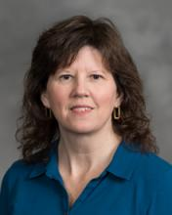  Michelle Aebersold, PhD, RN, CHSE, FSSH FAAN,  Clinical Professor | 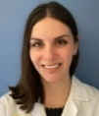  Alexandra Agapiou,  DNP, BSN,  FNP-BC, RN,  Clinical Assistant Professor | 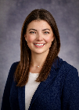  Jenna Allen,  DNP (C), BSN, RN  Clinical Instructor |   Jeri Antilla, PhD., MSN-Ed., RNC-OB  Clinical Assistant Professor | 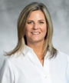  Melissa Bathish, PhD., RN, CPNP-PC, Clinical Associate Professor | 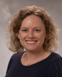  Sue Anne Bell,  PhD, FNP-BC, Associate Professor | 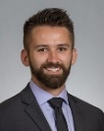  Alec Briggs,  MSN(c), RN, CNE(c), (DNPc)  Clinical  Assistant Professor | 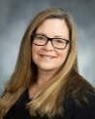  Amy Buckenmeyer,  PhD, MPH, RN, CPH, CPNP-PC,  Clinical Assistant Professor |   Susan Butterworth,  PhD, Research Assistant Professor |   Laura Calamos, PhD, RN, FNP-BC, FHEA, Clinical Assistant Professor
  Nadia A. Charania, PhD, RN, Clinical Associate Professor |   Cherie Conley,  PhD, MSN, BSN, MIS, MHS, BS  Assistant Professor | 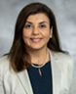  Hala Darwish,  RN, APN, PhD., FAAN, Associate Professor |   Matthew A. Davis,  MPH, DC, PhD, Professor |   Linda  DiClemente, DNP, BA, RN,  Clinical Assistant Professor | 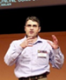  Ivo D. Dinov, PhD, Professor,  SPL Department Chair |   Emily Dove-Medows,  PhD, CNM,  Assistant Professor | 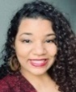  Jessica Dozier,  MPH,  UM President’s Postdoctoral Research Fellow |   Christopher R. Friese, PhD., RN, AOCN®, Professor |   Karen Harden,  DNP, MS, RN, AOCNS, NC-BC  Clinical Associate Professor
  Geoffrey J. Hoffman, PhD, MPH, Associate Professor |   Yun Jiang, PhD., MS, RN, FAMIA, Associate Professor | 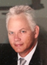  John Knight,  DNP, RN, CSSMBB, PMP, Clinical Assistant Professor |   Yasamin Kusunoki, PhD, MPH, Associate Professor |   HaEun Lee,  PhD, RN  Assistant Professor |   Youran Lee, PhD, RN Research Fellow | 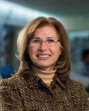  Milisa Manojlovich, PhD., RN, FAAN, Professor | 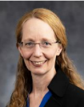  Deanna Marriott, PhD, Research Assistant Professor |   Barbara Medvec, DNP, RN, NEA-BC, Clinical Associate Professor | 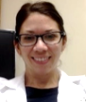  Lynda Pence,  DNP, RN, RD, AGPCNP-BC  Clinical Assistant Professor
  Beck Piasecki, PhD, RN, Research Fellow | 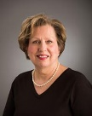  Kathleen Potempa,  BA, MS, PhD, RN, Professor |   Laura Prochnow, DNP, RN, CHSE, Clinical Assistant Professor |   Sheria G. Robinson-Lane,  PhD, RN, MHA, Associate Professor | 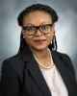  Marie-Anne Rosemberg,  PhD, MN, RN, FAAOHN, FAAN,  Associate  Professor |   Marvin Schilt- Solberg,  PhD, RN,  Assistant Professor |   Rhonda Schoville,  PhD, MSBA, RN,  Clinical  Associate  Professor |   Julia S. Seng,  PhD, CNM,  FAAN,  Professor |   Clayton J. Shuman,  Ph.D., MSN, RN,  Associate Professor |   Nicole Smith, MSN, RN, Clinical Instructor
 | 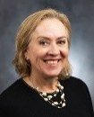  Jeanne-Marie Stacciarini, PhD, RN, FAAN,  Professor,  Associate Dean, Global Affairs |   Sarah A. Stoddard,  PhD, RN, FASHM, FAAN,  Associate Professor | 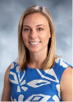  Ashley Thibodeau,  DNP, ARNP CPNP-PC, RN,  Clinical Assistant Professor | 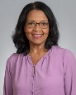  Patricia Tillman-Meakins,  PhD, ANP-BC,  Clinical Assistant Professor |   Dana  Tschannen,  PhD, RN,  Clinical  Professor | 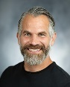  Philip Veliz, PhD,  Research Associate Professor, ABL |   Kai-Lin You, PhD, RN, Research Fellow |   Portia Zaire  PhD(c), MSNEd, BSN, RN, CNE,  NCSP Research Fellow
SPL Adjunct Faculty
SPL Adjunct Faculty |   Amy Allen,  DNP, CNML  Adjunct  Clinical  Instructor | 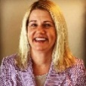  Colby  Anderson,  MSN, RN-BC,  Adjunct Clinical Instructor | 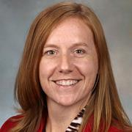  Noel Arring, DNP, PhD, RN  Adjunct Associate Professor |   Amanda Blok,  PhD, MSN, PHCNS-BC,  Adjunct  Assistant  Research  Scientist |   Michelle Bochinski, DNP, MHI, BSN, RN, CNRM, CNE, CNOR, Adjunct Clinical Instructor |   Margaret Calarco,  PhD., RN, NEA-BC, HealthyLifetime© Program Coordinator | 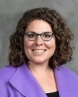  Deena Kelly Costa,  PhD, RN, FAAN  Adjunct Associate Professor | 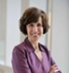  Diane DiFiore,  DNP, MHSA, RN, NEA-BC, ACM-RM, Adjunct Clinical Instructor | 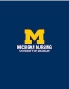  Kathy P. Dunnuck, MSN, BFA, RN  Adjunct Clinical Instructor
SPL Adjunct Faculty |   Laura Gonzalez, PhD, APRN, CNE, CHSE-A, ANEF, FAAN, Adjunct  Clinical Instructor |   Ann K. Gosselin,  DNP, RN, CEN, Adjunct Clinical Instructor |   Julie K. Ishak, DNP, RN, NP-BC, CENP, Adjunct Clinical Instructor |   Sheila Kellogg, CRNA, MS, Adjunct Clinical Instructor | 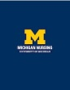  Joseph C. Kolars, MD, MACP, Adjunct Professor | 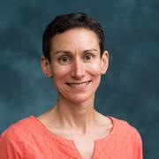  Sarah Krein,  PhD, RN, Adjunct Research Professor |   Bethany Lee-Lehner,  RN, MSN  Adjunct Clinical Instructor | 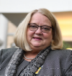  Nancy May,  DNP, RN-BC, NEA-BC,  Adjunct Clinical Instructor |   Anne McLeod,  RN, DNP,  Adjunct  Clinical Instructor
SPL Adjunct Faculty |   David C. Miller,  MD, MpH  Adjunct Professor |   Rama Mwenesi Musalia,  MSE, PhD,  Adjunct Clinical Instructor | 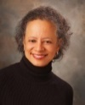  Lori Pierce, MD,  Adjunct Professor | 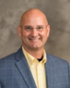  Robert J. Ploutz-Snyder,  PhD, PStat®  Adjunct Professor |   Tammy Ross, MSN(c), BSN, RN, OCN,  Adjunct Clinical Instructor |   Kelly A. Saran,  MS, RN, CPHRM, CPPS,  Adjunct Clinical Instructor |   Mickey Sperlich, BS, MA, MSW, PhD  Adjunct  Clinical  Instructor | 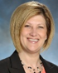  Kari Szczechowski DNP, RN,  PCCN-K, Adjunct  Clinical Instructor |   Olga Yakusheva,  PhD,  Adjunct Professor
SPL Emeriti Faculty
SPL Emeriti Faculty | 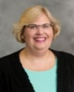  Christine Anderson, PhD, RN,  Clinical Associate Professor Emerita | 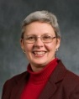  Elizabeth J. Brough,  PhD, RN,  Clinical Assistant Professor Emerita |   Marcelline Harris,  Ph.D., RN, FACMI, Associate Professor Emerita | 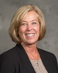  Valerie Y. Marsh,  BSN, MSN, DNP,  Clinical Assistant Professor  Emerita |   Marjorie C. McCullagh,  PhD, RN, APHN-BC, COHN-S, FAAOHN, FAAN,  Professor  Emerita | 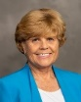  Deborah M. Price,  DNP, MS, RN  Clinical Associate Professor Emerita |   Stephen Strobbe,  PhD, RN, PMHCNS-BC,CARN-AP FIAAN, FAAN  Clinical Professor Emeritus |   Marita G. Titler,  PhD, RN, FAAN,  Professor Emerita

Recent faculty recruitment
The department continued to recruit faculty and fellows to support education, scholarship, clinical practice, and program growth.

Recruitment: New Faculty and Research Fellows (after June 2026):

 |  | 2026
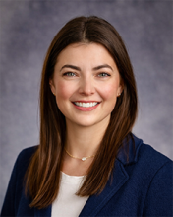 | Jenna Allen,  DNP, FNP-BC;  Clinical Assistant Professor | - Nursing education  - Situational awareness and patient safety  - Critical care nursing  - Interprofessional education  - Simulation-based learning | Former Clinical Instructor, UMSN  Board-certified Family Nurse Practitioner
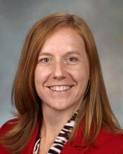 | Noël Arring,  DNP, PhD, RN;  Research Assistant Professor | - Developing evidence-based interventions to improve menopausal symptom management and quality of life among female cancer survivors | Former Adjunct Associate Professor, UMSN  Faculty, University of Manitoba Rady Faculty of Health Sciences. College of Nursing
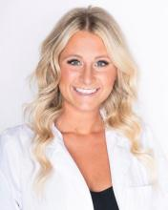 | Brianna Brand, DNP, APRN, CPNP-PC, GCNE;  Clinical Assistant Professor | - Pediatric human trafficking  - Medical mistrust  - Preventative care  - Health disparities  - Pediatric endocrinology | Wayne State University, College of Nursing  Clinical Instructor and Teaching Assistant
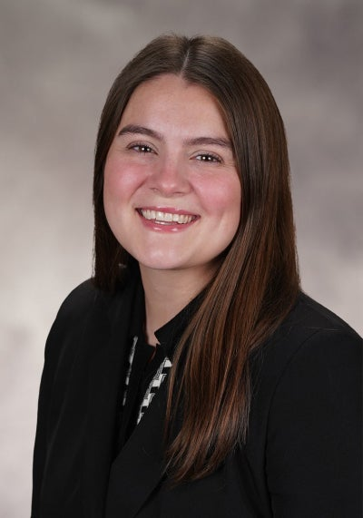 | Elaina Dean,  CNM;  Clinical Assistant Professor | - Midwifery  - Nonviolent crisis intervention  - Perinatal care and perinatal mental health | Nurse Midwife, Trinity Health IHA Medical Group
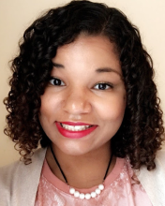 | Jessica Dozier,  PhD, MPH  Research Investigator | - Gender and health  - Sexual & reproductive health  - Reproductive autonomy  - Gender-based violence (reproductive coercion, intimate partner violence) | Former UM President’s Postdoctoral Research Fellow
 | Julie K. Ishak,  DNP, RN, NP-BC, CENP, Adjunct Clinical Instructor | - Strategic Planning, Hospitals, Healthcare, Healthcare Management, and Leadership | Chief Nurse and Operations Executive for Michigan Medicine’s academic medical center.
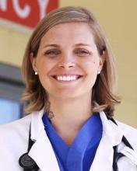 | Katherine Kruger,  PhD, ENP-BC, FNP-BC, ACNP-BC, CEN;  Research Fellow | - Global nursing workforce  - Disasters & public health emergencies  - Health system resilience  - Advanced practice emergency care | National Clinician Scholar, Institute for Healthcare Policy and Innovation
 | Natalie McHugh,  DNP, CPNP-PC;  Clinical Assistant Professor | - Pediatric primary care  - Vaccine-preventable illness  - Undergraduate nursing education | Member, National Association of Pediatric Nurse Practitioners

Faculty transitions
The department recognizes faculty members whose retirements or other transitions occurred during AY 2025-2026 and appreciates their contributions to UMSN and SPL:
  - Dr. Rhonda Schoville, retired Summer 2026
  - Dr. Julia Seng, retired Spring 2026

4. Department Advisory Council and Faculty Engagement
Faculty governance depends on sustained engagement in departmental identity, academic priorities, and School and University missions. The SPL Department Advisory Council (DAC) gathers faculty input, helps coordinate initiatives, and brings balanced recommendations to the Chair and Vice Chair. Administrative support includes meeting coordination and documentation.
During AY 2025-2026, the DAC was co-chaired by Linda DiClemente and Deanna Marriott and included Michelle Aebersold, Amy Buckenmeyer, Marvin Schilt-Solberg, Clayton Shuman, and Philip Veliz. DiClemente and Marriott completed two terms as co-chairs; Amy Buckenmeyer and Philip Veliz are expected to serve as co-chairs in AY 2026-2027.

May 2026 SPL writing retreat
SPL held a writing retreat on May 26-27, 2026, at the Maryville Retreat Center in Holly, Michigan. Twenty faculty attended, and 13 completed the post-retreat survey. Respondents emphasized the value of uninterrupted writing time, a productive environment, balanced pacing, and collegial support. Suggestions included attention to room temperature, more ergonomic seating options, and optional structured stretch or group breaks.
Among survey respondents, approximately 90% reported that they fully met or exceeded their writing goals and approximately 10% reported partially meeting their goals. These percentages should be described as survey-response results rather than outcomes for all attendees.
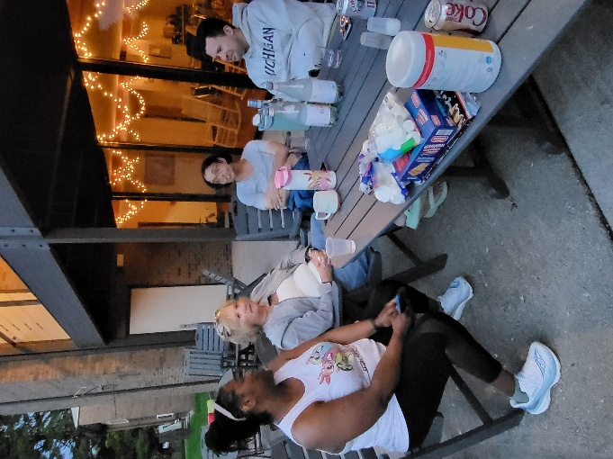
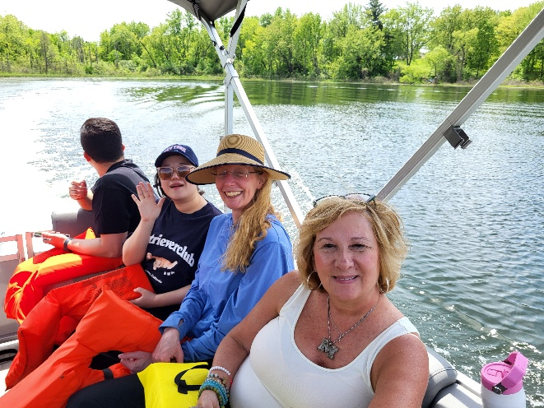
May 2026 writing-retreat photographs
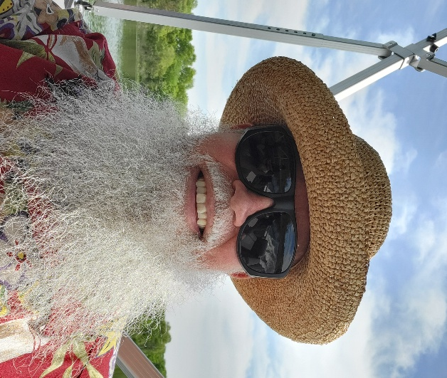

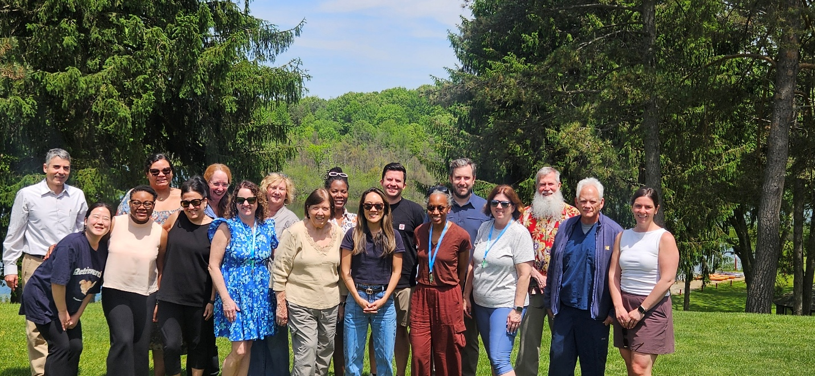

Maryville Writing Retreat May 26-27, 2026 Survey Results (13 responses submitted)
What Worked Well (The Highlights)
Theme | Participant Comments & Feedback
Productivity & Focus | - "The uninterrupted blocks of writing time were exactly what I needed to finish my chapter."  - "Great atmosphere that naturally encouraged everyone to stay focused."
Structure & Pacing | - "Loved the breakdown of the writing blocks; it kept me from burning out too early in the day."  - "The balance between independent work and brief check-ins was perfect."
Community Support | - "It felt great being surrounded by peers who were all working toward similar writing goals."

Areas for Improvement & Suggestions
Category | Feedback & Suggested Changes
Environment / Room Setup | - "The room got a little chilly in the afternoon, so maybe a reminder to bring layers next time."  - "A few more ergonomic seating options or standing desks would be amazing for long stretches."
Scheduling | - "Perhaps add one more optional short group break or standard stretching interval halfway through."

Participant Sentiment Breakdown
An analysis of the overall tone and feedback left by the attendees regarding the event's structure and environment.
Sentiment | Percentage | Focus Area
Highly Satisfied | 90% | Loved the quiet writing blocks, community focus, and distraction-free environment.
Neutral / Constructive | 10% | Wanted minor adjustments like temperature control or structured stretch breaks.
Dissatisfied | 0% | No negative structural complaints reported.

Other DAC activity
- Supported nominations of SPL faculty for major professional recognitions, including FAAN consideration, and discussed how the School might better anticipate costs associated with major awards and induction events.
- Advanced priorities identified during the fall 2025 SPL retreat, including collaboration, mentoring, faculty retention, and potential centers of excellence.
- Initiated planning for the third annual SPL department retreat, scheduled for October 20, 2026.
- Supported planning for a return to Maryville in spring 2027 for a second department writing retreat.

5. Faculty Personnel Actions and Recognitions

Reappointments and promotions
The 2025-2026 cycle included faculty reappointments and, where applicable, promotion actions. Reappointment and promotion should be reported as distinct personnel actions.
- Laura Calamos - reappointed as Clinical Assistant Professor.
- Emily Dove-Medows - reappointed as Assistant Professor.

Selected faculty recognitions
SPL faculty received professional recognition across education, practice, scholarship, leadership, and public engagement. The final report should present a verified, consistently dated list rather than a mixture of nominations, future events, and completed awards.
Aggregate categorization of all (34) SPL faculty recognitions.
Category of Recognition | # | Key Faculty & Highlights
Professional Inductions & Fellowships | 5 | Tschannen & Buckenmeyer (NAP), Dove-Medows (FACNM), Lee (IHPI Accelerator), Conley (DREAMS Center)
Leadership & Advisory Appointments | 5 | Robinson-Lane (MNRS President), Stoddard (NIH Advisory Council), Rosemberg (Assoc. Dean), Dinov (APS/GDS Vice-Chair), Stacciarini (PAHO/WHO lead)
Scholarly & Research Publication Awards | 9 | Aebersold (JONA & JNR spotlights, Article of the Year), Bell & Friese (Editors' Choice Awards), Rosemberg (AIHA President's Award), Lee & Dove-Medows (MNRS Distinguished Abstracts), Shuman (ISPN Poster)
Media & Public Engagement | 5 | Bell (NPR), Darwish (CBS News), Friese (Crain's, Mich. Public, Mich. Advance)
Keynotes, Lectureships & Teaching Awards | 5 | Aebersold (NLN Spunt Lectureship, USI Keynote), Bathish & Buckenmeyer (Sigma Rho Teaching Awards), Lee (DAISY Award)
Grants, Honors & Other Notable Awards | 5 | Dove-Medows (BBF Grant), Aebersold & Medvec (Bronze Telly Award), Charania (Syllabus Digital Impact Award), Dozier (Changemakers Award)
Total Newsfeed Items Recorded | 34 | Reflects the total number of distinct accolades logged in the SPL Faculty Newsfeed.

Aggregate SPL faculty accolades, awards, and other recognitions during the 2025-2026 academic year.
2025-2026 SPL Faculty Recognitions (by track) | Awards | Fellowships | News Reports | Promotions | Other
Clinical (20 CT) | 7 | 3 | - | - | 4
Instructional & Research  (20 TT, 3 RT) | 9 | 2 | 5 | 1 | 3

Collective accomplishments
- Faculty teams continued to explore and pilot generative-AI approaches in graduate nursing education, with emphasis on usability, learning outcomes, adoption, and responsible use.
- SPL sustained peer-mentoring and senior-faculty support structures for early-career faculty.
- DAC continued implementation of department priorities identified at the 2025 retreat.

Office of Global Affairs
The week of August 3, 2026, the Office of Global Affairs’ Developing Advanced Practice Nurses Globally program welcomed 22 international colleagues and key stakeholders from 10 different countries across Latin America, the Caribbean, Asia and the Pacific. Roughly 17 faculty members, 10 students, 6 staff members and several community leaders helped to support a rich agenda for these international guests. Programming was conducted in English, with AI-supported translation available for participants.

The main goal of the program was NP education, roles and legislation. The Office of Global Affairs also celebrated 30 years of global partnerships and impact and highlighted this program as part of the celebration. The founder of the Office of Global Affairs, Dr. Shaké Ketefian, offered remarks to the international guests and reflected on the momentous occasion. Many of the countries in attendance are still in the early stages of developing NP roles, education and policy, which made this a valuable opportunity for mutual learning and global exchange.

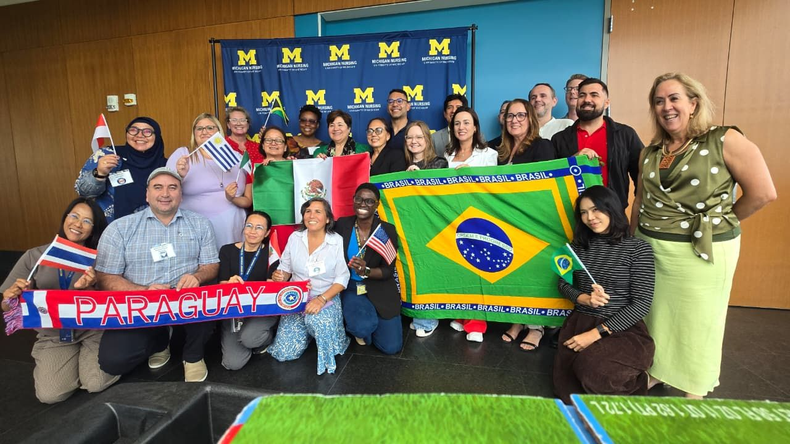

6. Culture, Safety, Ethics, and Reporting
SPL is committed to a professional environment grounded in respect, integrity, accountability, safety, and the UMSN E.P.I.C. values. Concerns should be addressed promptly through the appropriate School or University process. Department leadership should support good-faith reporting and avoid retaliation.

Emergency and public-safety resources
- For emergencies or a crime in progress, call 911.
- For non-emergency public-safety assistance, contact U-M Division of Public Safety and Security (DPSS) at (734) 763-1131.
- U-M Anonymous Tip Line: (800) 863-1355.
The prior draft included a separate "9-9-9" Michigan Medicine emergency instruction. Current public DPSS guidance emphasizes 911 for emergencies; the separate number is therefore omitted here unless a current Michigan Medicine policy is supplied and verified.

Employee reporting responsibilities
All non-confidential U-M employees, including faculty, staff, and student employees, are required to share with the Equity, Civil Rights, and Title IX Office (ECRT), within 48 hours, information learned in the scope of employment about alleged sexual or gender-based misconduct and protected-class discrimination, harassment, or retaliation. Campus Security Authorities have additional Clery Act reporting responsibilities for specified incidents.
For other suspected wrongdoing, use the relevant U-M reporting channel, including DPSS for public-safety matters and University ethics/compliance mechanisms for financial, regulatory, research, patient-safety, or other institutional concerns.

7. Leadership, Analytics and Innovation (LAI) Graduate Program
The Leadership, Analytics and Innovation MSN program is an established graduate offering led by SPL faculty with expertise in executive leadership, health care operations, research, evidence-based practice, informatics, analytics, and technology-enabled education. Its stated learning goal is to build students' confidence in using, analyzing, and interpreting data to develop clinical and financial cases for change, patient-care delivery, and health programs across the health care continuum.
LAI is not enrolling new students for fall 2026 while the School reviews the program and future curriculum. Published program plans will continue for previously enrolled cohorts. LAI students may pursue an Occupational Health Concentration, Certificate in Nursing Education, or Health Informatics Certificate; the prior draft's reference to a Global Health certificate has been corrected.
The current SPL Leadership, Analytics and Innovation (LAI) graduate nursing program includes the following courses.

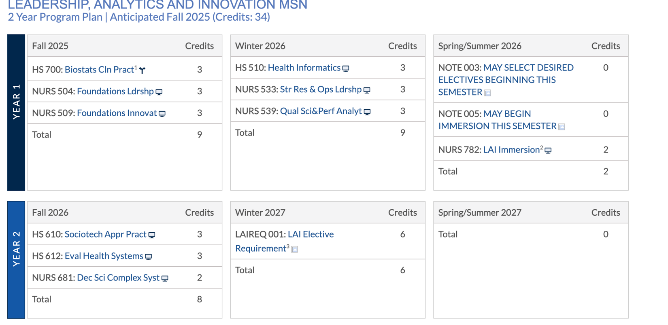

In the year ahead, UMSN will continue to pause admission into the Leadership, Analytics and Innovation (LAI) graduate program. This will allow SPL/LAI faculty to plan, design, implement, evaluate a new graduate executive nursing curriculum including additional classes, such as “Artificial Intelligence (AI) and Health Analytics.” While the curriculum is actively being developed, we will explore executive graduate program developments covering relevant topics such as:

Module 1: Intro to AI and Analytics in Healthcare
Module 2: Foundations of AI
Module 3: Healthcare Data Management
Module 4: Predictive Analytics in Healthcare
Module 5: Diagnostic Imaging
Module 6: Clinical Decision Support Systems (CDSS)
Module 7: Healthcare Operations Optimization
Module 8: Healthcare AI Legal, Ethical, and Regulatory Considerations
Module 9: AI Healthcare Impacts on Nurses and Healthcare Professionals
Module 10: AI In Patient, Family, Population and Community Education and Monitoring
Module 11: AI Healthcare Future Trends and Technologies
Module 12: Healthcare AI Innovation and Utilization
Module 13: AI Future Considerations for the World

Program evaluation
The LAI review should use a defined evaluation framework that connects program purpose to learning outcomes, student experience, enrollment and completion, faculty and resource requirements, professional relevance, fiscal sustainability, and post-graduation outcomes. Certification pass-rate measures should be included only where they are applicable to the program or credential under review.

For 2026, UMSN's MSN program is ranked No. 6 nationally and its DNP program No. 4 by U.S. News & World Report. These are School-level rankings and should not be characterized as LAI-specific rankings.

Metrics/Indicators | Established Benchmarks (from Accrediting Agency & UMSN)
National Certification Board Pass Rates | The CCNE standards for accreditation require the following pass rates to be achieved:  - The pass rate for each certification examination is 80% or higher for first-time takers for the most recent calendar year (January 1 through December 31); or  - The pass rate for each certification examination is 80% or higher for all takers (first-time and repeaters who pass) for the most recent calendar year
U.S. News and World Report Ranking:  In 2025-2026, UMSN’s master’s program ranked 6th, and DNP program ranked 4th | The UMSN has identified a goal of having all of our programs in the top 20 rankings with at least 50% in the top 10 for our graduate programs
Revenue/Course | Fiscal sustainability, and returns-on-investment (ROI)
Impact on Professional Services and Community Networking | Performance, simulations (testing), clinical evaluations, preceptor evaluations of students & student self-evaluations
Learning | Enrollment and graduation statistics, teaching evaluations, post-graduation surveys, technology curricular utilization

8. SPL Web and Digital Resources
SPL department homepage:
https://nursing.umich.edu/about/departments/department-systems-populations-and-leadership-spl
SPL Canvas site:
https://umich.instructure.com/courses/328919
UMSN AI in Health Initiative:
https://ai.nursing.umich.edu/
U-M Equity, Civil Rights, and Title IX Office:
https://ecrt.umich.edu/
PEAR - Prevention, Education, Assistance, and Resources:
https://ecrt.umich.edu/prevention-education-pear/

9. UMSN AI in Health Initiative
The UMSN AI in Health Initiative (https://AI.nursing.umich.edu/) is a school-wide collaborative effort exploring responsible integration of artificial intelligence in nursing education, clinical practice, research, service, and operations. Its public mission emphasizes advancing AI literacy and practical applications while preserving the human values central to excellent nursing practice.
During AY 2025-2026, the initiative continued faculty and student engagement, demonstrations, resource development, and exploration of AI-supported educational, analytical, and clinical-decision tools. This report intentionally distinguishes prototype or educational tools from validated clinical systems and avoids claims of diagnostic accuracy, autonomy, or transformation unless those claims are supported by appropriate evaluation data.

Educational applications
Examples include U-M generative-AI services such as U-M GPT/Maizey, course-specific intelligent teaching-assistant concepts, AI-supported statistical/data-analysis learning resources, and synthetic-data environments for practice. These tools can expand access to guided practice and feedback, but their educational value should be assessed through learning outcomes, usability, accessibility, academic-integrity practices, and faculty oversight.

Practice and decision-support applications
SPL/UMSN investigators are also exploring AI-supported decision-support and clinical-learning applications, including imaging, medication-calculation, and nursing-training tools. Any clinical use should be governed by appropriate validation, privacy, security, regulatory, bias, safety, and human-oversight requirements.

Research and scholarly applications
AI-supported tools may assist with literature synthesis, study design, data analysis, drafting, and proposal/manuscript workflows. These uses should preserve scholarly accountability, source verification, confidentiality, authorship standards, research integrity, and reproducibility. AI output should be treated as an aid to expert judgment rather than a substitute for it.
Many initiative resources are publicly accessible; others, including some University-provided generative-AI services, may require U-M authentication or have specific terms of use. The final resource table should state access requirements accurately.

Designing a Transformative AI Education @ UMSN: Expected Graduate AI Competencies
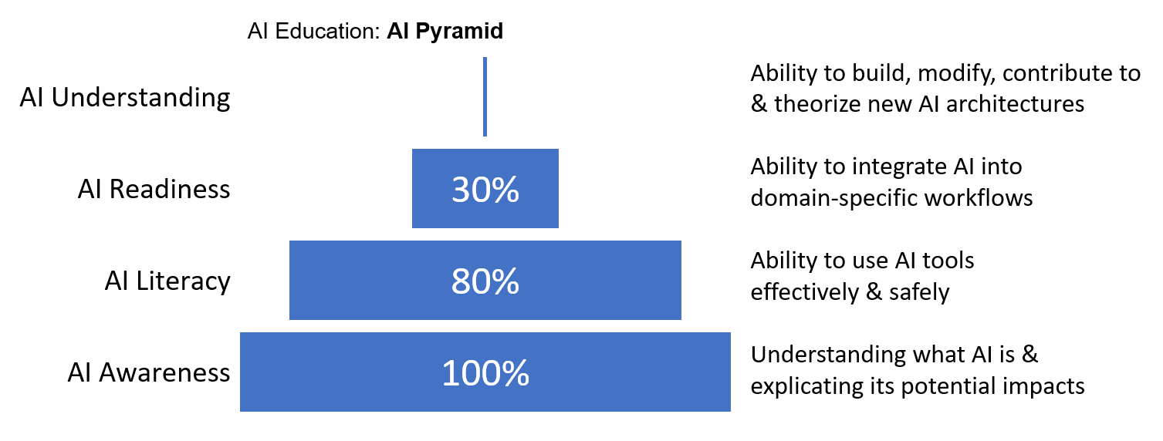

UMSN AI in Health Team

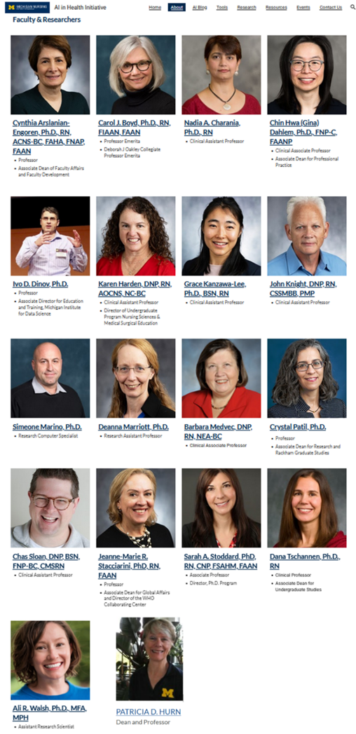
In the spirit of open science, reproducible discoveries, collaborative engagement, and lasting impact, all UMSN AI in Health resources are globally and freely accessible.
Examples of several AI in Health Initiative resources are described below.
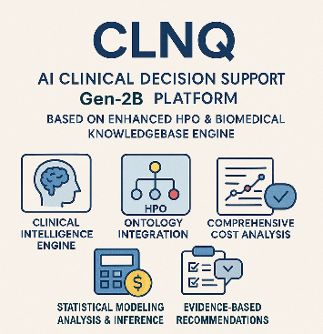  CLNQ is an advanced AI-supported clinical decision support (Gen-2) platform utilizing enhanced human phenotype ontologies and sophisticated biomedical knowledgebase engine  https://socr.umich.edu/GAIM/SOCR_CLNQ_2.html |  | 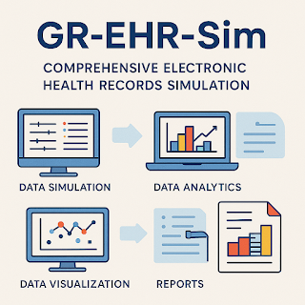  Synthetic Electronic Health Record Generator (GR-EHR-Sim), a comprehensive platform for simulating realistic electronic health records data with full control over clinical parameters and data  https://ehr.statisticalcomputing.org | 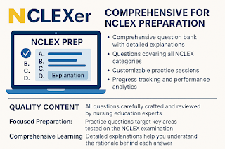  NCLEXer, a comprehensive nursing licensure learning platform  https://nurse-trainer.statisticalcomputing.org/
 | 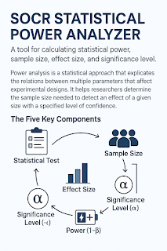  SOCR Statistical Power Analyzer (SPA), a tool for calculating statistical power, sample size, effect size, and significance level  https://power.statisticalcomputing.org | 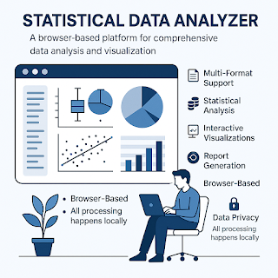  AI-driven Statistical Data Analyzer (SDA)  https://sda2.statisticalcomputing.org | 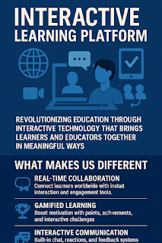  Interactive Learning Platform (ILP) , which revolutionizes health, nursing, and inter-professional education through AI and Cloud technologies  https://ilp.statisticalcomputing.org/
 | 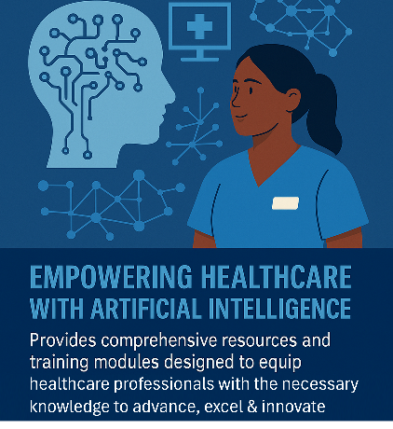  Nurse AI Trainer (NAIT), an innovative healthcare using Artificial/Augmented Intelligence with comprehensive resources and training modules  https://nait2.statisticalcomputing.org/ | 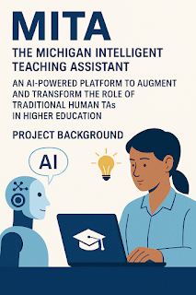  Michigan Intelligent Teaching Assistant (MITA), AI-powered teaching assistant platform for enhancing educational experiences and active learning  https://mita2.statisticalcomputing.org | 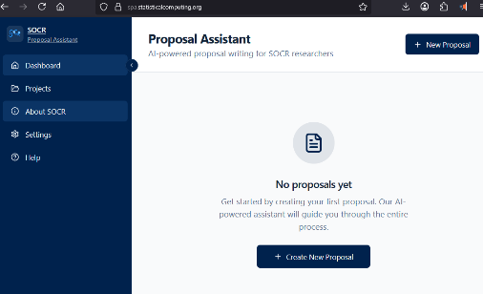  Proposal and Manuscript Assistant (PMA)  AI-augmented grant and paper writing support  https://pma.statisticalcomputing.org

10. Faculty Scholarly Interests, Productivity, and Connectivity
SPL uses annual faculty productivity reports and public scholarly metadata to describe departmental scholarship in aggregate. These analyses can help identify strengths, emerging themes, collaboration opportunities, and areas where additional support may be useful. They are descriptive and exploratory; they should not substitute for holistic, track- and rank-appropriate faculty evaluation.

Composite academic productivity
The draft composite framework pools four domains with equal weighting: research (grants, grant funding, h-index, citations), teaching (teaching credits and courses), service (intramural and extramural activity), and clinical/professional contribution (such as clinical scholarship and relevant professional recognition). Because the underlying measures differ in scale, completeness, meaning, and relevance by track, the composite should be presented as an exploratory visualization rather than a definitive ranking.
Data availability varies by measure. Self-reported and externally indexed data can also differ because of reporting definitions, timing, author-name disambiguation, or incomplete indexing. Quality control should focus on consistent definitions and reconciliation rather than attributing discrepancies to individual intent.
The following diagram illustrates some of the key metrics about the aggregate accomplishments of the 83 SPL Department faculty (including 20 CT, 3 RT, 20 TT, 27 adjunct faculty, 5 research fellows, and 8 emeriti faculty) over the 2025-2026 academic year (AY). These data were pulled from the 2026 annual faculty productivity reports, Michigan Experts, the SPL Newsfeed, and other open-access scholarship resources.

2025-2026 SPL Aggregate Faculty Productivity
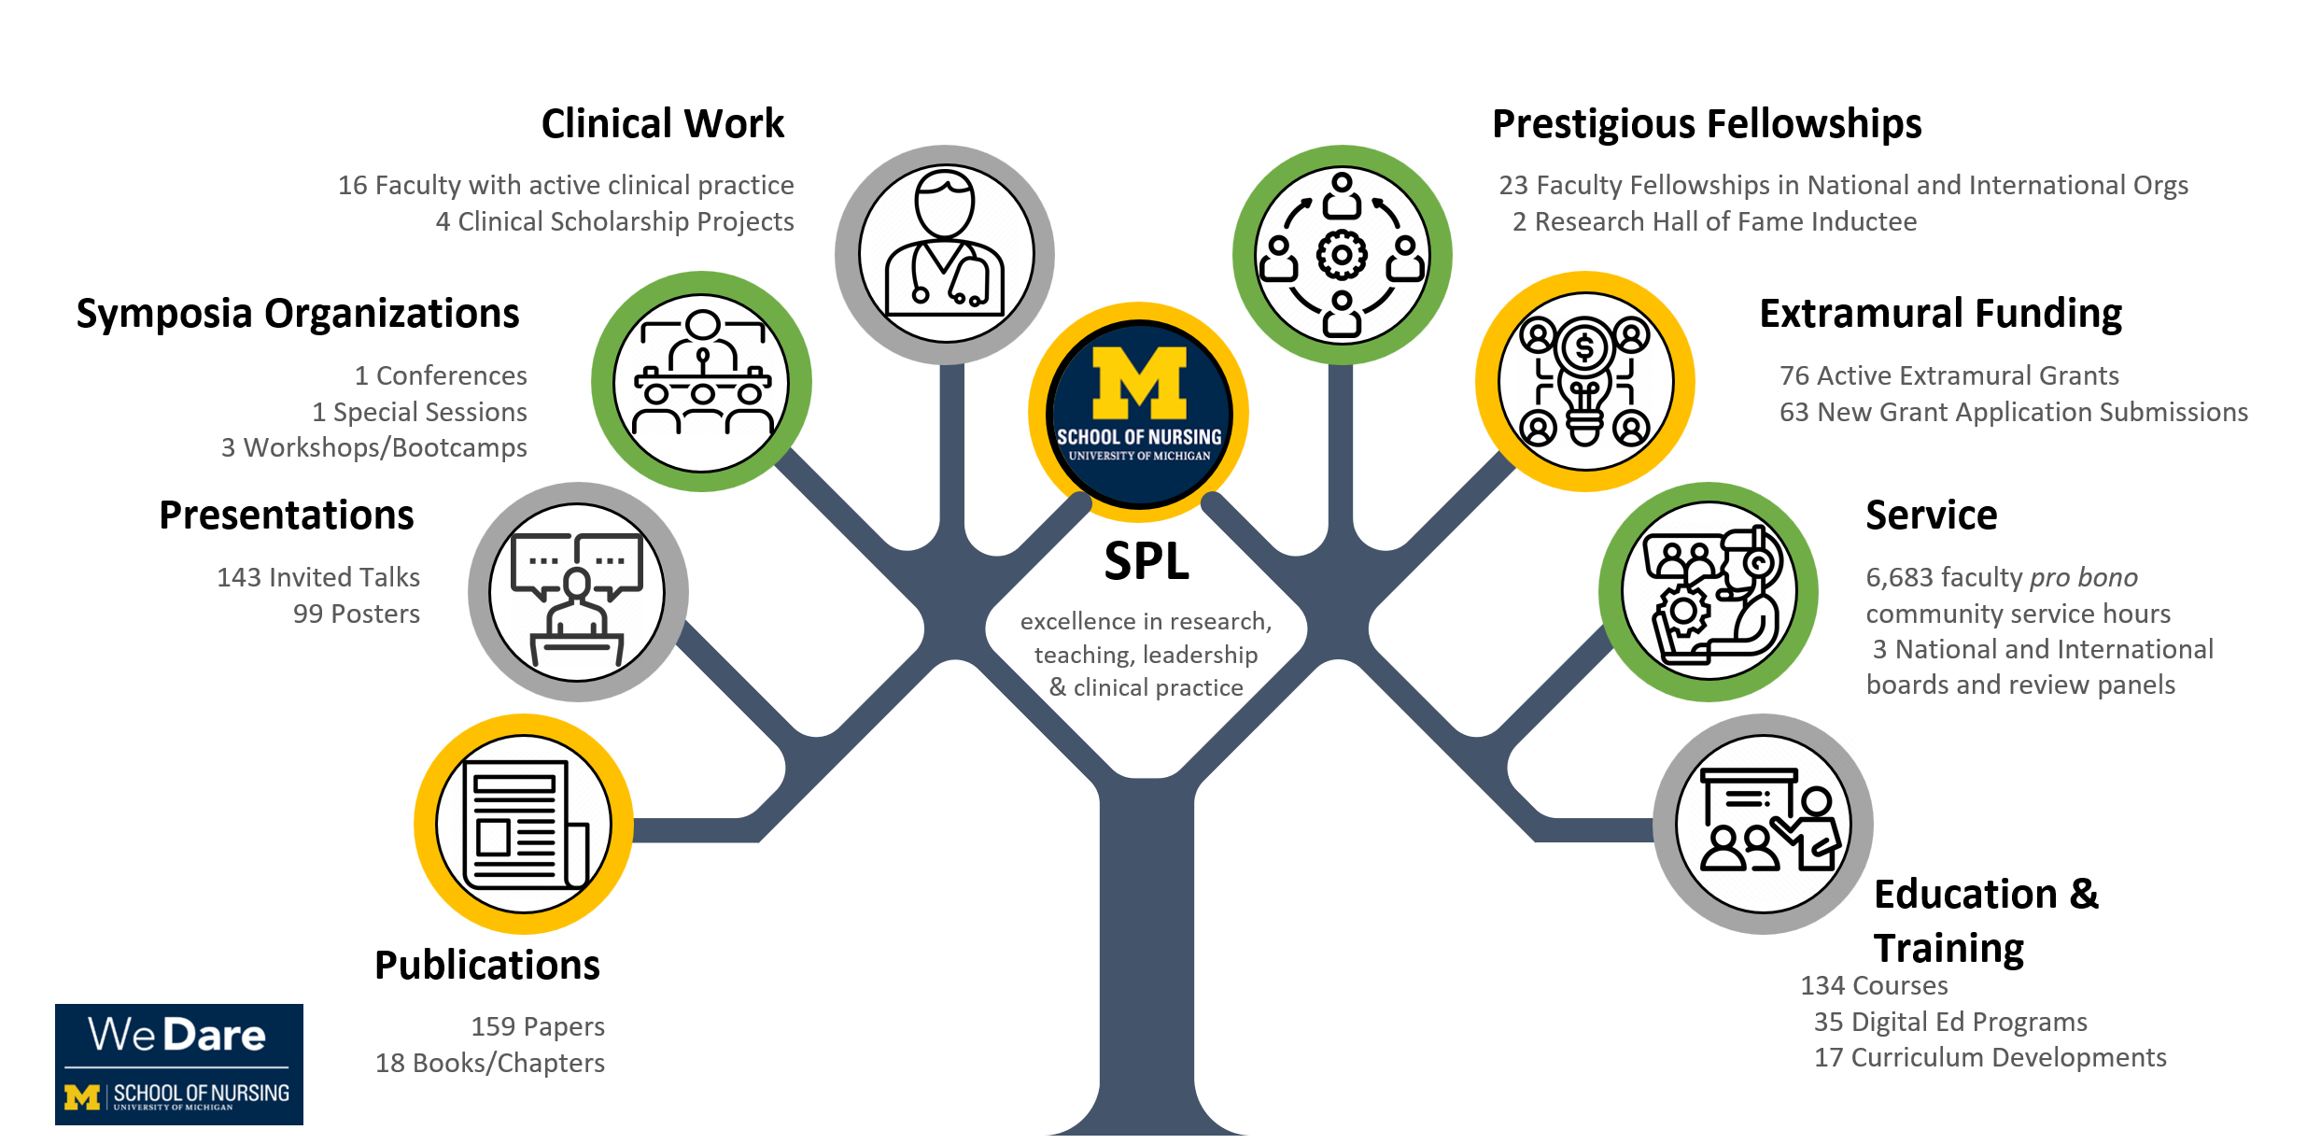
Aggregate SPL faculty accolades, awards, and other recognitions during the 2025-2026 academic year.

Distribution of Composite SPL Faculty Academic Productivity Scores by faculty Rank.

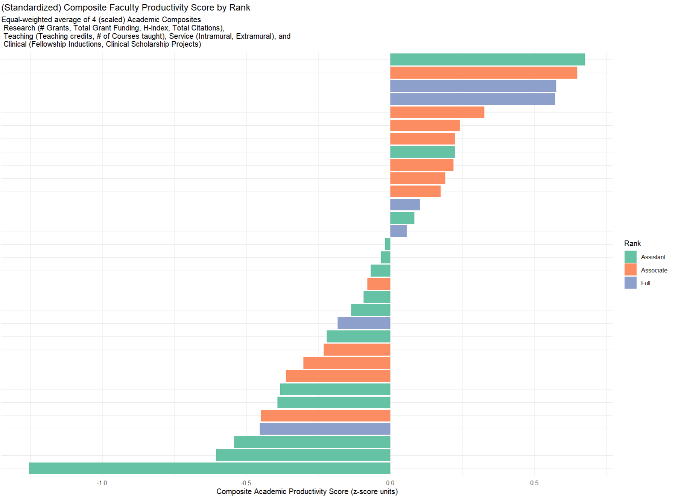

Text mining of publications and grants
Using natural-language processing/text-mining methods, the 2025-2026 faculty productivity narratives can be converted into a document-term matrix for aggregate topic analysis. The draft analysis used 41 faculty reports and retained 200 high-frequency or research-relevant terms/phrases, yielding a 41 x 200 analytical matrix before downstream clustering or visualization.
Faculty names appearing in titles, author lists, presentations, grants, or narrative fields can create disambiguation artifacts. Any figure containing names should therefore be checked against the source data, and name order on an axis should not be interpreted as a rank unless explicitly designated as one.

Frequently used terms in various SPL faculty scholarly activities (2025-2026).
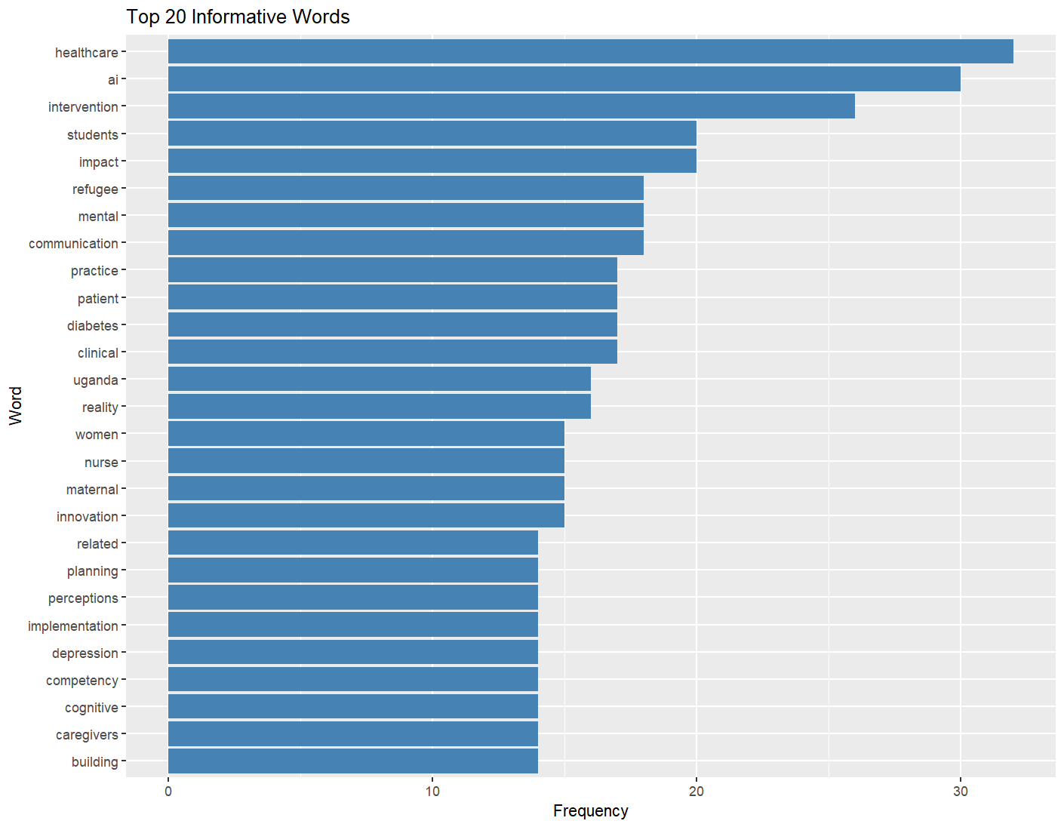 | 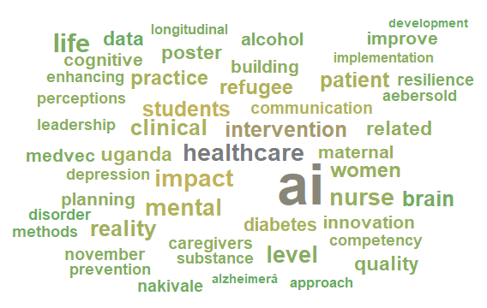
Scholarly themes and frequent research terms (2025-2026).

SPL faculty scholarly publications by track and rank, and grants by track (2025-2026).

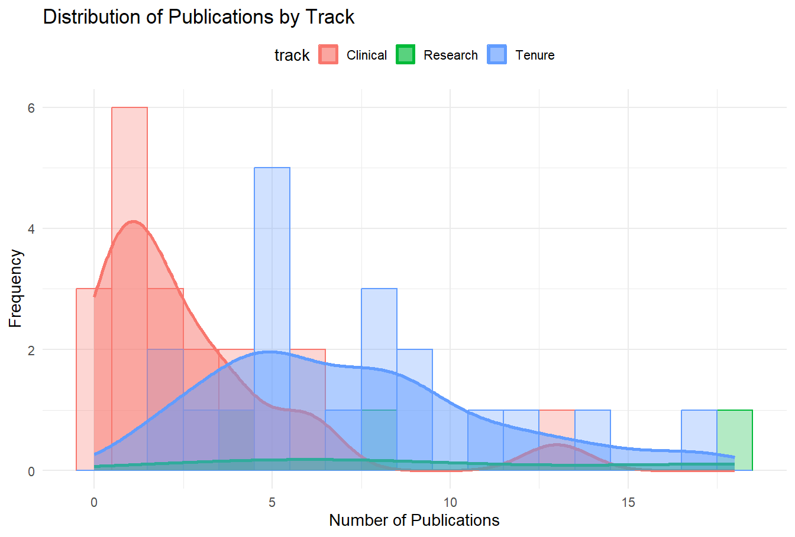

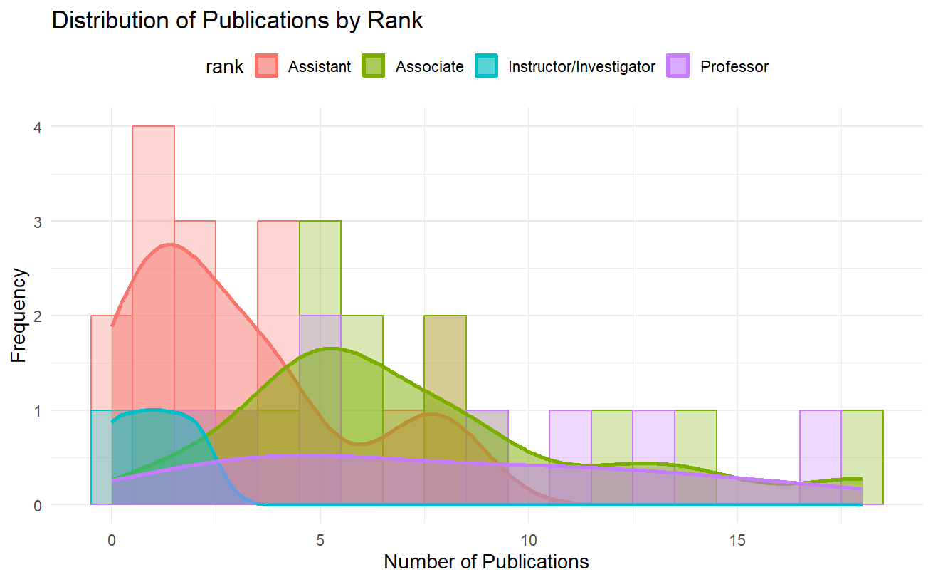

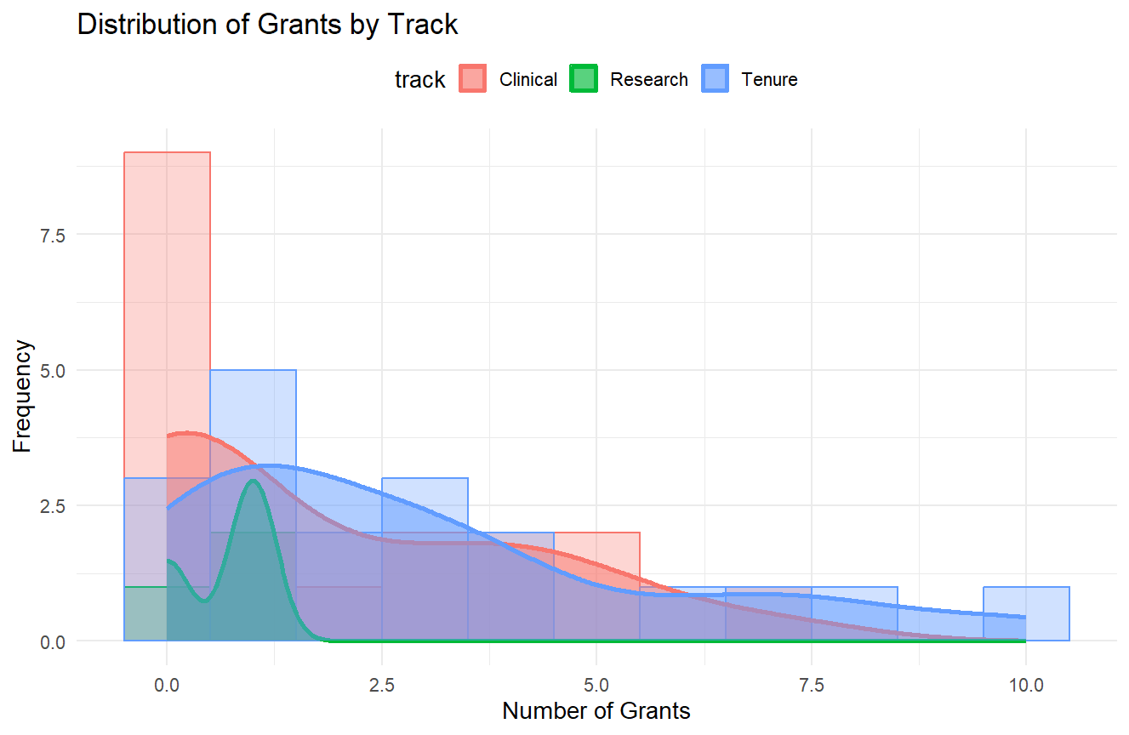

Return on extramural funding investment – grants vs. scholarly publications by faculty rank & track (2025-26).

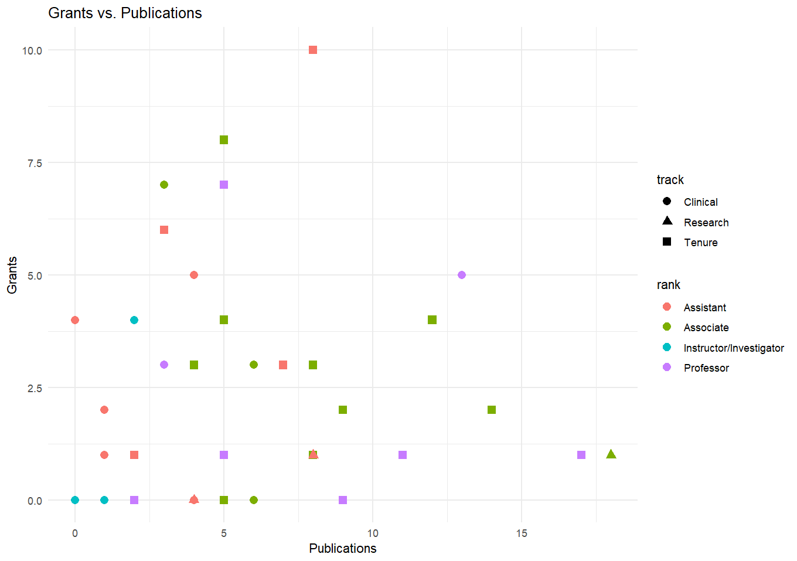

Faculty connectivity
Connectivity analyses use public productivity-report fields such as grant titles, publication titles, and presentations to estimate scholarly relatedness. Hierarchical clustering can identify groups with similar language and topic profiles and may suggest opportunities for cross-faculty collaboration. A cluster is not evidence of an existing collaboration unless confirmed independently.

Hierarchical dendrogram (tree), clustering graphs of SPL faculty
according to their 2025-2026 scholarly work.

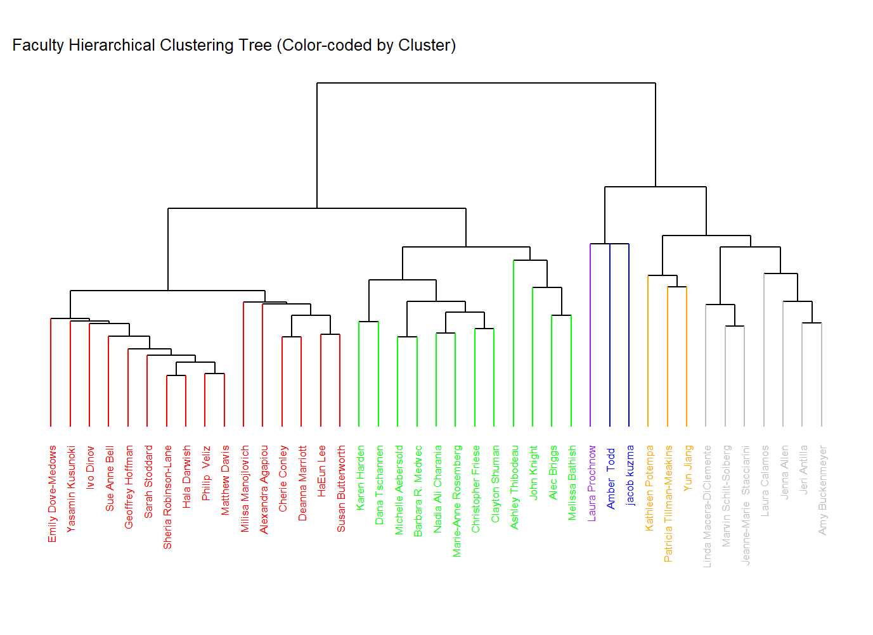
Legend: Hierarchical clustering (with cosine similarity) using grant, pubs & presentation meta-data.

SPL Faculty | Derived Cluster | Color
Emily Dove-Medows | 1 | red
Yasamin Kusunoki | 1 | red
Ivo Dinov | 1 | red
Sue Anne Bell | 1 | red
Geoffrey Hoffman | 1 | red
Sarah Stoddard | 1 | red
Sheria Robinson-Lane | 1 | red
Hala Darwish | 1 | red
Philip Veliz | 1 | red
Matthew Davis | 1 | red
Milisa Manojlovich | 1 | red
Alexandra Agapiou | 1 | red
Cherie Conley | 1 | red
Deanna Marriott | 1 | red
HaEun Lee | 1 | red
Susan Butterworth | 1 | red
Karen Harden | 2 | green
Dana Tschannen | 2 | green
Michelle Aebersold | 2 | green
Barbara R. Medvec | 2 | green
Nadia Ali Charania | 2 | green
Marie-Anne Rosemberg | 2 | green
Christopher Friese | 2 | green
Clayton Shuman | 2 | green
Ashley Thibodeau | 2 | green
John Knight | 2 | green
Alec Briggs | 2 | green
Melissa Bathish | 2 | green
Laura Prochnow | 6 | purple
Amber Todd | 3 | blue
Jacob Kuzma | 3 | blue
Kathleen Potempa | 5 | orange
Patricia Tillman-Meakins | 5 | orange
Yun Jiang | 5 | orange
Linda Macera-DiClemente | 4 | gray
Marvin Schilt-Solberg | 4 | gray
Jeanne-Marie Stacciarini | 4 | gray
Laura Calamos | 4 | gray
Jenna Allen | 4 | gray
Jeri Antilla | 4 | gray
Amy Buckenmeyer | 4 | gray

SPL faculty connectivity score (horizontal axis) provides a proxy-measure of scholarly relatedness
to other SPL faculty using textural and metadata about faculty research, publications, and grants.
The absolute magnitude of the connectivity score reflects indirectly the scholarly output synergies between each SPL faculty and their colleagues in the department.

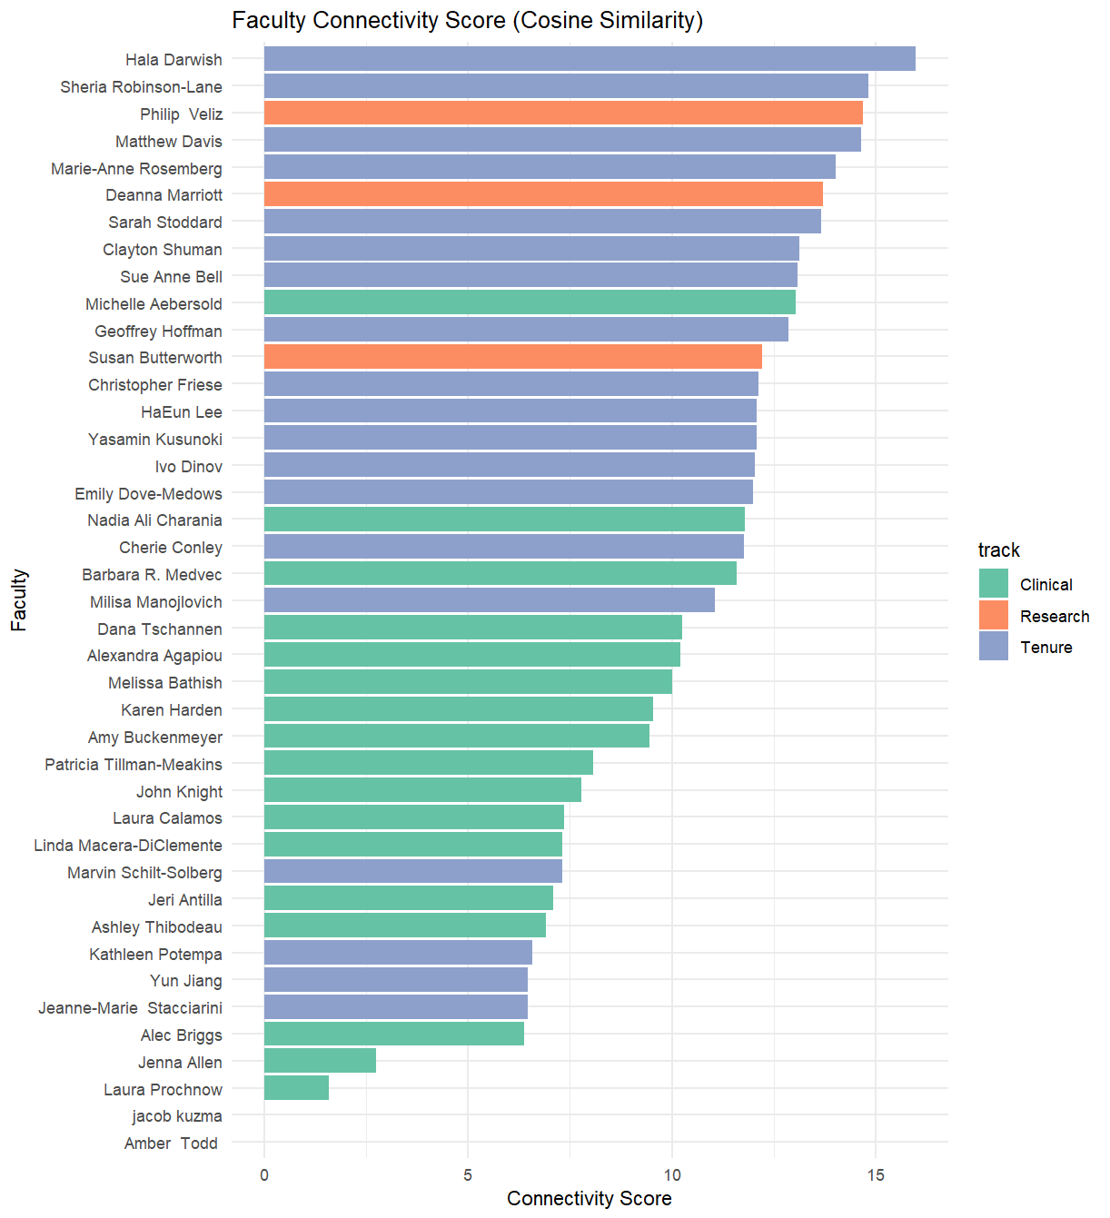

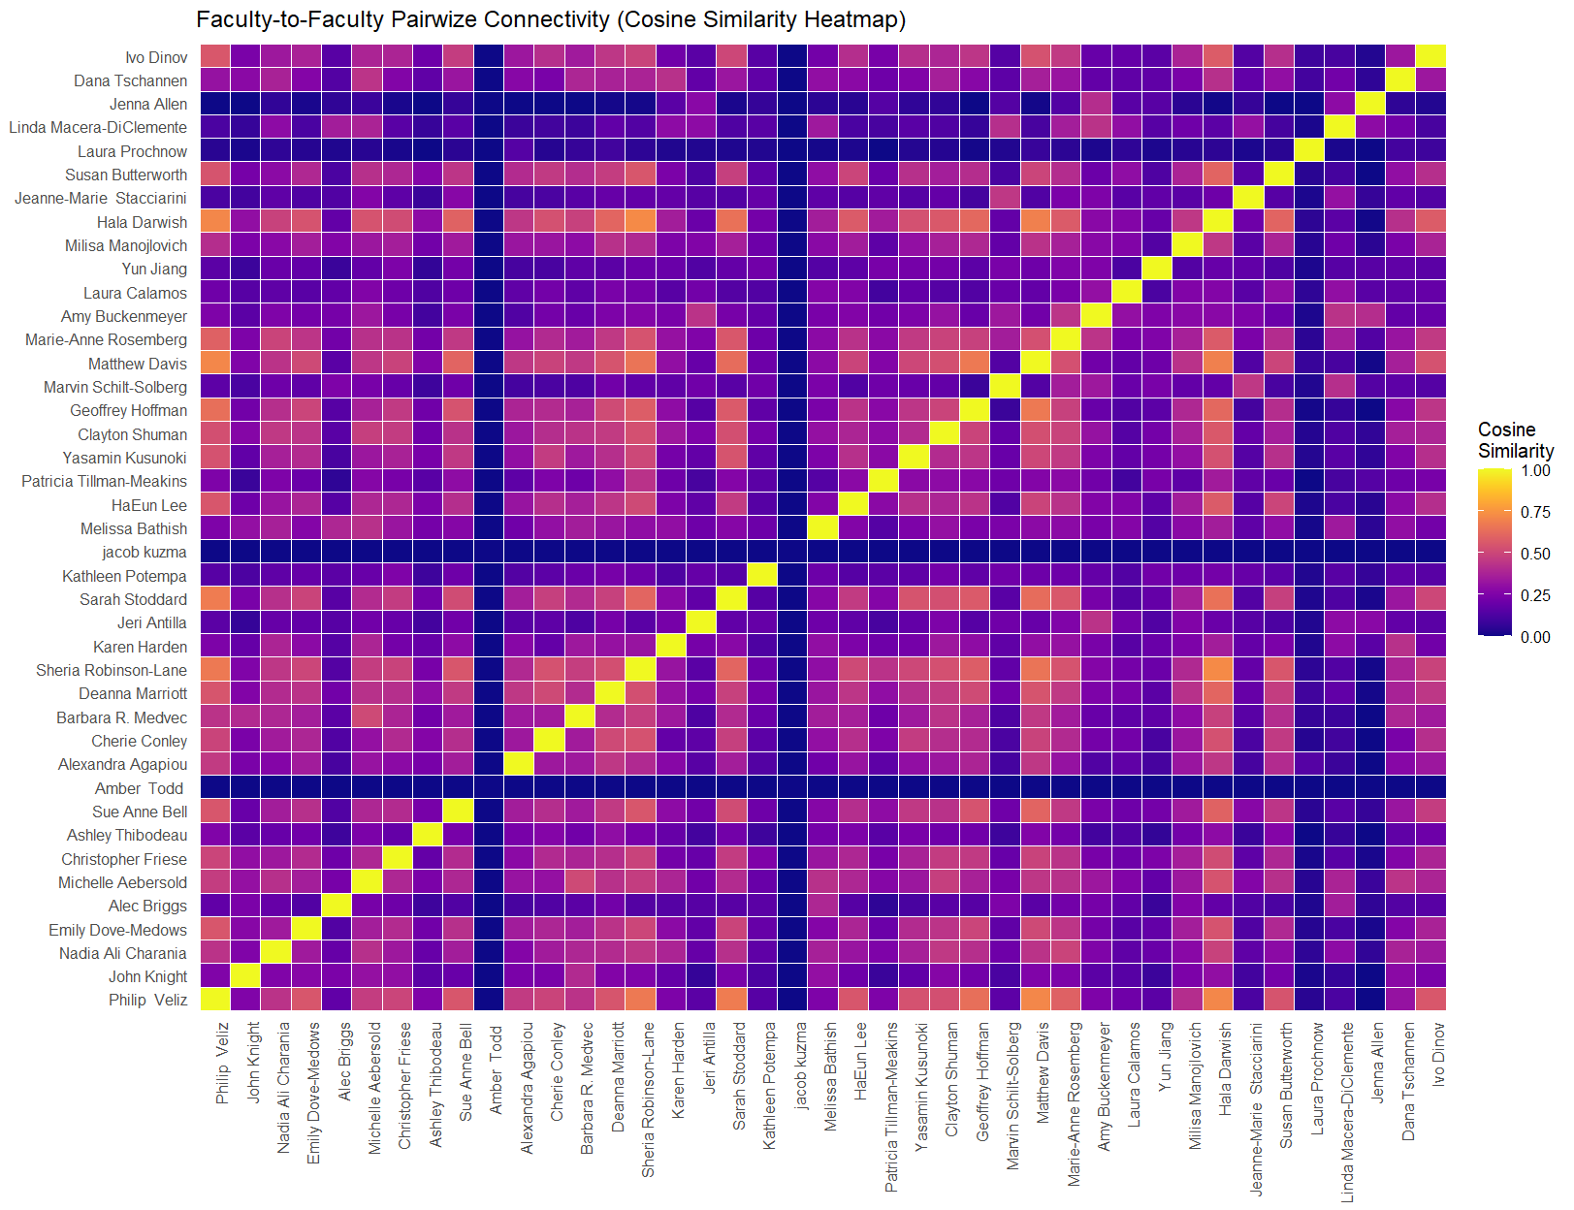

Alluvial diagram of SPL Faculty Grant/Publication/Project Flows:

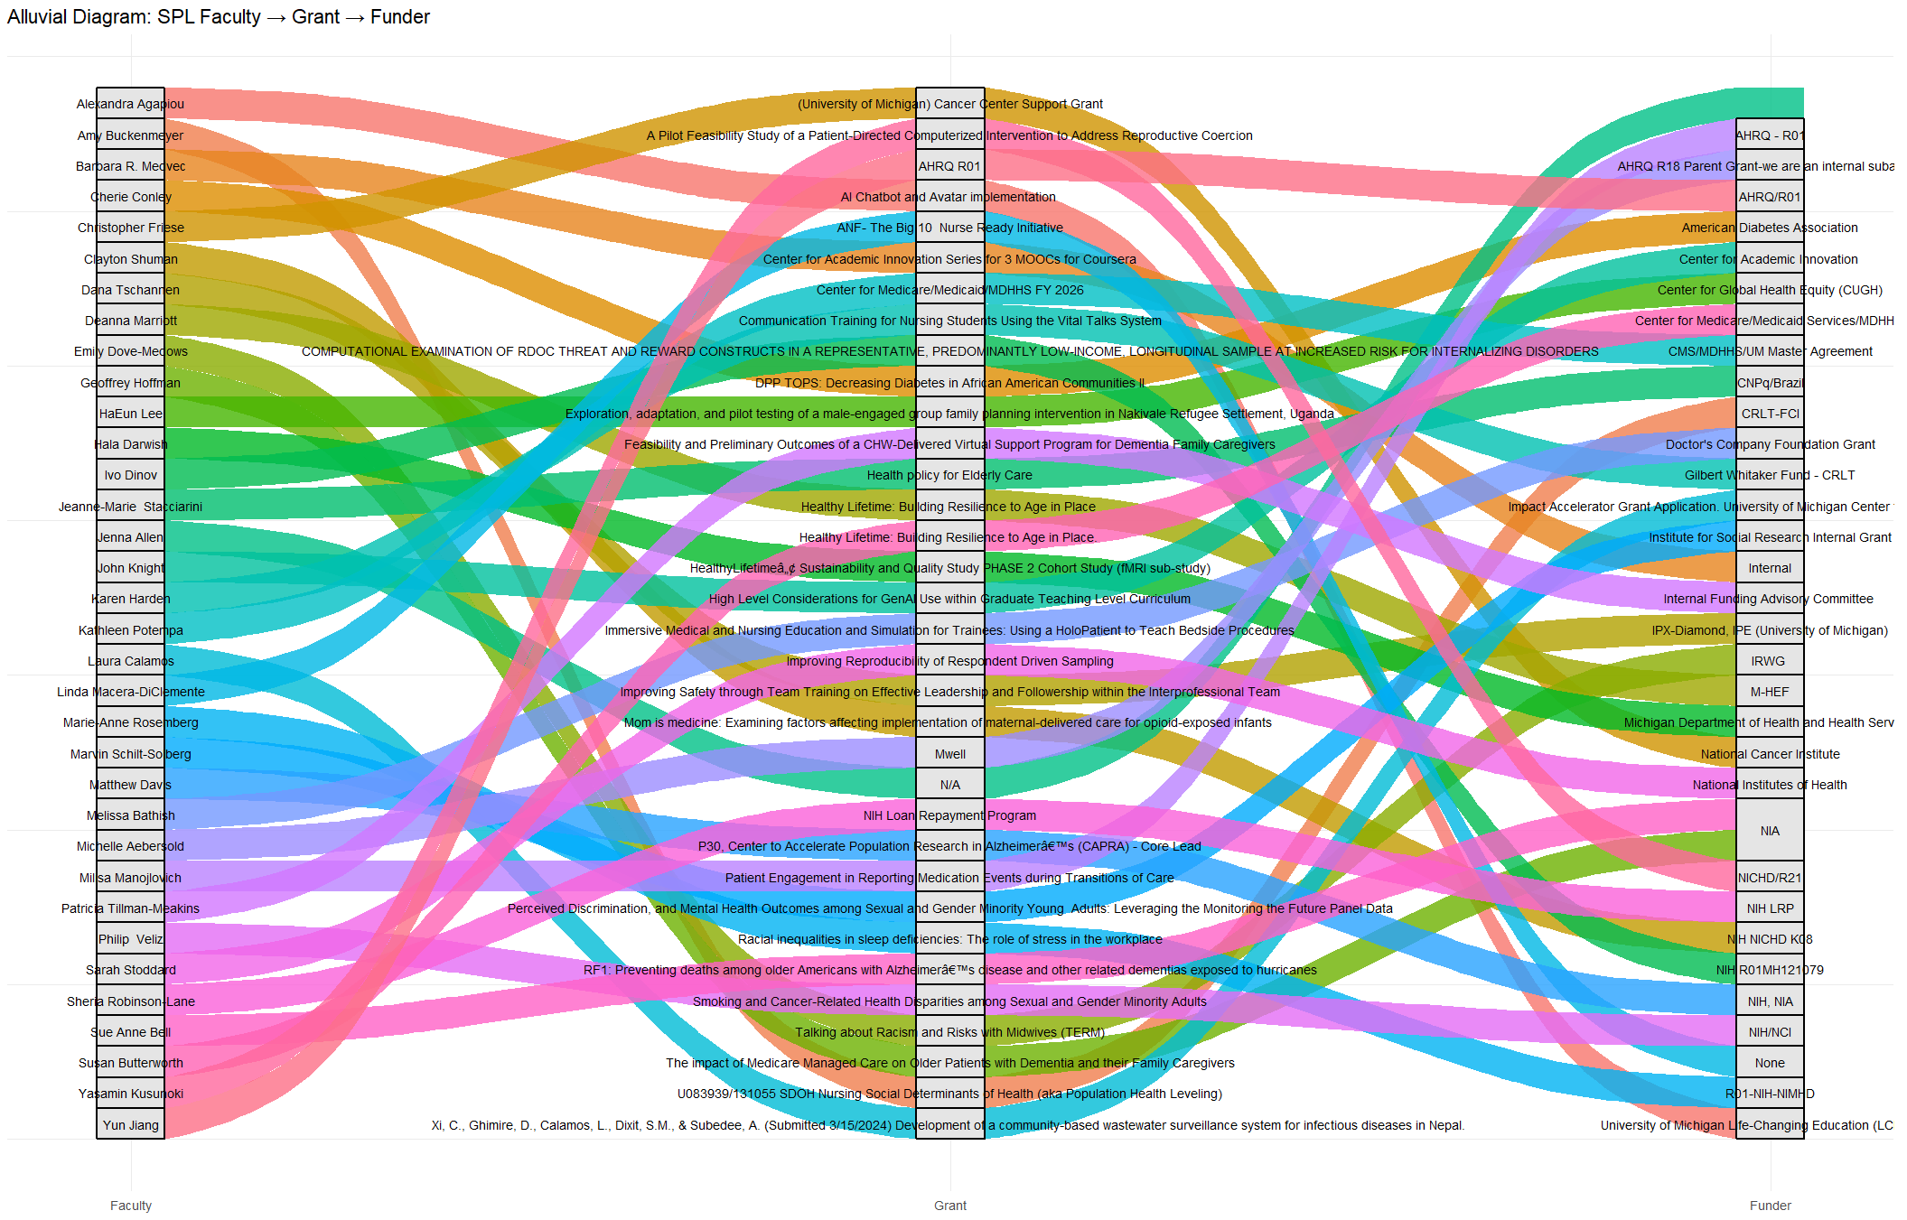
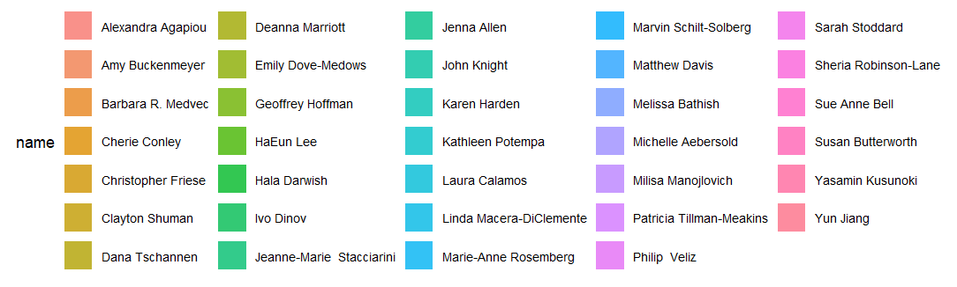

Alluvial diagram for SPL Faculty → Publication Theme,
highlighting scholarly focus areas and thematic synergies

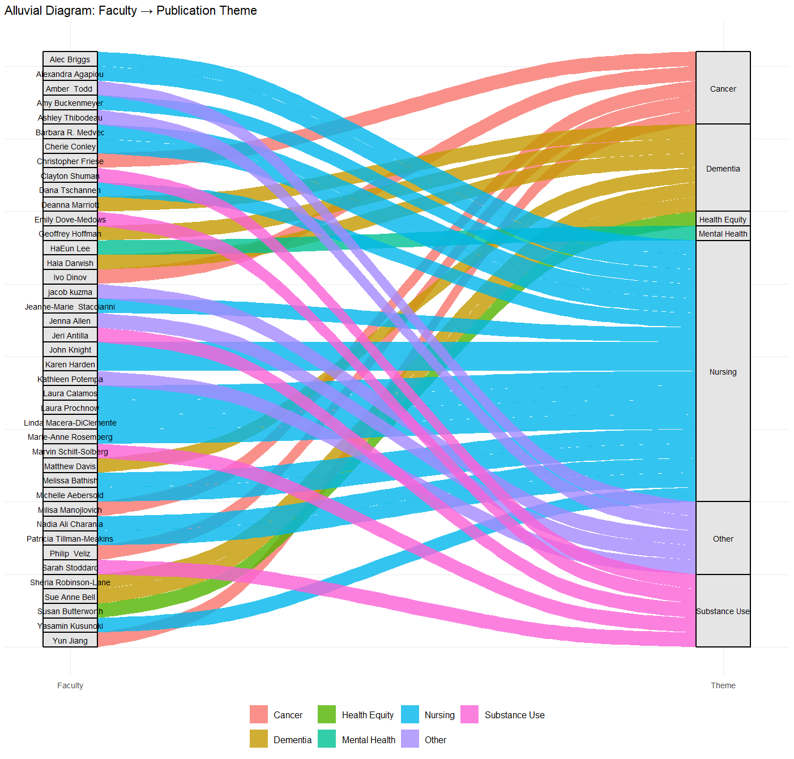

SPL Faculty → Cluster → Theme Alluvial diagram,
explicating the prior hierarchical faculty scholarship clustering (dendrogram)
and supporting identification of common interests and commentary expertise.

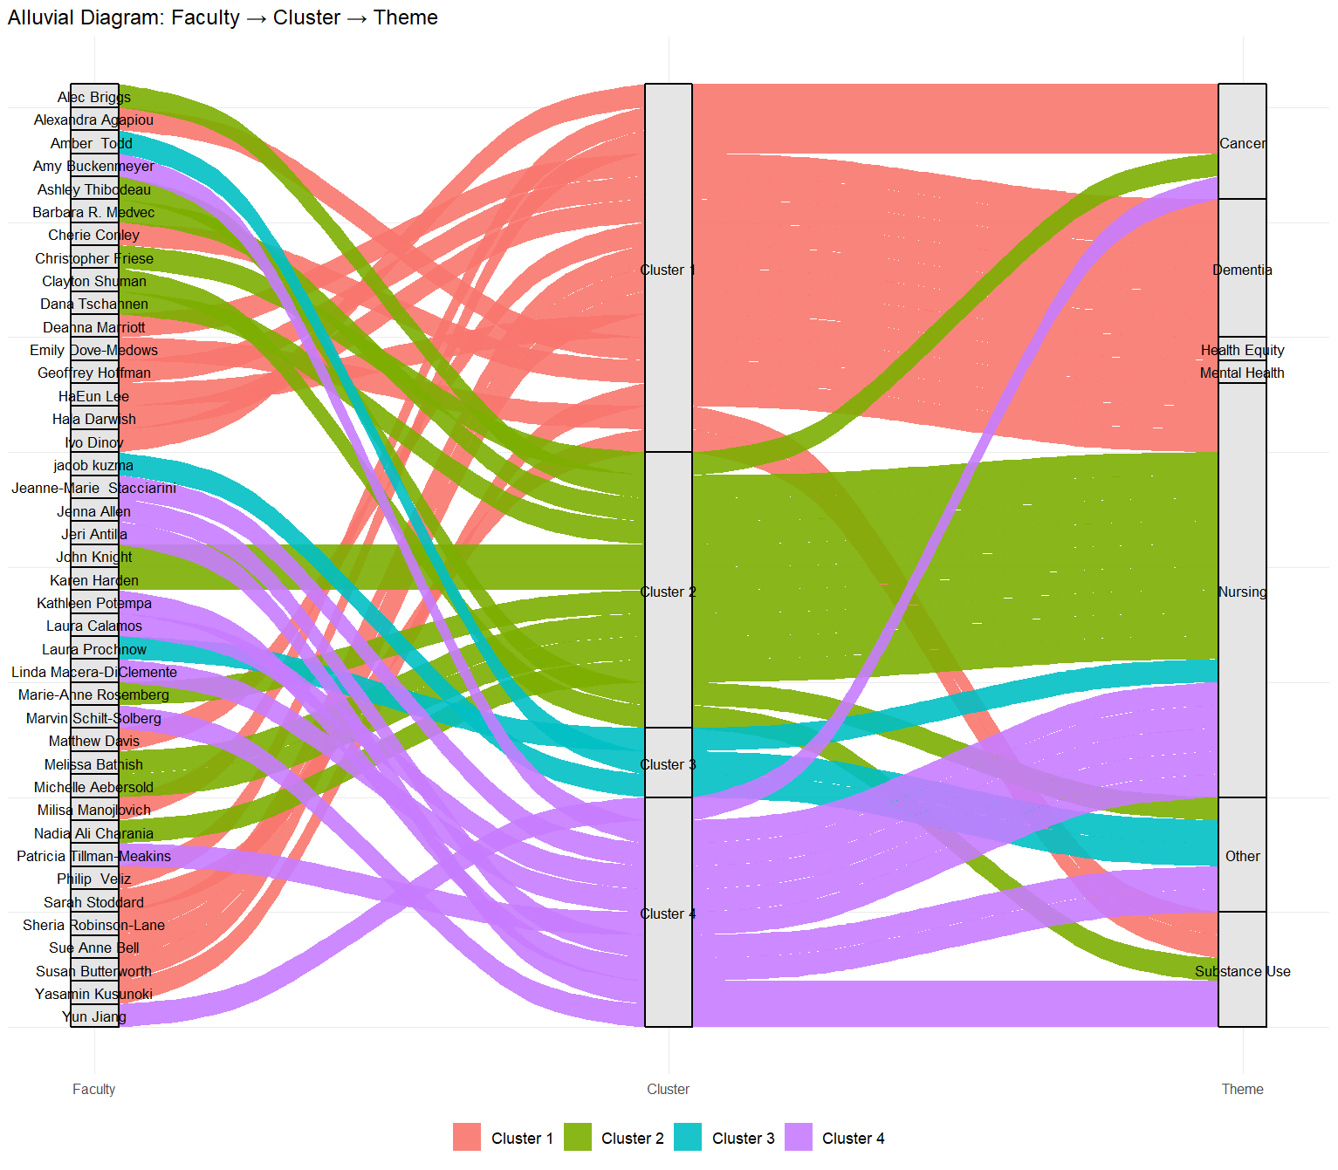

Aggregate productivity statistics
The draft descriptive-statistics table includes teaching, service, presentations, publications, grant activity, citation indices, clinical scholarship, and professional recognition, with valid sample sizes that vary substantially by variable. The final table should retain N for every measure and use readable currency and scientific-notation formatting.

Aggregate Summary Statistics of SPL Faculty Productivity (AY 2025-2026)

Metric | N Valid | Mean | Median | SD | Min | Max
teaching_cr | 38 | 8.05 | 8 | 6.4 | 0 | 20
ay_service_hrs | 34 | 156 | 133 | 124 | 30 | 688
conferences_led | 34 | 0.059 | 0 | 0.239 | 0 | 1
courses_taught | 34 | 4 | 3 | 2.81 | 0 | 12
curricula_dev | 34 | 0.5 | 0 | 0.788 | 0 | 3
dig_ed_courses | 34 | 1.06 | 0 | 1.81 | 0 | 8
fellowships | 34 | 0.706 | 0 | 0.97 | 0 | 3
hall_of_fame | 34 | 0.088 | 0 | 0.288 | 0 | 1
natl_boards | 34 | 0.235 | 0 | 0.923 | 0 | 5
new_grant_apps | 34 | 1.91 | 1 | 1.99 | 0 | 7
outside_service_hrs | 34 | 202 | 154 | 205 | 0 | 1092
pres_posters | 34 | 2.97 | 2 | 2.52 | 0 | 9
pres_talks | 34 | 4.38 | 3 | 4.08 | 0 | 19
pubs_2025_26 | 34 | 8.21 | 5.5 | 8.92 | 0 | 46
pubs_books_chapters | 34 | 0.676 | 0 | 1.68 | 0 | 8
pubs_papers | 34 | 4.82 | 4 | 4.6 | 0 | 18
special_sessions | 34 | 0.059 | 0 | 0.343 | 0 | 2
workshops_led | 34 | 0.118 | 0 | 0.409 | 0 | 2
active_grants | 33 | 2.36 | 1 | 2.77 | 0 | 9
career_pubs | 33 | 69.2 | 34 | 81.4 | 1 | 300
clin_scholarship | 33 | 0.121 | 0 | 0.696 | 0 | 4
career_grant_total | 30 | 19684889 | 2785100 | 33805381 | 0 | 1.17E+08
n_grants | 30 | 11.4 | 9.5 | 10.1 | 0 | 39
career_citations | 26 | 2761 | 1423 | 3462 | 11 | 14600
h_index | 25 | 23.3 | 23 | 15.1 | 5 | 63
i_index | 25 | 43.4 | 35 | 42.2 | 4 | 169
clinical_practice | 16 | 1 | 1 | 0 | 1 | 1
faan | 7 | 1 | 1 | 0 | 1 | 1

SPL Faculty Productivity Statistics

Category |  | Metric | Assistant  (n, mean, median) | Associate  (n, mean, median) |  | Full  (n, mean, median)
Publications & Impact | Career pubs |  | 13, 14.4, 15 | 13, 80.2, 60 | 6, 173, 158
Publications & Impact | Pubs 2025 2026 |  | 14, 4.14, 3.5 | 13, 12.1, 10 | 6, 9.5, 9
Publications & Impact | Career citations |  | 7, 400, 340 | 12, 2,178, 1,658 | 6, 7,044, 5,228
Publications & Impact | H index |  | 6, 8.17, 8 | 12, 23.7, 23.5 | 6, 39.8, 35.5
Publications & Impact | I index |  | 6, 7.83, 7 | 12, 41.8, 36.5 | 6, 87.8, 72.5
Grants & Funding | Active grants |  | 14, 0.5, 0 | 13, 4, 5 | 6, 3.17, 3.5
Grants & Funding | N grants |  | 11, 5.18, 3 | 13, 12.5, 10 | 6, 20.5, 19.5
Grants & Funding | Career grant total |  | 11, 789,875, 386,334 | 13, 24,597,213, 8,994,435 | 6, 43,682,378, 26,762,134
Service & Teaching | AY service hrs. |  | 15, 116, 103 | 13, 211, 150 | 6, 139, 127
Service & Teaching | Outside service hrs. |  | 15, 122, 108 | 13, 322, 288 | 6, 144, 155
Service & Teaching | Courses taught |  | 15, 5.2, 4 | 13, 3.31, 2 | 6, 2.5, 2.5
Service & Teaching | Fellowships |  | 15, 0.467, 0 | 13, 0.692, 0 | 6, 1.33, 1
Service & Teaching | Nat’l boards |  | 15, 0, 0 | 13, 0, 0 | 6, 1.33, 0.5
Service & Teaching | Presentation talks |  | 15, 3.8, 3 | 13, 4.31, 5 | 6, 6, 3.5

Radar Plot: Median SPL Faculty Productivity Metrics by Rank Level (Normalized 0–1)
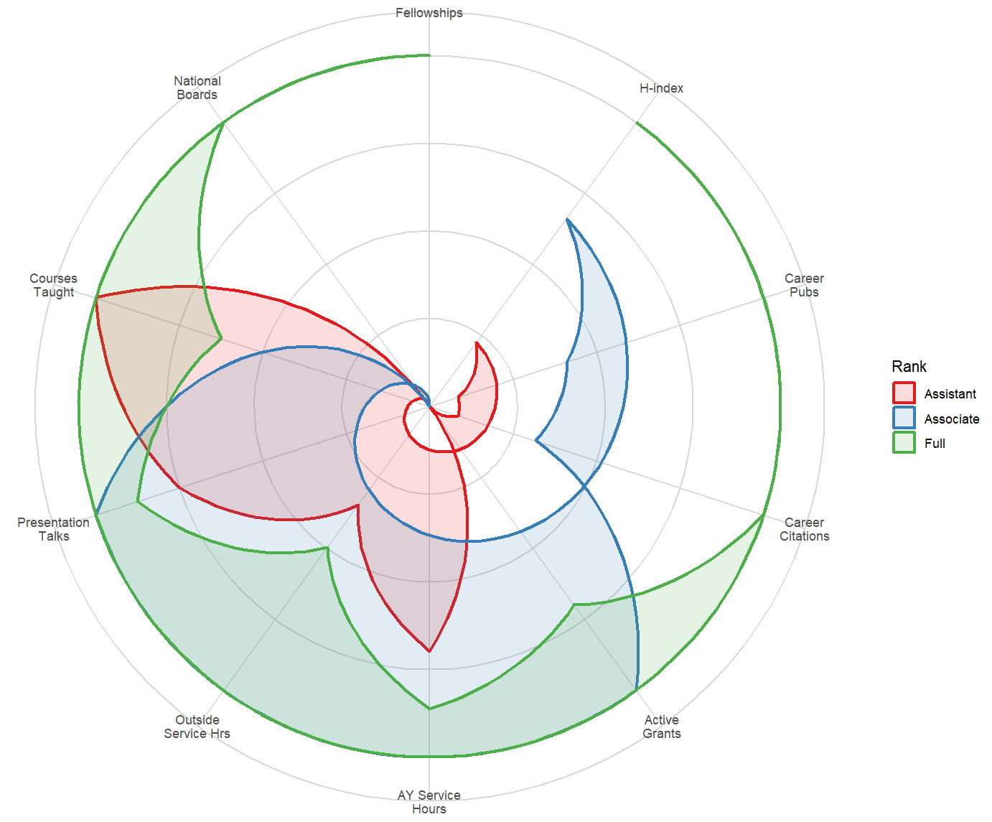

PART II: AY 2026-2027 Priorities

11. Operating Context and Department Priorities
AY 2026-2027 will combine opportunity with resource discipline. UMSN is supporting growth in educational programs while managing faculty and staff capacity, physical and digital infrastructure, student support, and fiscal constraints. SPL will welcome new colleagues and continue to support faculty across tenure, clinical, research, and fellowship roles.
Dean Allison R. Webel began serving as UMSN's 10th Dean on July 1, 2026, following Prof. Dr. Patricia D. Hurn's decade of leadership. The leadership transition provides an opportunity to align SPL priorities with School-wide goals while maintaining continuity in core academic commitments.

Core department priorities for AY 2026-2027
- Manage continued undergraduate-program growth while protecting educational quality and student support.
- Recruit, onboard, mentor, retain, and develop faculty, with attention to workload, recognition, promotion, and sustainable scholarly trajectories.
- Respond collectively and transparently to resource constraints, prioritizing essential academic functions and commitments.
- Redesign and strengthen undergraduate leadership education and the graduate executive-nursing/LAI curriculum through appropriate governance.
- Expand interdisciplinary scholarship, team science, grant development, basic science discoveries, mechanistic modeling, causal inference, and translational partnerships within SPL, across U-M, and beyond.
- Use AI and advanced analytics where they demonstrably improve learning, teaching, research, practice, or operations while maintaining human oversight and responsible-use safeguards.
SPL may expand and refine the four internal operating principles from the prior academic year 2024-2025, which included preserving talent, protecting the youngest/most junior, honoring contracts and promises, and completing key strategic investments.

Collaboration and mentoring
SPL faculty are encouraged to assess their internal and external scholarly networks and identify collaboration opportunities that fit their expertise and goals. Cross-track collaboration can be especially valuable when it combines clinical knowledge, methodological expertise, implementation capacity, and access to practice or community settings. Department mechanisms such as pilot collaboration projects, structured mentoring, writing activities, and intramural partnership development should be evaluated by participation, outputs, participant experience, and longer-term scholarly impact.

12. LAI Redesign and Executive Nursing Curriculum
The pause in new LAI enrollment for Fall 2026 creates an opportunity to define the next generation of executive nursing education. Redesign should begin with the program's target learners and professional value proposition, then map competencies, learning experiences, delivery mode, practice/immersion requirements, assessment, faculty capacity, market demand, and fiscal sustainability.

Conceptual AI and health-analytics content
The following topic sequence is a planning concept, not an approved curriculum. It may inform course or module design after faculty vetting and review, and UMSN-wide faculty curriculum governance:
- Introduction to AI and analytics in health care
- Foundations of AI and machine learning
- Health data management, interoperability, privacy, and governance
- Predictive and prescriptive analytics in health care
- Imaging and multimodal AI
- Clinical decision-support systems and human-AI collaboration
- Health care operations, quality, safety, and optimization
- Legal, ethical, regulatory, equity, and bias considerations
- Workforce implications for nurses and other health professionals
- Patient, family, population, and community education and monitoring
- Evaluation of AI tools: validity, reliability, safety, usability, and impact
- Innovation, implementation, procurement, and change management
- Future trends, emerging technologies, and strategic leadership

In AY 2026-2027, SPL faculty will determine the final topics in the redesigned program, their learning outcomes and credit-bearing structure, faculty ownership, sequencing, practice requirements, and formal curriculum-approval pathway.

13. AI Content in Faculty Development and Teaching
Faculty development should help instructors properly use frontier AI models, generative AI, and related technologies thoughtfully rather than simply increasing tool adoption. Useful preparation includes prompt and workflow design, source verification, assessment redesign, academic integrity, privacy/security, bias and accessibility, disclosure expectations, and evaluation of whether an AI-supported activity improves learning. The UMSN AI in Health Nursing AI Trainer (NAIT2) provides train-the-trainer learning modules, including “Ethical Writing with AI” (https://NAIT2.statisticalcomputing.org/).
The UMSN Teaching Academy and Nurse AI Trainer/related resources can provide a shared foundation for hands-on faculty learning. Training should be coordinated with School policies and supported by practical examples from UMSN courses and clinical education.
UMSN Teaching Academy 2026: Module 2 Teaching with GenAI Course launched. 0F

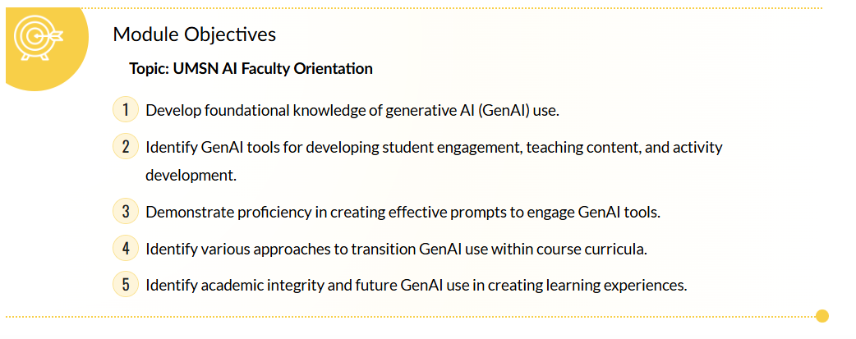

Drs. Aebersold, Ammerman, Dinov, Franklin, Knight, Lee, and Medvec will be building and deploying these faculty AI training modules to the UMSN Teaching Academy Canvas site 1F as well as the UMSN Nurse AI Trainer (NAIT) platform.2F

PART III: Mid-Term Strategic Vision and Opportunities

14. SPL Strategic Vision and Look to Michigan Alignment
SPL's long-term strength lies in combining nursing expertise with population science, systems thinking, leadership, implementation, analytics, and emerging technologies. The department's strategic direction should remain aligned with the UMSN mission and E.P.I.C. values while responding to School and University priorities and to changes in health care, science, education, and society.
At the University level, the current strategic framework is Look to Michigan, which includes five impact areas: Life-Changing Education; Human Health and Well-Being; Democracy, Civic and Global Engagement; Energy, Climate Action, Sustainability, and Environmental Equity, and Advanced Technology. SPL is especially well-positioned to contribute at the intersections of Human Health and Well-Being, Life-Changing Education, and Advanced Technology, while also partnering across the other impact areas when faculty expertise and community needs align.
The prior draft referenced "University of Michigan 2050 Strategic Plan." Campus Plan 2050 is a long-range physical planning effort, not the University's primary academic strategic framework; the report therefore uses Look to Michigan for strategic alignment.

15. SPL Cultural Identity and Fall 2026 Retreat
The October 14, 2026 all-hands SPL retreat is an opportunity to translate department values and strategic themes into a short list of shared commitments. Proposed topics from the planning draft include centers of excellence, LAI, pilot collaboration projects, structured mentoring, onboarding and faculty development, AI integration, faculty retention, and team building.
A Strategic Doing approach can support the retreat by moving from possibilities to choices, concrete commitments, and near-term follow-up: What could we do with the assets already available? What should we do? What will we do first? When will we reconvene to review progress and adjust?
Below is a draft plan for the SPL all-hands-on-deck faculty retreat in fall 2026.

SPL Retreat DRAFT Agenda
Date: October 20, 2026
Location: Michigan Adventure

Morning
- 09:00 AM – 09:30 AM: Kickoff & Framing
  - Review outcomes from October 2025 notes.
  - Introduce the CREATE methodology rules.
- 09:30 AM – 11:30 AM: CREATE Breakout Sprints (Separate Groups)
  - Group A: AI Integration Sprint
  - Group B: Faculty Collaboration Sprint
- 11:30 AM – 12:15 PM: The "Pitch & Translate" Exchange
  - Both groups rejoin.
  - Each group presents their top 2–3 actionable innovations developed during the Translate phase.
- 12:15 PM – 01:00 PM: Lunch & Commitments (What Will We Do?)
  - Vote on immediate priorities and assign project champions for each selected idea.
Afternoon
Teambuilding Fun

16. Look to Michigan Faculty Expansion Program (FEP)
The University's Look to Michigan Faculty Expansion Program is a potential mechanism for strategic faculty growth. For AY 2026-2027, the program targets mid-career tenure-track faculty, generally associate professors and early full professors with tenure, whose scholarship can expand U-M’s capacity for transformative, interdisciplinary inquiry aligned with the Look to Michigan campaign.
The five current Look to Michigan impact areas are:
- Life-Changing Education
- Human Health and Well-Being
- Democracy, Civic and Global Engagement
- Energy, Climate Action, Sustainability, and Environmental Equity
- Advanced Technology

The AY 2026-2027 FEP supports single opportunity hires and cluster hires. Cluster-hire letters of intent are reviewed on a rolling basis, with October 16, 2026 identified as the deadline for review during this academic year. Cross-school/college research activity is strongly preferred. Proposals may include new or expanded research centers, but they must address sustainability or a planned transition/sunset. Proposals focused primarily on curricular or instructional gaps are not eligible for FEP.
The program can provide up to 50/50 cost sharing on base salary and start-up with the participating unit(s), subject to program caps and conditions. Research-track and clinical-track faculty, as well as staff research personnel, are not eligible for Provost Office FEP funding. Selected hires receive a Michigan Impact Professorship for one five-year, non-renewable term after required approvals.
In AY 2026-2027, SPL/UMSN may pursue FEP single-hires or cluster-hires aligned with the Look to Michigan impact areas. As and when necessary, the department will support the Office of Dean Webel with the French Family Endowed Professorship search, which is intended as a nursing-oncology cluster anchor.

17. SPL Intramural Partnership Pathways (IPP)
The SPL Intramural Partnership Pathways (IPP) concept is intended to connect SPL faculty with complementary U-M investigators, institutes, centers, and programs. The goal is to convert existing expertise and infrastructure into stronger interdisciplinary teams that can pursue high-impact research, education, practice, and external funding opportunities.
The draft IPP team includes Sarah Stoddard, Philip Veliz, Sheria Robinson-Lane, Milisa Manojlovich, Hala Darwish, Christopher Friese, and Ivo Dinov. Other faculty are always welcome to participate and lead IPP activities.

IPP objectives
- Identify U-M faculty, groups, institutes, and centers with complementary interests and capabilities.
- Share SPL/UMSN expertise, methods, tools, data/analytics capacity, AI resources, and practice knowledge while learning from partner capabilities.
- Develop joint pilot work, concept papers, grant proposals, centers, or other scholarly products when there is clear strategic fit.
- Build durable interdisciplinary capacity rather than one-time transactional collaborations.
- Create readiness for responsible AI-enabled research and education where AI adds measurable value.

18. Strategic Initiative Fund (SIF)
The U-M Strategic Initiative Fund supports high-value, high-impact initiatives aligned with the Look to Michigan vision. It provides one-time funding for projects that demonstrate institutional or societal value, interdisciplinary problem-solving, innovation, and potential for lasting impact. The University describes the SIF as a $100 million-per-year investment over ten years, for $1 billion in overall University funds.
Tier | Maximum award | General scale
Tier 1 | Up to $5 million | Large-scale initiatives with evidence of substantial impact, leadership potential, scalability, and sustainability.
Tier 2 | Up to $1 million | Initiatives aligned with Look to Michigan that may improve operations, stability, or revenue and create meaningful impact.
Tier 3 | Up to $500,000 | Earlier-stage or focused ideas with potential for impact and leverage into additional opportunities.

The inaugural open call closed on February 9, 2026. U-M plans to announce future annual calls. The fund is not accepting applications as of this report date. SPL should therefore treat SIF as a recurring strategic opportunity rather than announce a specific future deadline until the next call is posted.

19. UMSN Preparedness for the AI-Enabled Future
UMSN has already developed a foundation for responsible AI experimentation through faculty projects, educational resources, school-wide discussion, and technical prototypes. The next stage should emphasize evidence and institutionalization: clear use cases, measurable outcomes, integration with curriculum and workflows, faculty/staff support, privacy and security, accessibility, governance, evaluation, and sustainable maintenance.
Examples documented in the draft include projects led by Dana Tschannen, Barbara Medvec, and John Knight addressing AI-supported feedback, nursing-practice guidance, and deliberate practice for leadership communication. Several UMSN faculty have already received intramural funding to pursue AI integration in education, training, teaching, and scholarship:
- Dana Tschannen et al. CAI AI project, “Improving Feedback Literacy through AI-enhanced Role Play for Nursing Students, Graduates, and Preceptors.” Grant amount: $10,000.
- Barb Medvec et al., CAI AI project, “Growing AI Competency Use with the AI-Driven Nurse Practice Advisor.” Grant amount: $10,000.
- John Knight et al., CRLT AI project, “GenAI-Supported Deliberate Practice for High-Stakes Leadership Communication.” Grant amount: $1,500.
- John Knight et al., LCE AI project, “Deliberate Practice at Scale: Using AI and Avatar Simulation to Improve Leadership Communication.” Grant amount: $15,750.

Near-term principles for AI work
- Human-centered: use AI to augment, not displace, professional judgment and caring relationships.
- Evidence-based: evaluate learning, workflow, clinical, and research outcomes rather than relying on demonstrations or anecdote.
- Secure and private: match data sensitivity to approved tools and institutional policies.
- Transparent: disclose AI use where appropriate and preserve traceability of sources, decisions, and analytic steps.
- Equitable and accessible: test for bias, differential performance, usability, and accessibility across users and populations.
- Sustainable: plan for ownership, maintenance, support, training, cost, version change, and retirement of tools.

REFERENCES

Selected Public References and Resources
The following current public sources support program, policy, ranking, leadership, and University-opportunity information in this report. Internal SPL metrics and personnel data should be validated against the final departmental/School records noted in yellow.
SPL Department: https://nursing.umich.edu/about/departments/department-systems-populations-and-leadership-spl
UMSN Rankings & Recognition: https://nursing.umich.edu/about/rankings-recognition
UMSN LAI specialty page: https://nursing.umich.edu/academics/specialties/leadership-analytics-and-innovation
LAI MSN program plan (published plan notes): https://nursing.umich.edu/program_plans/plan.php?id=16&year=2025
UMSN AI in Health Initiative: https://ai.nursing.umich.edu/
U-M ECRT employee reporting: https://ecrt.umich.edu/reporting/employee-reporting/
U-M DPSS contact information: https://www.dpss.umich.edu/about/contact-us/
Look to Michigan Faculty Expansion Program: https://provost.umich.edu/look-to-michigan-faculty-expansion-program-fep/
Strategic Initiative Fund: https://looktomichigan.umich.edu/about/strategic-initiative-fund/
UMSN Dean Allison R. Webel announcement: https://nursing.umich.edu/about/news-portal/202607-university-michigan-school-nursing-welcomes-allison-webel-dean
UMSN Faculty Handbook (January 2026): https://nursing.umich.edu/sites/default/files/content/page/407/faculty_handbook_january_2026_0.pdf

Notes and Appendices

Supplementary Appendix to SPL-2026 Annual Report: Faculty Accolades

During the 2025-2026 academic year, faculty in the Department of Systems, Populations, and Leadership (SPL) demonstrated exceptional national and global impact through prestigious leadership appointments, fellowships, and scholarly achievements. Notable leadership milestones include Dr. Sheria G. Robinson-Lane’s election as President of the Midwest Nursing Research Society (MNRS) and Dr. Sarah Stoddard’s appointment to the NIH National Advisory Council for Nursing Research. The department also celebrated significant professional inductions, with Dr. Dana Tschannen and Dr. Amy Buckenmeyer inducted into the National Academies of Practice (NAP), and Dr. Emily Dove-Medows inducted as a Fellow of the American College of Nurse-Midwives. Furthermore, Dr. Marie-Anne Rosemberg was appointed as UMSN’s Associate Dean for Faculty Affairs, Dr. Ivo D. Dinov was elected Vice-Chair of the American Physical Society’s Group on Data Science, and Dr. Jeanne-Marie Stacciarini led a global PAHO/WHO "Train the Trainer" initiative for nurse educators in the Caribbean.

SPL faculty consistently translated their research into high-impact scholarly recognition and public discourse. Dr. Michelle Aebersold earned multiple accolades for her work in nursing simulation, including the 2026 Debra L. Spunt Lectureship at the NLN Education Summit, the Clinical Simulation in Nursing Non-Research Article of the Year, and features in the Journal of Nursing Regulation and JONA Magnet Supplement. Several faculty members received distinguished publication awards, such as Dr. Sue Anne Bell and Dr. Christopher Friese, who earned Editors' Choice Awards from Innovations in Aging and Health Affairs Scholar, respectively. Additionally, faculty expertise was highly sought by national and local media, with Dr. Bell featured on NPR’s All Things Considered, Dr. Hala Darwish profiled by CBS News for her VR interventions, and Dr. Friese prominently quoted in Crain's Detroit Business, Michigan Public, and Michigan Advance regarding nursing shortages and health policy.

The department’s commitment to education, mentorship, and community impact was equally prominent. Dr. Amy Buckenmeyer and Dr. Melissa Bathish were honored with Sigma Rho Chapter Excellence in Education Awards, while Dr. HaEun Lee received the DAISY Award for Advancing Health Equity. Research translation and community impact were further recognized through awards such as Dr. Jess Dozier’s Changemakers in Family Planning Award, Dr. Dove-Medows’ Building Better Futures grant, Dr. Rosemberg’s President’s Award from the American Industrial Hygiene Association, and a Bronze Telly Award for Drs. Aebersold and Medvec for their immersive training simulation. Together, these accomplishments reflect the SPL department’s unwavering dedication to advancing nursing science, shaping health policy, and mentoring the next generation of healthcare leaders.

Supplementary Appendix to SPL-2026 Annual Report: New SPL Faculty Since 2023

New Faculty | Title | Expertise | Background
2023
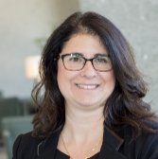 | Laura Calamos, PhD, Clinical Assistant Professor  (2023) | - Primary care  - Mental health  - Diabetes services  - Knowledge exchange across health-care sectors | Fellow of the Higher Education Academy (HEA), United Kingdom  Family Nursing Practitioner, Chelsea, MI  Primary Care Provider  Family Nursing Practitioner, Washtenaw County Medical Reserve
 | Cherie Conley, PhD, MSN, MIS, MHS,  Assistant Professor  (2023) | - Designing and disseminating community-based interventions  - Cardiometabolic health equity  - Systems and implementation science | Previously research fellow & National Clinician Scholars Program fellow at the Institute for Health Policy and Innovation (IHPI)
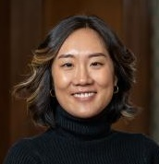 | HaEun Lee, PhD,  Assistant Professor  (2023) | - Education & Training  - Social Justice & Gender Equity  - Health Promotion & Prevention  - Healthcare Outcomes & Quality  - Infant & Child Mortality  - Sexual & Reproductive Health | UMSN graduate (PhD ’21)  Post-Doctoral fellow in the University of Michigan Center for Global Health Equity  Previously worked in Liberia, Zambia & Uganda
 | Amy Buckenmeyer, PhD  Clinical Assistant Professor  (2023) | - Community participation  - Capacity building services  - Health promotion & prevention  - Maternal-child health  - Global health, biostatistics | Completed the AACN Elevating Leaders in Academic Nursing (ELAN) fellowship program  Statistical modeling at the World Health Organization Collaborating Centre, University of Illinois at Chicago  Previously at The George Washington University.
 | Florence Johnson, PhD,  Research Fellow  (2023) | - Gerontology  - Medicare & Medicaid service quality improvements  - Aging and dementia | Fellow, (UMSN NIH/NINR T32 Training Grant) NR016914 Complexity: Innovations in Promoting Health and Safety  Health Services Student Travel Award, Gerontological Society of America (GSA)
2024
New Faculty | Title | Expertise | Background
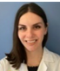 | Alexandra Agapiou, DNP, BSN, FNP-BC, RN, Clinical Assistant Professor (2024) | - Language choices and Type 2 diabetes stigma  - Diabetes care and management  - Nursing interventions to reduce hospital readmissions | Former clinical instructor (UG), UMSN  Former co-chair of the Evidence-Based Practice and Research Council, Henry Ford HS
 | Alec Briggs, MSN, RN, CNE, (DNPc), Clinical Assistant Professor (2024) | - Increasing nurse resident resiliency and retention  - Improving clinical judgement in junior-level nursing students  - Effects of working conditions on attrition of inpatient nurses | Former LEO Lecturer I, UMSN  Experience in cardiothoracic and cardiovascular nursing
 | Jessica Dozier, MPH, University of Michigan President’s Postdoctoral Fellow (2024) | - Sexual and reproductive health,  - Community-engaged research, MCH,  - SRH stigma | Johns Hopkins (PhD)  Emory University (MPH)  University of Michigan (BA)
 | Laura N. Gonzalez, PhD, APRN, CNE, CHSE-A, ANEF, FAAN, Adjunct Clinical Instructor (2024) | - Health disparities  - Adult health  - Simulation in healthcare | Vice President for Clinical Learning Resources at Sentinel U®  Advanced Certified Healthcare Simulation Educator  Fellow of the Academy of Nurse Educators  Fellow of the American Academy of Nursing
 | John Knight, DNP, RN, CSSMBB,  Clinical Assistant Professor (2024) | - Translating evidence-based practice research  - Improved access to care for lower socioeconomic class populations  - Patient outcomes and practitioners' mental health | Lean Six Sigma – Master Black Belt, University of Michigan College of Engineering  Former UMSN adjunct instructor
 | David C. Miller,  MD, MPH  Adjunct Professor (2024) | - Health services research  - Physician-led collaborative quality improvement  - Physician organization and the efficiency of specialty care | President, Michigan Medicine  Professor in Urology Surgery, University of Michigan
 | Lynda Pence, DNP, RN, RD, AGPCNP-BC, Clinical Assistant Professor (2024) | - Doctoral Dissertation: Motivational Interviewing to Promote Self Care in Patients with COPD  - Using effective therapeutic communication to engage students and professionals in promoting optimal quality of life for those we serve. | Former UMSN adjunct instructor  Global Volunteer Network, Guatemala, Healthcare missionary (2015)
 | Marvin Schilt-Solberg, PhD, RN, Assistant Professor (2024) | - Childhood adversity and health outcomes among sexual and gender minorities and on sexual minority men  - Substance use and abuse  - Injury control and prevention | Graduate certificate in Alcohol Use and Drug Abuse Studies, WSU School of Social Work; Doctor of Philosophy in Nursing, WSU
 | Ashley Thibodeau,  DNP, CPNP-PC, RN, Clinical Assistant Professor (2024) | - Pediatric healthcare  - Bringing new therapies to neuromuscular patients  - Quality improvement  - Patients with complex medical conditions | Service-learning opportunities in South Africa and Haiti  Formerly with Mott Children’s Hospital (Ann Arbor) and Seattle Children’s Hospital
 | Portia Zaire, PhD(c), MSNEd, BSN, RN, CNE, (NCSP Postdoc Fellow)(2024) | - Professional nursing development  - Continuing nursing education  - Family Medicine & Primary Care | Ohio State University (PhD)  University of Phoenix (MSN)  Cleveland State University (BSN)
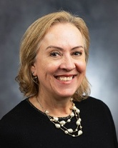 | Jeanne-Marie Stacciarini,  PhD,  AD for Global Affairs | - Global health  - Mental health promotion  - Health disparities  - Rural health | Fellow, American Academy of Nursing, 2015  SIGMA International Nurse Researcher Hall of Fame, 2024
2025
 | Youran Lee, PhD, RN,  U-M Presidential Research Fellow | - Social determinants/health  - Cancer health disparities  - Cancer symptom science
  Rising Star dissemination award, Sigma Theta Tau International (STTI), 2023
  PhD Academic Scholarship, Oncology Nursing Foundation, 2024/25
 | Rebecca Piasecki,  PhD, RN, NCSP Research Fellow (dry appt.) | - Cardiac arrest and resuscitation care  - Preventative cardiac care | Pre-doctoral Fellowship in Interdisciplinary Training in Cardiovascular Health Research (2016-2018)
 | Kai-Lin You, PhD, RN,  NCI Research Fellow | - Return-to-work issues faced by nurses and healthcare workers with cancer | Predoctoral to Postdoctoral Fellow Transition (F99/K00) Award (NIH/NCI), 2024  Team Shark Tank Finalist, University of Pittsburgh Medical Center (UPMC) Hillman Scientific Retreat, 2024

https://umich.instructure.com/courses/766739/modules#module_630762 (Canvas login required)
https://umich.instructure.com/courses/720039 & https://umich.instructure.com/courses/766739
https://nait.statisticalcomputing.org/

