Department of Systems, Populations and Leadership


University of Michigan School of Nursing (UMSN)

Department of Systems, Populations and Leadership (SPL)

Chair’s State of the Department Report (Summer 2025)

(July 15, 2025)

Continuing with the established tradition, the SPL Chair drafts an annual report documenting department activities over the past academic year, summarizing the state of the SPL department, and outlining future opportunities and inspirations. The 2025 Chair’s report provides informative data, includes a factually accurate summary of present circumstances and conditions, and offers some useful reflections on past faculty activities in the department. The report also grounds prospective faculty discussions, guiding consensus building, and formulating the cultural identity of the Department of Systems, Populations and Leadership. The report has three parts, including a year-in-review covering the 2024-2025 academic year, a current plan for the year ahead, and a mid-term vision for SPL scholarly activities, professional networks, and prospective opportunities for the department. All SPL faculty are encouraged to reflect individually upon the current state of the department, collectively consider the road ahead, and provide constructive feedback directly to the Chair, the Vice-Chair (Dr. Michelle Aebersold), SPL DAC, or the UMSN Dean (Dr. Patricia Hurn). During the next year, we will have ample opportunities to jointly discuss various ideas, openly share pragmatic recommendations to improve operations, strengthen the scholarship, enhance our education and training efforts, and reenergize the SPL community.

Ivo D. Dinov, PhD
Chair, UMSN Department of Systems, Populations and Leadership
Henry P. Tappan Collegiate Professor

Many UMSN faculty and colleagues have previewed the report and provided constructive remarks and content. These include Michelle Aebersold, Barbara Medvec, Linda M. DiClemente, Deanna Marriott, Matthew Davis, Phil Veliz, Deb Lee,
William Barast & others.

Contents
Executive Summary 2
A Year-in-Review (2024-2025) 4
Background 4
SPL Scholarship and Practice Foci 4
SPL Department Faculty 5
New SPL Faculty Recruits (since 2023) 7
Department Advisory Council (DAC) 9
SPL Faculty Promotions (2024-2025 cycle) 10
SPL Faculty Searches 11
Cultural Climate and Ensuring Ethical Standards 12
Emergency Assistance 12
Non-Emergency Assistance 12
Leadership, Analytics and Innovation (LAI) Graduate Program 13
SPL by the Numbers 14
SPL Web Resources 15
SPL/UMSN AI in Health Forum Activities 15
SPL Faculty Scholarly Interests 17
Text Mining using Publications and Grants 17
Looking Forward to AY 2025-2026 20
Leadership, Analytics and Innovation (LAI) Curriculum 22
AI Content Immersion in the UMSN Faculty Teaching Academy (TA) 23
SPL Strategic Vision 23
SPL Cultural Identity and Future Vision – All-Hands Retreat (Oct 14, 2025) 23
SPL Cluster Recruitment & Launch of new Centers/Cluster-Hires FEP 26
Notes 27
Appendix 28
Criteria for QS University (Institutional) Rankings 28
Common Faculty Scholarly Productivity Metrics 29
Quantitative tracking metrics 29
Qualitative scholarly productivity measures 30
Clinical Performance Metrics 31

Executive Summary
This executive summary of the 2025 SPL annual report encapsulates the comprehensive efforts and strategic direction of the SPL department, emphasizing its commitment to advancing health sciences through outstanding research, education excellence, professional service, and community leadership.
This annual State of the SPL Department Report for 2024-2025 by the Chair provides an overview of department activities, achievements, and future opportunities. The Department of Systems, Populations and Leadership (SPL) supports the UM School of Nursing values, the University of Michigan vision, and the broader academic mission. SPL activities involve pioneering research, transformative teaching, and leadership that address complex health dynamics affecting diverse populations globally.

SPL Foci
- Systems: Research and practice aimed at optimizing healthcare delivery systems, utilizing artificial and augmented intelligence (AI), enhancing patient experiences, and informing policy development through evidence-based insights.
- Populations: Focus on promoting healthy lifestyles, reducing health disparities, and improving quality of life across various demographics.
- Leadership: Preparing future healthcare leaders through rigorous education, mentoring, and engaged research for executive roles.
Faculty & Research Highlights
- SPL faculty include a diverse and highly connected group of academic experts in nursing, epidemiology, health informatics, data analytics, artificial intelligence, and other scientific areas.
- Recent faculty promotions and new hires reflect our growth and commitment to academic excellence.
- Over 120 notable research publications, hundreds of presentations, and dozens of awards in a wide range of basic, applied, translational health sciences, and clinical nursing practice.
Progress
- Achievements: High job placement rates for graduates, successful research publications, active-learning curricular design, implementation and assessment, and substantial grant funding.
- Challenges: Addressing funding limitations, enhancing administrative support for proposal preparation, improving faculty diversity, and affirming the department identity.
Strategic Initiatives & Vision
- The SPL department is committed to fostering innovation, interdisciplinary collaboration, impactful scholarship, educational excellence, and outstanding clinical practice.
- Upcoming initiatives include new courses and curriculum redesign, the “AI in Health Forum” Initiative, and continued efforts to enhance mentoring and faculty development programs.
- In the years ahead, the department aims to recruit talented scholars and exceptional academics to support its mission of improving health outcomes and shaping healthcare systems.
Metrics & Indicators
- National Certification Board pass rates: Department graduates meet or exceed national standards with pass rates above 80% for first-time takers. To support undergraduate nursing students as they prepare for their board certification exams, we introduced the NCLEXer, an interactive NCLEX testing platform.
- Rankings: The UMSN master's program ranked 8^{th,} and the DNP program ranked 6th nationally.
- Impact and ROI: The department tracks faculty productivity and returns on investment (ROI), emphasizing the importance of impact of scientific advances, fiscal sustainability, and translational discoveries.
Future Directions
- SPL plans to continue to support and expand undergraduate and graduate programs, increase faculty recruitment efforts, and support growing student, staff, and faculty needs.
- The department will host its annual faculty retreat in fall 2025 to discuss strategic goals, department identity, cultural priorities, and collaborative opportunities.
- We will continue our focus on cutting-edge interdisciplinary research, innovative teaching strategies, community engagement, and impact throughout our academic, clinical, and professional networks.

The report Appendix includes specific tracking metrics on the aggregate collective organizational and individual faculty scholar contribution to science, health, culture, and society.

A Year-in-Review (2024-2025)

The annual State of the SPL Department Report by the Chair documents various department activities over the past year and outlines future opportunities and inspirations. The report intends to provide useful information about present circumstances and conditions, offer some reflections of past successes and delineate future opportunities. The three parts of the report cover an annual summary of the past academic year (2024-2025), offer a draft plan for the year ahead, and suggest a vision for impactful scholarly activities, growing of professional networks, and pursuits of prospective opportunities. Feedback from all SPL faculty and staff is always welcomed and encouraged.

Background

In 2022, the inaugural annual SPL chair’s report outlined the rich school history over the past century, the provenance of the SPL department, and the evolution of various education and training activities over the decades. The UM School of Nursing currently enrolls close to 1,400 undergraduate, graduate and professional-program students pursuing BS, MS, DNP, and PhD degrees, and a number of interprofessional certificates. These students are supported by our incredible 125+ core School of Nursing faculty, another 250 adjunct and emerita faculty, and about 130 talented staff members.

At the forefront of interdisciplinary innovation, the Department of Systems, Populations, and Leadership (SPL) is committed to conducting pioneering research, transformative teaching, and executive leadership that addresses the complex health dynamics shaping diverse populations and communities worldwide. With expertise spanning nursing, epidemiology, economics, health informatics, data analytics, mathematics, statistics, demography, and artificial intelligence (AI), our faculty collaboratively pursue knowledge discovery, translation, and implementation in real-world settings. Through multifaceted research approaches, SPL faculty strive to uncover novel solutions, rigorously evaluate their effectiveness, and apply them in clinical practice. Our mission is to empower the development of evidence-based research, education, practice, and policies that drive positive change in health outcomes, healthcare systems, and global communities. By fostering a culture of innovation, collaboration, and interdisciplinary exchange, we aim to make a profound impact on human well-being in Michigan and beyond.

SPL Scholarship and Practice Foci

SPL faculty conduct educational research, scientific discoveries, and clinical practice in three key domains:

- Systems: SPL faculty are dedicated to advancing knowledge and best practices in healthcare through research, scholarship, education, and hands-on experience. Their collective endeavors aim to develop evidence-based educational strategies to improve learning and optimize health care delivery systems by enhancing patient experiences, outcomes, and access to care. By leveraging evidence-based insights from quality and safety science, simulation science, team dynamics, interprofessional practice, performance metrics, occupational wellness, advanced AI analytics, and value-driven market analysis, our faculty's work informs the development of contemporary healthcare policies and environments, ultimately striving to create a more sustainable, equitable, and patient-centered healthcare ecosystem.
- Populations: SPL faculty have a wide-reaching and deep expertise in population health – across local and global contexts. We conduct research, teaching, and practice that center on developing and testing approaches promoting healthy lifestyles and quality of life among populations ranging from children and adolescents to older adults. Our emphasis is on identifying critical determinants of health outcomes across multiple levels (i.e., families, communities, and systems). Population and health research within SPL focuses on issues ranging from sexual and reproductive health, to substance use, violence, hearing health, chronic disease, aging, neuroscience and neurobehavior, cancer, and pain management.
- Leadership: SPL faculty prepare future healthcare leaders through exceptional clinical operations management, tailored mentoring, cutting-edge scholarship, rigorous education, and learning (both in person and digitally), and engaged research for executive leadership roles. We provide training in information systems, health services research, implementation science, data science, health analytics, and opportunities to collaborate with clinical and community partners. SPL faculty conduct innovative research to understand and improve the functioning of clinical teams. SPL faculty are routinely represented in leadership roles in national and international nursing and health sciences organizations (e.g., AACN and WHO).

In all internal and external professional interactions and communications, the department fully supports the School’s E.P.I.C. values:

Empower each other to interrupt or disrupt disrespect;
Practice communication that is beneficial, kind, and true;
Inspire and be inspired by our members’ worth, significance, and integrity; and
Cultivate respect for ourselves and others routinely, publicly, and privately.

SPL Department Faculty

This matrix lists all core SPL faculty (2024-2025), including 21 clinical track faculty (14 assistant, 3 associate, and 2 full, as well as 2 instructors), 4 research track faculty (2 assistant, 1 associate, and 1 full), 21 tenure track faculty (6 assistant, 9 associate, and 6 full), 3 research fellows, 8 emeriti faculty, and 24 adjunct faculty.

Core SPL Faculty
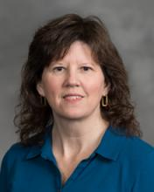  Michelle Aebersold, PhD, RN, CHSE, FSSH FAAN,  Clinical Professor | 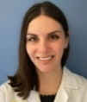  Alexandra Agapiou, DNP, BSN, FNP-BC, RN,  Clinical Assistant Professor | 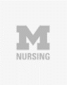  Jenna Allen,  DNP (C), BSN, RN  Clinical Instructor | 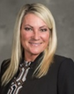  Jeri Antilla, PhD., MSN-Ed., RNC-OB  Clinical Assistant Professor | 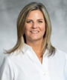  Melissa Bathish, PhD., RN, CPNP-PC, Clinical Associate Professor | 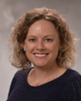  Sue Anne Bell,  PhD, FNP-BC, Associate Professor | 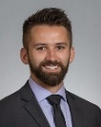  Alec Briggs,  MSN(c), RN, CNE(c), (DNPc)  Clinical  Assistant Professor | 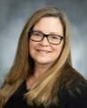  Amy Buckenmeyer,  PhD, MPH, RN, CPH, CPNP-PC,  Clinical Assistant Professor |   Susan Butterworth,  PhD, Research Assistant Professor |   Laura Calamos, PhD, RN, FNP-BC, FHEA, Clinical Assistant Professor
  Nadia A. Charania, PhD, RN, Clinical Assistant Professor |   Cherie Conley,  PhD, MSN, BSN, MIS, MHS, BS  Assistant Professor | 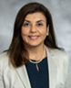  Hala Darwish,  RN, APN, PhD., FAAN, Associate Professor |   Matthew A. Davis,  MPH, DC, PhD, Associate Professor |   Linda  DiClemente, DNP, BA, RN,  Clinical Assistant Professor | 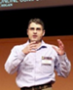  Ivo D. Dinov, PhD, Professor,  SPL Department Chair |   Emily Dove-Medows,  PhD, CNM,  Assistant Professor | 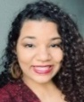  Jessica Dozier,  MPH,  UM President’s Postdoctoral Fellow |   Christopher R. Friese, PhD., RN, AOCN®, Professor |   Karen Harden,  DNP, MS, RN, AOCNS, NC-BC  Clinical Assistant Professor
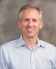  Geoffrey J. Hoffman, PhD, MPH, Associate Professor | 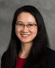  Yun Jiang, PhD., MS, RN, FAMIA, Associate Professor | 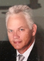  John Knight,  DNP, RN, CSSMBB, PMP, Clinical Assistant Professor | 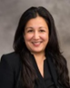  Yasamin Kusunoki, PhD, MPH, Associate Professor | 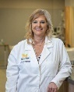  Deb Lee  PhD, FNP, ACNP-BC, CHSE,  Clinical  Assistant Professor,  Director, CLC |   HaEun Lee,  PhD, RN  Assistant Professor | 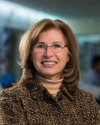  Milisa Manojlovich, PhD., RN, FAAN, Professor |   Deanna Marriott,  PhD, Research Assistant Professor |   Barbara Medvec,  DNP, RN, NEA-BC, Clinical Associate Professor |   Luis Parra,  PhD, MS, Assistant Professor
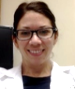  Lynda Pence,  DNP, RN, RD, AGPCNP-BC  Clinical Assistant Professor | 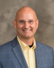  Robert J. Ploutz-Snyder,  PhD, PStat®  Research Professor | 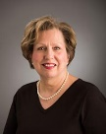  Kathleen Potempa,  BA, MS, PhD, RN,  Professor | 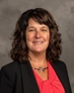  Laura Prochnow,  DNP, RN, CHSE,  Clinical Assistant Professor |   Jill Randall,  PhD, MSW, LICSW, Research Fellow |   Sheria G. Robinson-Lane,  PhD, RN, MHA, Associate Professor | 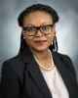  Marie-Anne Rosemberg,  PhD, MN, RN, FAAOHN, FAAN,  Associate  Professor |   Rhonda Schoville,  PhD, MSBA, RN,  Clinical  Associate  Professor |   Julia S. Seng,  PhD, CNM,  FAAN,  Professor |   Clayton J. Shuman,  Ph.D., MSN, RN,  Assistant Professor
  Nicole Smith, MSN, RN, Clinical Instructor | 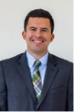  Marvin Schilt-Solberg,  PhD, RN,  Assistant Professor | 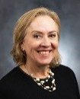  Jeanne-Marie Stacciarini, PhD, RN, FAAN,  Professor &  AD, Global Affairs |   Sarah A. Stoddard,  PhD, RN, FASHM, FAAN,  Associate Professor | 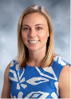  Ashley Thibodeau,  DNP, ARNP CPNP-PC, RN,  Clinical Assistant Professor |   Patricia Tillman-Meakins,  PhD, ANP-BC,  Clinical Assistant Professor |   Dana  Tschannen,  PhD, RN,  Clinical  Professor | 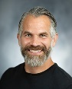  Philip Veliz, PhD,  Research Associate Professor, ABL |   Portia Zaire  PhD(c), MSNEd, BSN, RN, CNE,  NCSP Research Fellow
SPL Adjunct Faculty
SPL Adjunct Faculty | 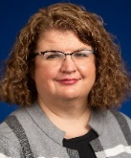  Amy Allen,  DNP, CNML  Adjunct  Clinical  Instructor | 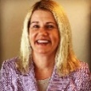  Colby  Anderson,  MSN, RN-BC,  Adjunct Clinical Instructor | 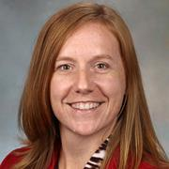  Noel Arring, DNP, PhD, RN  Adjunct Associate Professor |   Amanda Blok,  PhD, MSN, PHCNS-BC,  Adjunct  Assistant  Research  Scientist |   Michelle Bochinski, DNP, MHI, BSN, RN, CNRM, CNE, CNOR,  Adjunct Clinical Instructor |   Margaret Calarco,  PhD., RN,  NEA-BC, HealthyLifetime© Program Coordinator | 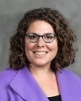  Deena Costa,  PhD, RN, FAAN  Adjunct Associate Professor | 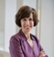  Diane DiFiore,  DNP, MHSA, RN, NEA-BC, ACM-RM,  Adjunct Clinical Instructor | 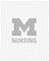  Laura Gonzalez, PhD, APRN, CNE, CHSE-A, ANEF, FAAN  Adjunct  Clinical Instructor
SPL Adjunct Faculty |   Ann K. Gosselin,  DNP, RN, CEN, Adjunct Clinical Instructor | 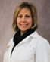  Sheila Kellogg, CRNA, MS, Adjunct Clinical Instructor | 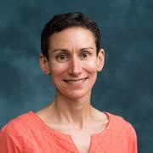  Sarah Krein,  PhD, RN, Adjunct Research Professor |   Bethany Lee-Lehner,  RN, MSN  Adjunct Clinical Instructor |   John E.  Marcotte,  PhD,  Adjunct  Clinical  Instructor | Nancy May,  DNP, RN-BC, NEA-BC,  Adjunct Clinical Instructor | 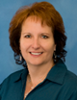  Anne McLeod,  RN, DNP,  Adjunct  Clinical Instructor |   David C. Miller,  MD, MPH  Adjunct Professor |   Rama Mwenesi Musalia, MSE, PhD,  Adjunct Clinical Instructor
SPL Adjunct Faculty |  | 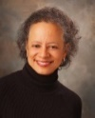  Lori Pierce, MD,  Adjunct Professor |   Tammy Ross, MSN(c), BSN, RN, OCN,  Adjunct Clinical Instructor |   Kelly A. Saran,  MS, RN, CPHRM, CPPS,  Adjunct Clinical Instructor |   Mickey Sperlich,  BS, MA, MSW, PhD  Adjunct  Clinical  Instructor | 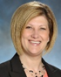  Kari Szczechowski, DNP, RN,  PCCN-K, Adjunct  Clinical Instructor |   Olga Yakusheva,  PhD,  Adjunct Professor
SPL Emeriti Faculty
SPL Emeriti Faculty | 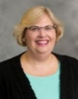  Christine Anderson, PhD, RN,  Clinical Associate Professor Emerita | 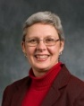  Elizabeth J. Brough,  PhD, RN,  Clinical Assistant Professor Emerita |   Marcelline Harris,  Ph.D., RN, FACMI, Associate Professor Emerita | 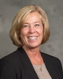  Valerie Y. Marsh,  BSN, MSN, DNP,  Clinical Assistant Professor  Emerita |   Marjorie C. McCullagh,  PhD, RN, APHN-BC, COHN-S, FAAOHN, FAAN,  Professor  Emerita | 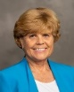  Deborah M. Price,  DNP, MS, RN  Clinical Associate Professor Emerita |   Stephen Strobbe,  PhD, RN, PMHCNS-BC,CARN-AP FIAAN, FAAN  Clinical Professor Emeritus |   Marita G. Titler,  PhD, RN, FAAN,  Professor Emerita

New SPL Faculty Recruits (since 2023)

The department has welcomed a number of new faculty since fall 2023, and there are additional SPL faculty joining in fall 2025.

New Faculty | Title | Expertise | Background
2023
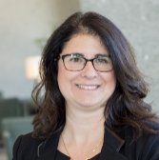 | Laura Calamos, PhD, Clinical Assistant Professor  (2023) | - Primary care  - Mental health  - Diabetes services  - Knowledge exchange across health-care sectors | Fellow of the Higher Education Academy (HEA), United Kingdom  Family Nursing Practitioner, Chelsea, MI  Primary Care Provider  Family Nursing Practitioner, Washtenaw County Medical Reserve
 | Cherie Conley, PhD, MSN, MIS, MHS,  Assistant Professor  (2023) | - Designing and disseminating community-based interventions  - Cardiometabolic health equity  - Systems and implementation science | Previously research fellow & National Clinician Scholars Program fellow at the Institute for Health Policy and Innovation (IHPI)
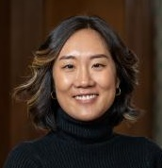 | HaEun Lee, PhD,  Assistant Professor  (2023) | - Education & Training  - Social Justice & Gender Equity  - Health Promotion & Prevention  - Healthcare Outcomes & Quality  - Infant & Child Mortality  - Sexual & Reproductive Health | UMSN graduate (PhD ’21)  Post-Doctoral fellow in the University of Michigan Center for Global Health Equity  Previously worked in Liberia, Zambia & Uganda
 | Amy Buckenmeyer, PhD  Clinical Assistant Professor  (2023) | - Community participation  - Capacity building services  - Health promotion & prevention  - Maternal-child health  - Global health, biostatistics | Completed the AACN Elevating Leaders in Academic Nursing (ELAN) fellowship program  Statistical modeling at the World Health Organization Collaborating Centre, University of Illinois at Chicago  Previously at The George Washington University.
 | Florence Johnson, PhD,  Research Fellow  (2023) | - Gerontology  - Medicare & Medicaid service quality improvements  - Aging and dementia | Fellow, (UMSN NIH/NINR T32 Training Grant) NR016914 Complexity: Innovations in Promoting Health and Safety  Health Services Student Travel Award, Gerontological Society of America (GSA)
2024
New Faculty | Title | Expertise | Background
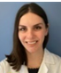 | Alexandra Agapiou, DNP, BSN, FNP-BC, RN, Clinical Assistant Professor (2024) | - Language choices and Type 2 diabetes stigma  - Diabetes care and management  - Nursing interventions to reduce hospital readmissions | Former clinical instructor (UG), UMSN  Former co-chair of the Evidence-Based Practice and Research Council, Henry Ford HS
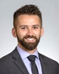 | Alec Briggs, MSN, RN, CNE, (DNPc), Clinical Assistant Professor (2024) | - Increasing nurse resident resiliency and retention  - Improving clinical judgement in junior-level nursing students  - Effects of working conditions on attrition of inpatient nurses | Former LEO Lecturer I, UMSN  Experience in cardiothoracic and cardiovascular nursing
 | Jessica Dozier, MPH, University of Michigan President’s Postdoctoral Fellow (2024) | - Sexual and reproductive health,  - Community-engaged research, MCH,  - SRH stigma | Johns Hopkins (PhD)  Emory University (MPH)  University of Michigan (BA)
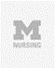 | Laura N. Gonzalez, PhD, APRN, CNE, CHSE-A, ANEF, FAAN, Adjunct Clinical Instructor (2024) | - Health disparities  - Adult health  - Simulation in healthcare | Vice President for Clinical Learning Resources at Sentinel U®  Advanced Certified Healthcare Simulation Educator  Fellow of the Academy of Nurse Educators  Fellow of the American Academy of Nursing
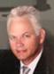 | John Knight, DNP, RN, CSSMBB,  Clinical Assistant Professor (2024) | - Translating evidence-based practice research  - Improved access to care for lower socioeconomic class populations  - Patient outcomes and practitioners' mental health | Lean Six Sigma – Master Black Belt, University of Michigan College of Engineering  Former UMSN adjunct instructor
 | David C. Miller,  MD, MPH  Adjunct Professor (2024) | - Health services research  - Physician-led collaborative quality improvement  - Physician organization and the efficiency of specialty care | President, Michigan Medicine  Professor in Urology Surgery, University of Michigan
 | Lynda Pence, DNP, RN, RD, AGPCNP-BC, Clinical Assistant Professor (2024) | - Doctoral Dissertation: Motivational Interviewing to Promote Self Care in Patients with COPD  - Using effective therapeutic communication to engage students and professionals in promoting optimal quality of life for those we serve. | Former UMSN adjunct instructor  Global Volunteer Network, Guatemala, Healthcare missionary (2015)
 | Marvin Schilt-Solberg, PhD, RN, Assistant Professor (2024) | - Childhood adversity and health outcomes among sexual and gender minorities and on sexual minority men  - Substance use and abuse  - Injury control and prevention | Graduate certificate in Alcohol Use and Drug Abuse Studies, WSU School of Social Work; Doctor of Philosophy in Nursing, WSU
 | Ashley Thibodeau,  DNP, CPNP-PC, RN, Clinical Assistant Professor (2024) | - Pediatric healthcare  - Bringing new therapies to neuromuscular patients  - Quality improvement  - Patients with complex medical conditions | Service-learning opportunities in South Africa and Haiti  Formerly with Mott Children’s Hospital (Ann Arbor) and Seattle Children’s Hospital
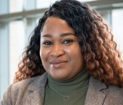 | Portia Zaire, PhD(c), MSNEd, BSN, RN, CNE, (NCSP Postdoc Fellow)(2024) | - Professional nursing development  - Continuing nursing education  - Family Medicine & Primary Care | Ohio State University (PhD)  University of Phoenix (MSN)  Cleveland State University (BSN)
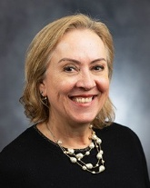 | Jeanne-Marie Stacciarini, PhD  AD Global Affairs | - Global health  - Mental health promotion  - Health disparities  - Rural health | Fellow, American Academy of Nursing, 2015  SIGMA International Nurse Researcher Hall of Fame, 2024
2025
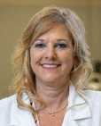 | Deborah Lee, Ph.D., FNP, ACNP-BC, CHSE  Clinical Assistant Professor | - Critical Care  - Patient Safety  - Simulation  - XR (Virtual, Augmented, and Mixed) Technology  - AI in Healthcare | 2025 Michigan State University School of Nursing Distinguished Alumni Award
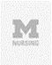 | Youran Lee, U-M Presidential Research Fellow | - Social determinants/health  - Cancer health disparities  - Cancer symptom science
  Rising Star dissemination award, Sigma Theta Tau International (STTI), 2023
  PhD Academic Scholarship, Oncology Nursing Foundation, 2024/25
 | Rebecca Piasecki, NCSP Research Fellow (dry appt.) | - Cardiac arrest and resuscitation care  - Preventative cardiac care | Pre-doctoral Fellowship in Interdisciplinary Training in Cardiovascular Health Research (2016-2018)
 | Kai-Lin You, NCI Research Fellow | - Return-to-work issues faced by nurses and healthcare workers with cancer | Predoctoral to Postdoctoral Fellow Transition (F99/K00) Award (NIH/NCI), 2024  Team Shark Tank Finalist, University of Pittsburgh Medical Center (UPMC) Hillman Scientific Retreat, 2024

- Recruitment:
  - New Faculty/Research Fellows (after May 2025):
    - Youran Lee, U-M Presidential research fellow (8.25.2025)
    - Kai-Lin You, NCI research fellow (awaiting signed offer letter - not final; 12.1.2025)
    - Rebecca Piasecki, NCSP (dry) research fellow (awaiting signed offer letter - not final; 7.1.2025)

- Retirements/Terminations/Transfers:
  - Dr. Parra, resigned
  - Dr. Ploutz-Snyder, resigned
  - Dr. Marsh, retired

Department Advisory Council (DAC)

Faculty governance depends on the continuous engagement of faculty in establishing departmental identity, promoting the UMSN vision, and supporting the university’s pursuit of academic excellence. The SPL Department Advisory Council (DAC) gathers feedback, coordinates faculty activities and synthesizes balanced and unbiased ideas to support the operations of teaching, education and service. The DAC typically consists of 3-5 faculty members, in addition to the vice-chair. Administrative support is provided by the department administrative assistant, who attends meetings and prepares notes. The vice-chair regularly coordinates DAC activities, progress, and ideas with the SPL chair.

In AY 2024/25, DAC was co-Chaired by Drs. Linda DiClemente and Deanna Marriott and included Drs. Aebersold, Bell, Buckenmeyer, Dinov, Robinson-Lane, Shuman and Veliz. The committee fulfilled the DAC’s charge (as issued by Dr. Dinov) across a variety of areas, some highlights of which are given below. DAC co-chairs, Drs. DiClemente and Marriott, have agreed to serve a second term (2025/26) as DAC leads.

Unexpected fiscal limitations made it necessary to postpone the spring 2025 writing retreat, which had been scheduled for May 27-28, 2025 and had been planned to take place at a new venue, the Maryville Retreat Center in Holly, Michigan. The budgetary shortfalls anticipated from changes announced to NIH funding necessitated prudent fiduciary actions and postponement of this event to a future date (yet to be determined, but sometime within the next two years). The director of the Maryville Retreat Center has agreed to hold the deposit until a new date is selected.

Progress was made by the committee in nominating candidates for major awards with two candidates being put forth as FAAN nominees. In conversation around this topic, committee members recognized that acceptance of a major award often comes with unforeseen costs, as many organizations require the recipient to appear in person at a gala event or similar function, with the honoree incurring costs for travel, wardrobe, accommodations, and other related expenses.

Finally, the committee made progress in the planning of the second annual SPL department retreat, to be held on October 14, 2025. The event had originally been planned to once again take place on the grounds of UM Adventure Leadership, but it was decided that in order to minimize expense, the day-long event would instead be held on the same date but at UMSN Nursing Building 2. Areas of focus (based on the outcomes of last year’s retreat) were determined to be collaboration, faculty retention and the establishment of centers of excellence. Drs. Michelle Aebersold and Barb Medvec were asked (and have accepted) to lead the 2025 retreat and draft an agenda that inspires active engagement, collaboration, and community building.

SPL Faculty Promotions (2024-2025 cycle)

Congratulations to the following SPL faculty who received well-deserved promotions and reappointments during the past academic year:

- Dr. Melissa Bathish, promoted to Clinical Associate Professor;
- Dr. Sue Anne Bell, promoted to Associate Professor;
- Dr. Geoff Hoffman, promoted to Associate Professor;
- Dr. Yun Jiang, promoted to Associate Professor;
- Dr. Barb Medvec, promoted to Clinical Associate Professor;
- Dr. Sheria Robinson-Lane, promoted to Associate Professor;
- Dr. Rhonda Schoville, promoted to Clinical Associate Professor.

- Dr. Jeri Antilla, reappointed Clinical Assistant Professor;
- Dr. Linda DiClemente, reappointed Clinical Assistant Professor;
- Dr. Laura Prochnow, reappointed Clinical Assistant Professor;
- Dr. Patricia Tillman-Meakins, reappointed Clinical Assistant Professor.

* Faculty promoted during the AY 2024-2025 will be announced in fall 2025 and acknowledged in the 2026 SPL annual report.

Examples of 2024-2025 Individual SPL Faculty Recognitions/Accolades | Date
Dr. Miller named EVP of Michigan Medicine, succeeding Dr. Marschall Runge, effective July 1, 2025. Dr. Miller most recently served as the executive vice dean of clinical affairs for the Medical School and president of U-M Health. | 9/19/2024
Dr. Tchannen was named Beatrice J. Kalisch Collegiate Professor of Nursing. Dr. Tschannen is the first Clinical Professor in the school to be named Collegiate Professor, and her new title honors former SPL Chair, Dr. Beatrice Kalisch. | 10/24/2024
Dr. Kusunoki was named training program director at the ISR Population Studies Center, where her research focuses on understanding the sources of gender, racial/ethnic, and socioeconomic disparities in health and demographic behaviors during adolescence and the transition to adulthood. | 9/1/2024
Dr. Sarah Stoddard received the 2025 Marianne Marcus Award, for her work to advance the frontier of substance use prevention through interventions that enhance future expectations and school connectedness among vulnerable youth. | 11/15/2024
Dr. Lori J. Pierce received the Karin Muraszko, M.D., Advancing Women in Academic Medicine and Science Award on Feb. 5, 2025 at the third annual Celebration of Women in Academic Medicine and Science. | 12/9/2024
Dr. Michelle Aebersold has been selected winner of the 2025 NLN Marilyn H. Oermann Award for Distinguished Research in Nursing Education. Dr. Aebersold is only the second person to be chosen for this prestigious honor, awarded in connection with the Nursing Education Research Conference (NERC), a biannual gathering of leading scholars in nursing education. | 3/3/2025
Dr. Deb Lee received the prestigious 2025 Michigan State University School of Nursing Distinguished Alumni Award. The award will be presented at a ceremony later this summer. | Summer 2025

Examples of Collective SPL/UMSN Accomplishments (2024-2025)
An SPL faculty team from the School of Nursing will pilot the use of generative AI tools in the delivery of nursing education to master’s and doctoral-level students. The goal is to evaluate ease of use, learning outcomes, student adoption, and potential future applications of the approach.
SPL established a vibrant peer-mentoring group and a senior-faculty group (led by Michelle Aebersold and Milisa Manojlovich) to provide support and advice to early-career (assistant professor) faculty.
The SPL Department advisory council (DAC) made significant strides forward in identifying opportunities to nominate SPL faculty for awards and recognition, as well as to advance the SPL strategic priorities identified at the fall 2024 SPL retreat.
In May 2025, SPL hosted the spring LAI Immersive for the graduate students in the Leadership, Analytics and Innovation program. We will welcome the 2025 cohort of LAI graduate students matriculating in the program in the fall.

SPL Faculty Searches

In the next few years, SPL will seek to recruit strong academic scholars, at all ranks and tracks, pursuing impactful research in several areas including nursing science, population health, and translational science. The department will look for faculty leading ground-breaking interdisciplinary research, promoting innovative teaching excellence, and emphasizing interprofessional clinical practice. SPL’s interdisciplinary faculty represent nursing science and a wide range of disciplines including epidemiology, economics, health informatics, data analytics, mathematics, statistics, demography, health-AI, clinical decision support systems, and executive leadership.

Outstanding academics integrating multifaceted research approaches, theoretical models, and clinical practices are strongly encouraged to apply and join the school. To address the expected nursing faculty-scholar shortage/challenge, we plan to seek and recruit talented new faculty to support our quest to improve health outcomes, shape the systems and structural factors that influence healthcare, and impact health policy in Michigan and around the world.

Cultural Climate and Ensuring Ethical Standards

All SPL students, staff and faculty actively support the UMSN E.P.I.C. Values and the University of Michigan Mission and Principles and Values. This includes a commitment to promptly report any suspected wrongdoing. Everyone in SPL is aware that the chair and the school administration are prepared to handle issues properly, resolving them, or as appropriate, reporting them to higher authorities. Maintaining open communication is vital and there is strong commitment that reporting suspected wrongdoing will never result in reprisal.

SPL faculty should be prepared to act immediately if they suspect abuse or other crimes, whether encountered directly or indirectly. The UM protocol for reporting wrongdoing includes:

Emergency Assistance

- If immediate emergency assistance is needed or a crime is in progress, dial 9-1-1 for emergency response.
- At the Ann Arbor medical campus, dial 9-9-9 for cardiac arrests, medical emergencies, or patient-related incidents.

Non-Emergency Assistance

- For non-emergency situations, call the U-M Division of Public Safety and Security at (734) 763-1131. Public safety professionals can help assess the situation and determine what other notification or action is necessary.
- Information on potential criminal activity also may be reported anonymously by calling the university’s Anonymous Tip Line at (800) 863-1355.
- SPL affiliates are considered Campus Security Authorities under the Clery Act or Individuals with Reporting Obligations under Title IX and therefore have additional reporting obligations for certain crimes and conduct. Information for Individuals with Reporting Obligations (IROs) can be found in Section VII of U-M’s Policy on Sexual and Gender-Based Misconduct. For more information on the Clery Act, contact the Division of Public Safety and Security. For information on Title IX reporting, contact your campus Title IX coordinator (Ann Arbor).
- University community members who believe they have witnessed any type of wrongdoing – including but not limited to financial, regulatory, NCAA or patient safety – can report the situation confidentially or anonymously through the university’s Ethics, Integrity & Compliance website.

Our collective and continuous efforts in SPL and UMSN will ensure a safe, secure, and vibrant community within the school and the university.

Leadership, Analytics and Innovation (LAI) Graduate Program

SPL’s Master of Science in Nursing (MSN) program Leadership, Analytics and Innovation (LAI) is in its 5th year. LAI is a part-time, fully online, graduate degree program that enrolls about 30 students annually. LAI is a top-ranked nursing leadership program designed and taught by SPL faculty with real-world experience in executive leadership, research, clinical practice, health analytics, evidence-based practice, informatics, and health applications of artificial intelligence. Matriculating students can choose a 2- or 3-year curriculum plan that suits their needs, including online and residential learning environments. Students are trained in highly effective and cutting-edge strategies for optimal learning and student engagement. The main goal of LAI is to develop students’ confidence in the use, analysis and interpretation of data to build clinical and financial cases for change, patient care delivery and health programs throughout the health care continuum. In addition to the core degree program, LAI students can also pursue add-on graduate certificates in “Occupational Health”, “Nursing Education”, and “Global Health”, as well as transitioning into graduate-level DNP programs. LAI is directed by Dr. Barbara Medvec, a UMSN Clinical Associate Professor who has considerable experience in executive leadership, nursing practice, and effective pedagogical utilization of technology-enhanced education and training. In the year ahead, LAI and all UMSN Digital Education Programs will undergo a rigorous assessment (based on Kirkpatrick’s evaluation model) to evaluate the goals, accomplishments, and returns-on-investment (scholarly, pedagogical, fiscal, and professional). The assessment will also track the overall progress and remap the synergies between different UMSN online and blended educational programs.

In 2025-2026, UMSN will pause the LAI graduate student admission process to review the program plans, remap and modernize the curriculum, explore the current nursing executive needs, and restructure the program to address future demands for healthcare management.

Table: LAI Graduate Curriculum Evaluation Metrics
Metrics/Indicators | Established Benchmarks (from Accrediting Agency & UMSN)
National Certification Board Pass Rates | The CCNE standards for accreditation require the following pass rates to be achieved:  - The pass rate for each certification examination is 80% or higher for first-time takers for the most recent calendar year (January 1 through December 31); or  - The pass rate for each certification examination is 80% or higher for all takers (first-time and repeaters who pass) for the most recent calendar year
U.S. News and World Report Ranking  In 2024-2025, UMSN master’s program ranked 8th, and DNP program ranked as 6th | The UMSN has identified a goal of having all of our programs in the top 20 rankings with at least 50% in the top 10 for our graduate programs
Revenue/Course | Fiscal sustainability, and returns-on-investment (ROI)
Impact on Professional Services and Community Networking | Performance, simulations (testing), clinical evaluations, preceptor evaluations of students & student self-evaluations
Learning | Enrollment and graduation statistics, teaching evaluations, post-graduation surveys, technology curricular utilization

SPL by the Numbers

The following diagram illustrates some of the key metrics about the aggregate accomplishments of the 81 SPL Department faculty (including 21 CT, 4 RT, 21 TT, 24 adjunct faculty, 3 research fellows, and 8 emeriti faculty) over the 2024-2025 academic year (AY). These data were pulled from the 2025 annual faculty productivity reports, Michigan Experts, the SPL Newsfeed, and other open-access scholarship resources.

2024-2025 SPL Aggregate Faculty Productivity

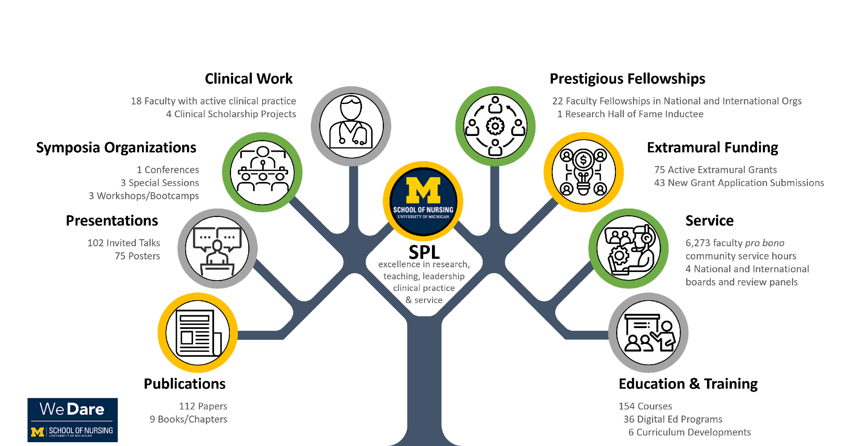

Aggregate SPL faculty accolades, awards, and other recognitions during the 2024-2025 academic year.

2024-2025 SPL Faculty Recognitions (by track) | Awards | Fellowships | News Reports | Promotions | Other
Clinical 21 CT) | 4 | 7 | 4 | 7 | 7
Instructional & Research  (21 TT, 4 RT) | 4 | 16 | 6 | 4 | 1

SPL Web Resources

- Main Homepage:
https://nursing.umich.edu/about/departments/department-systems-populations-and-leadership-spl
- Canvas Site: https://umich.instructure.com/courses/328919
- AI in Health Forum: https://ai.nursing.umich.edu/
- The UM offices of ECRT (Equity, Civil Rights, and Title IX Office) and PEAR (Prevention, Education, Assistance and Resources) provide on-demand support including faculty education/training, counseling, and advising. Our dedicated UMSN PEAR advisor is Pedro Coracides.

SPL/UMSN AI in Health Forum Activities

In winter 2025, the school and many SPL faculty started a grassroots faculty effort to explore the rapidly evolving and highly transformative space of “AI in Health”. This resulted in forming a new “AI in Health” Forum, which explores the opportunities, identifies gaps, designs, develops, and deploys AI services, and pilot-tested various augmented and artificial intelligence resources. The Forum developed an active AI in Health Blog that summarizes the major AI in Health developments to date. The table below shows the core AI tools and services that all UMSN students, staff and faculty can utilize across the spectrum of academic activities, from education and training to clinical practice, translational research, inter-professional collaborations, health policy advocacy, and clinical decisions support.

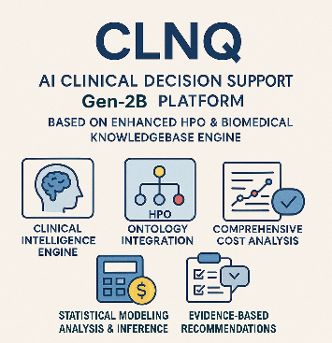  CLNQ is an advanced AI-supported clinical decision support (Gen-2) platform utilizing enhanced human phenotype ontologies and sophisticated biomedical knowledgebase engine  https://socr.umich.edu/GAIM/SOCR_CLNQ_2.html | 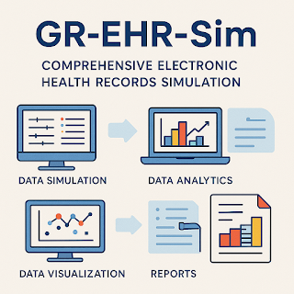  Synthetic Electronic Health Record Generator (GR-EHR-Sim), a comprehensive platform for simulating realistic electronic health records data with full control over clinical parameters and data characteristics.  https://ehr-sim.statisticalcomputing.org/ | 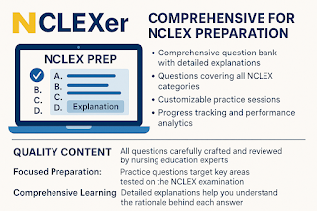  NCLEXer, a comprehensive nursing licensure learning platform  https://nclex-exam.statisticalcomputing.org/
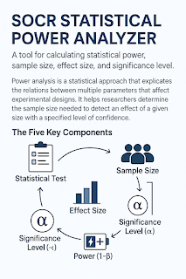  SOCR Statistical Power Analyzer (SPA), a tool for calculating statistical power, sample size, effect size, and significance level  https://socr-spa.statisticalcomputing.org/ | 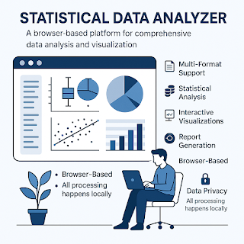  AI-driven Statistical Data Analyzer (SDA)  https://sda.statisticalcomputing.org/ | 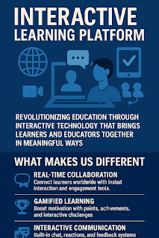  Interactive Learning Platform (ILP) , which revolutionizes health, nursing, and inter-professional education through AI and Cloud technologies  https://ilp.statisticalcomputing.org/
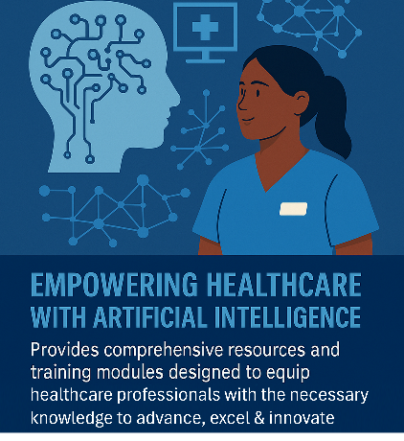  Nurse AI Trainer (NAIT), an innovative healthcare with Artificial/Augmented Intelligence with comprehensive resources and training modules  https://nait.statisticalcomputing.org/ | 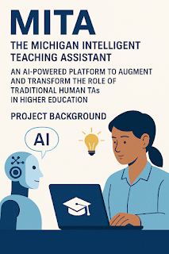  Michigan Intelligent Teaching Assistant (MITA), AI-powered teaching assistant platform for enhancing educational experiences and active learning  https://mita.statisticalcomputing.org/ | 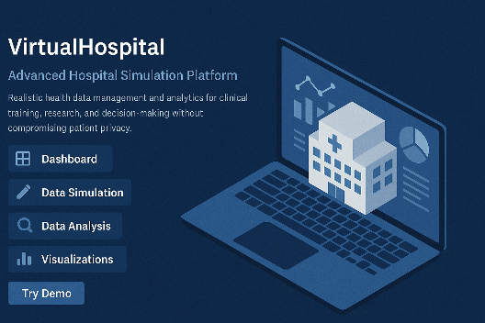  VirtualHospital, an advanced AI platform for hospital data simulation  https://vh.grayrain.ai/

SPL Faculty Scholarly Interests

The data-driven analytics below show in aggregate the research output and scholarly connectivity of SPL faculty over the past year. These visual and quantitative analytics are derived from metadata collected in the annual public faculty productivity reports.

Text Mining using Publications and Grants

By utilizing (HS650) DSPA NLP/TM methods,, we transformed the free text available in the 2024-2025 annual faculty public productivity reports into structured document term matrices (DTM). These matrices represent the original unstructured information as structured data where each entry (faculty document) is a row, and each word or phrase in a report is indexed as a column. In our case, the corpus had 35 documents (the public faculty productivity reports). We extracted the 200 top research-driven phrases; hence, the DTM is a $35×200$ matrix.

Included below are summary plots, graphs, and visualizations illustrating the aggregate SPL scholarly work, as well as the underlying deep community network of research, collaboration, and interactions between individual SPL faculty. These figures also identify communities of faculty pursuing similar, joint, and cooperative nursing science and healthcare research projects.

Note: On the horizontal axis, faculty names in this rank-order list should be ignored, as the analytical protocol could not disambiguate faculty names included in different fields, such as the public productivity report data, publication author lists, project titles, research collaborations, and other topics.

Frequently used terms in various SPL faculty scholarly activities (2024-2025).

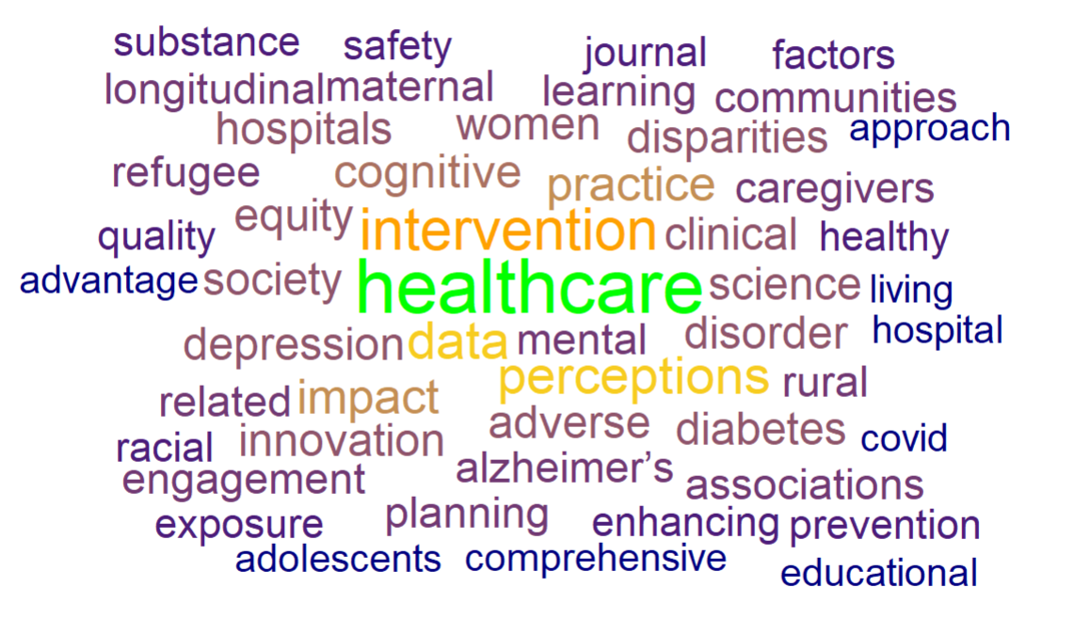

Scholarly themes and frequent research terms (2024-2025).

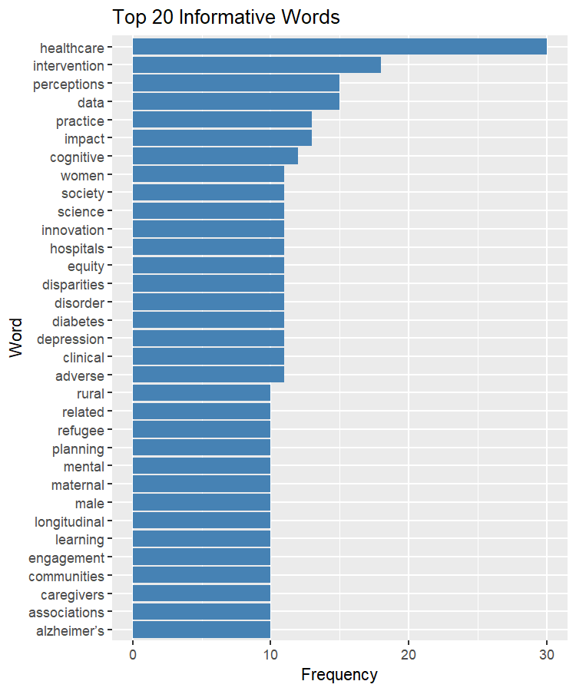

SPL faculty scholarly publications (left) and grants (right) (2024-2025).

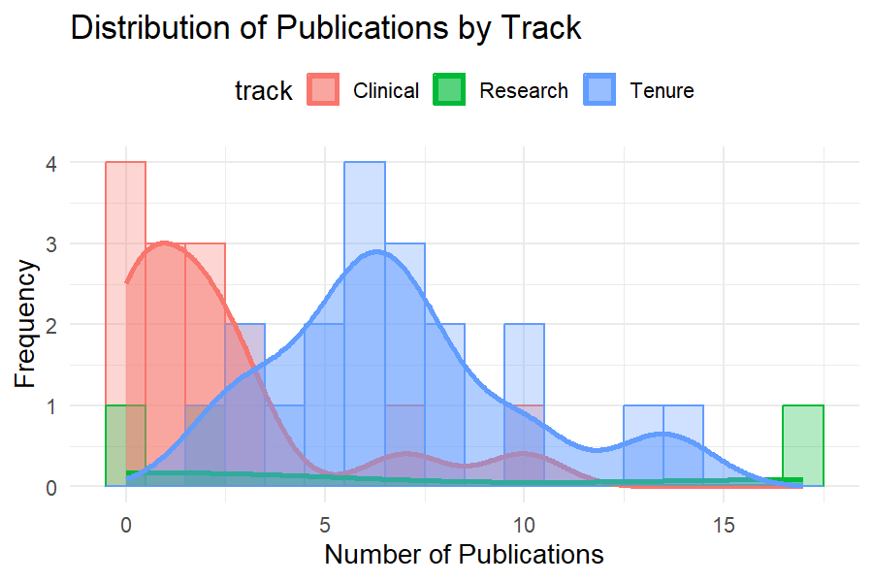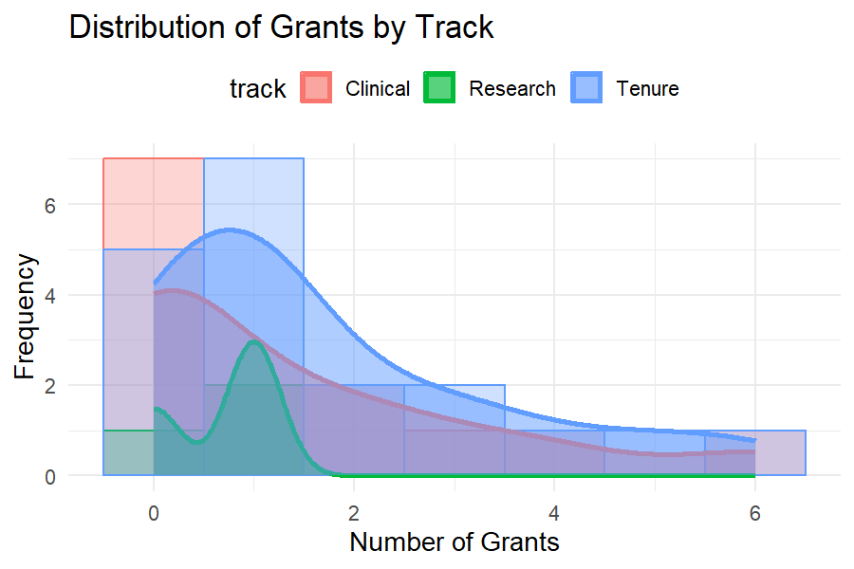

Return on extramural funding investment – grants vs. scholarly publications by faculty rank & track (2024-25).

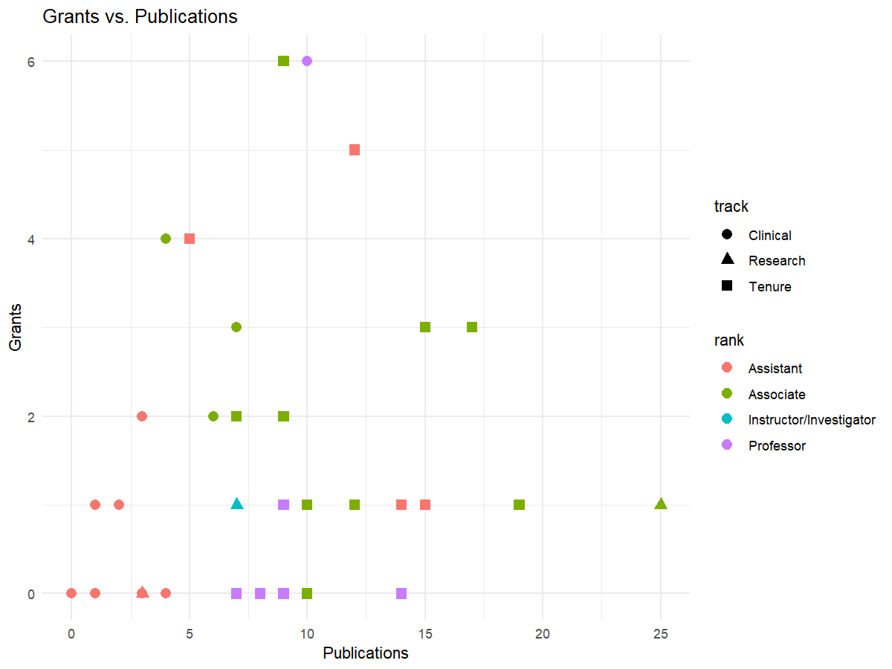

Looking Forward to AY 2025-2026

The year ahead promises to be both exciting and challenging. We expect to have our largest cohort of undergraduate freshmen, transferring juniors, professional master’s degree students, and doctoral trainees (DNP and PhD). SPL will also welcome several new fellows and faculty that are joining the department on various professorial tracks (TT, CT, RT, and fellowships). The provost has initiated the search for a new UMSN Dean to succeed Dean Patricia Hurn, who will be completing her decade of service to the school and the university in 2026. We expect some fiscal difficulties in the year ahead that will require rational, prudent, timely, and collective commitment to ensure we maintain all core UMSN operations while continuing to strive for academic excellence.

During AY 25-26, SPL and UMSN operations will be guided by the core principles outlined by Dean Hurn and UMSN Leadership:

- Preserve our human talent
- Protect our youngest
- Honor our contracts and promises to uphold our reputation
- Complete key ongoing strategic investments (e.g. expansion of the UG class, building the new student commons, offering contemporary salaries and merit raises).

In the year ahead, the increase in class sizes (accommodating the expected increase of student enrollment), potential space constraints, anticipated significant staff demands, and substantial needs for expeditious and effective senior (faculty and student) mentoring may be stressful at times. SPL and UMSN, working within existing university-wide systems, are ready to provide support, infrastructure, and resources to ensure every trainee, employee, and instructor can reach their full potential.

Continuing with SPL interdisciplinary research activities, each faculty member is encouraged to examine the current state of their intra-departmental connectivity, find and develop collaborative faculty research teams including SPL faculty, as well as networks of outside partners. Clinical track faculty may strongly benefit from cooperating with others in SPL to launch and sustain their scholarly activities. We strive to provide effective mechanisms for linking faculty, across tracks and ranks, on joint projects (e.g., Dr. Aebersold is leading the SPL Pilot Collab Projects). The department should assess and prioritize core faculty needs, as well as identify the most common barriers to educational excellence, faculty scholarly achievements, and impactful community services. Many successful projects may be seeded by the solo pursuits of individual faculty; however, long-term sustainability and strong scholarly research demand transdisciplinary engagement and team science endeavors. The resources, knowledgebase, tools and service developed, supported, and shared by the UMSN “AI in Health” Initiative will provide a fertile ground to increase academic productivity, improve active learning, and support innovative pedagogical strategies in traditional, digital and blended modes of education.

The SPL faculty collectively determine the future of the department and shape its education, research, service, and clinical activities. The main questions are what specific objectives we prioritize, what pathways we traverse to achieve these departmental goals, and how much energy each SPL faculty should devote to advancing our common mission.

The mixed quantitative and qualitative analysis above suggests that the SPL department is more than just a “community of faculty” … We are a “cohesive cluster of nursing and transdisciplinary faculty” with a shared vision and a common collaborative future.

In 2025-2026, major SPL academic foci will include (1) managing the continuous growth of the UG program; (2) active faculty recruitment, mentoring, retention, and professional growth; (3) responsive and collective actions addressing prospective resource limitations; and (4) effective and coordinated actions to redesign, enhance, and improve the undergraduate nursing leadership and the graduate health executive curriculum.

Leadership, Analytics and Innovation (LAI) Curriculum

The current SPL Leadership, Analytics and Innovation (LAI) graduate nursing program includes the following courses.

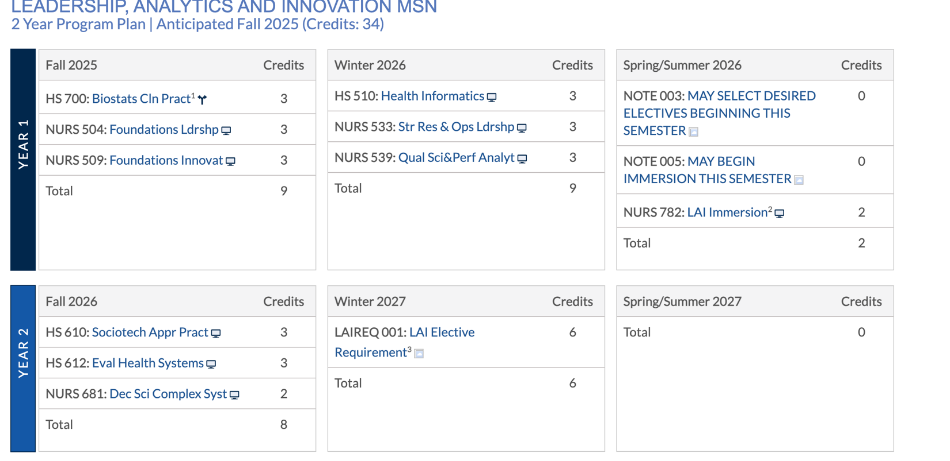

In the year ahead, UMSN will pause admission into the Leadership, Analytics and Innovation (LAI) graduate program. This will allow SPL/LAI faculty to plan, design, implement, evaluate a new graduate executive nursing curriculum including additional classes, such as “Artificial Intelligence (AI) and Health Analytics.” While the curriculum is actively being developed, we will explore executive graduate program developments covering relevant topics such as:

Module 1: Intro to AI and Analytics in Healthcare
Module 2: Foundations of AI
Module 3: Healthcare Data Management
Module 4: Predictive Analytics in Healthcare
Module 5: Diagnostic Imaging
Module 6: Clinical Decision Support Systems (CDSS)
Module 7: Healthcare Operations Optimization
Module 8: Healthcare AI Legal, Ethical, and Regulatory Considerations
Module 9: AI Healthcare Impacts on Nurses and Healthcare Professionals
Module 10: AI In Patient, Family, Population and Community Education and Monitoring
Module 11: AI Healthcare Future Trends and Technologies
Module 12: Healthcare AI Innovation and Utilization
Module 13: AI Future Considerations for the World

AI Content Immersion in the UMSN Faculty Teaching Academy (TA)

Jointly with Dr. Arslanian-Engoren, Associate Dean for Faculty Affairs, Dr. Barb Medvec leads the development of a new UMSN TA module on the use of AI in academic activities. This new AI faculty training module aims to:

(1) develop foundational knowledge of generative AI and its applications in nursing education;
(2) foster trustworthy applications of gen-AI tools to enhance student engagement, adapt to personal learning styles, and improve educational outcomes;
(3) develop proficiency in designing and implementing effective prompts to engage with gen-AI tools;
(4) foster equitable and inclusive learning experiences using gen-AI; and
(5) prepare nursing students for future healthcare environments, which will be increasingly supported by complex augmented intelligence systems, by integrating generative AI literacy into the curriculum.

Jointly with Drs. Aebersold, Ammerman, Dinov, Franklin, Knight, Lee, Schoville and others, Dr. Medvec will be building and deploying these faculty AI training modules to the UMSN Teaching Academy Canvas site as well as the UMSN Nurse AI Trainer (NAIT) platform.

SPL Strategic Vision

SPL faculty are dedicated to leading ground-breaking interdisciplinary research, innovative teaching, executive leadership, and clinical practice centered on systems- and population-level phenomena that shape the health of diverse groups and communities both locally and globally. We support the UMSN E.P.I.C. Values and the University of Michigan Mission and Principles and Values. Over the decades, the (division and then the) department vision and cultural identity have evolved to reflect the intramural needs and extramural environmental conditions. The core mission of the department will remain closely aligned with the established school values and University of Michigan 2034 Strategic Plan. At the same time, SPL’s cultural identity, near-term foci, and community-building activities will continue to evolve into the future. During the annual SPL department retreat in fall 2024, all faculty and staff had opportunities to actively participate and vigorously discuss strategies and tactics that will ensure the success of our academic mission. At the start of the next academic year, we will continue this process through deliberations, discussions, and collective ideation at the fall 2025 SPL retreat.

SPL Cultural Identity and Future Vision – All-Hands Retreat (Oct 14, 2025)

Below is a draft plan for the SPL all-hands-on-deck faculty retreat in fall 2025.

Time | Topics | Leads | Outcomes & Notes
7:45-8:15A | Set Up
8:15-9:00A | Light Breakfast and Name Game | Deanna (others)
9:00A-9:15A | Overview of the SPL past activities (2024-2025) and prospective plan for 2025-2026+ | Ivo Dinov
9:15-9:35A | Accomplishments (new) | SPL Attendees | https://ilp.statisticalcomputing.org/
9:35-10:05A  DAC Initiatives | SPL Strategic Programs & Opportunities Update (5-6 Minutes/Section/Strategy) | SPL Members
Centers of Excellence Proposals | 1) Centers of Excellence | D. Marriott  M. Aebersold
Department Initiative | 2) Leadership, Analytics & Innovation Program | B. Medvec and SPL LAI Faculty
Enhance Faculty Collaboration and Mentorship | 3) PITCH Projects | M. Aebersold
Enhance Faculty Collaboration and Mentorship | 4) Structured Mentorship | M. Manojlovich and M. Aebersold
Faculty Development and Retention | 5) Onboarding programs for new faculty with ADFAD. Enhanced faculty development opportunity, Workplace wellness and equitable allocation of efforts. | DAC
AI Integration & Technological Advancement | 6) Faculty Update on AI developments (workshops, training, resources sharing). Integrate AI, and SR technologies into research and teaching Practices. | I. Dinov  M. Aebersold  B. Medvec  J. Knight | AI in Health Initiative  https://ai.nursing.umich.edu  UMSN Faculty Teaching Academy  umich.instructure.com/courses/766739
10:05-10:20A | Break
Strategy Sprint & Overview
10:20-10:45A  25 Minute Mixed Sprint | Sprint 1 – AI Integration & Technological Advancement | Facilitators
10:45-11:10A  25 Minute Mixed Sprint | Sprint 2 – Leadership Analytics and Innovation | Facilitators
11:10-11:40A 25 Minute Mixed Sprint | Spring 3 – Faculty Development and Retention | Facilitators
11:45-12:45 | Lunch and Networking
12:45 – 1:15P  Sprint 1-3 Report Out |  | SPL Members
1:15 – 2:30P | Team Building | Ivo Dinov & DAC

Use a Strategic Doing Framework: A discussion lead by Dr. Medvec.

What Could we do? What are all the possible opportunities before us, using only the assets that we already have, that might address our concerns?

What Should we do? We can’t do everything. Which out of all the opportunities should we pursue and what would success look like?

What will we do? Where will we start and what are the commitments we are making to each other to begin that project?

What’s our 30/30? When exactly are we going to get back together to share what we’ve done, so that we can learn from our experience, adjust if we need to, and plot out our next set of commitments?

SPL Cluster Recruitment & Launch of new Centers/Cluster-Hires FEP

This is a faculty recruitment opportunity SPL can pursue, which is partially supported by the provost.

Overview: The UM-wide Faculty Expansion Program (FEP) will continue to recruit exceptional scholars, foster innovative centers, or promote cluster-hires with exceptional potential to expand the university capacity for high-risk inquiry into the following high-impact areas of research/scholarship: (1) Life-Changing Education, (2) Human Health & Well-Being, (3) Democracy and Climate Action, and (4) Sustainability & Environmental Justice. This document represents a UMSN-SPL internal call for faculty input in identifying 1 or 2 specific ideas, directions, centers, or interdisciplinary activities that align with this FEP vision, which may ultimately be appropriate to submit as proposals to the UMSN dean, and then UM provost for funding consideration.

Background: In April 2024, the UM president and provost launched a new initiative to radically expand the university capacity for innovative inquiry into several high-impact areas of research, academic scholarship, educational excellence, and long-term institutional sustainability. Significant UM resources will be dedicated to support creative ideas, recruit outstanding mid-career tenure-track faculty to catalyze, collaborate, and provide unparalleled intellectual and institutional leadership in areas outlined in the UM Vision 2034 Plan. In 2024-2027, the SPL department, and UMSN, will explore creative ideas to respond to this institutional challenge.

Objective: SPL faculty will consider relevant partnerships with other UM departments, schools, and units, and identify an appropriate vision/plan/need/opportunity that aligns with FEP ’34 vision to submit a UMSN-supported letter of intent (LoI). The UMSN Endowed French Chair position may serve as an anchor to attract an internationally renowned scholar, or a highly successful academic center at a peer institution, as a pillar for establishing a new large-scale center at UM/UMSN/other schools/colleges.

LoI Template: (2-pages)
- FEP hiring and/or activity plan, logic, and aims.
- Sponsoring unit(s), number of hires, and likely mechanism (person-specific, open search).
- How would this activity leverage, expand, or create new capacity for high-level, innovative, interdisciplinary research in an area of impact interest and commitment?
- How does the proposed activity align with the Vision 2034 plan to meet longer-term goals in impact areas?
- Potential for innovation, likelihood of high impact, and radical boost of UM interdisciplinary research.
- Attention to sustainability of the proposed activity and funding model.
- Budget estimate with breakdowns for base and one-time funding.

Timeline: (annually 2024-2027)
- May 15 (SPL faculty submit ideas to the chair)
- May 31 (SPL submits 1-2 ideas to UMSN dean)
- June 12 (UMSN dean submits 1-2 LoI’s to UM Vice Provosts for Academic & Faculty Affairs)
- Each fall (by invitation only) UMSN full proposals submitted to UM vice provosts
- Following fall (2025-2028), if approved, launch of centers/institutes/initiatives/hiring.

Examples (not an exclusive list): In this activity, partnering with other UM Units is vital!
- Launch a new transdisciplinary center for “Health Equity”, “Global Health”, “Rural Health”, “AI in Health”, etc. (or recruit outside lab/center).
- Partner with SPH/CoE/MM on “Creating a new National Center for Excellence in X”, where “X” is a specific area, e.g., Occupational Health; Disaster Preparedness; Global Health; Health Analytics; AI in Health; Transformative Health Science Education; etc.

Expected UM Support: Provost will cost share 50/50 salaries with units & provide startup funds $≤1.2M$/faculty

Contacts: Ivo D. Dinov (Chair, SPL), or directly to Patricia Hurn (Dean, UMSN).

Notes
This page is intentionally left blank

Appendix

The dual criteria for institutional ranking and faculty productivity ranking (below) provide a solid foundation for the aggregate collective organizational and individual scholar contribution to science, culture, and society. All SPL faculty are encouraged to review these basic tracking metrics.

Criteria for QS University (Institutional) Rankings

Below are core criteria used in the QS University rankings by Quacquarelli Symonds (QS). The QS rankings reflect a university’s global prestige (education, scholarly research, community service, sustainability), and determine to some extent the reputation to attract talent (e.g., students, staff, and faculty).

Criteria:
- Academic Reputation: based on a worldwide survey of academics
- Employer Reputation: based on a worldwide survey of employers
- Faculty/Student Ratio: fraction of #students to #faculty
- Research: Citations per faculty member on a 6-year post-publication window and normalized by field and nation (based on Elsevier data).
- International Faculty Ratio
- International Student Ratio
- International Research Network: A z-score normalized measure that captures the spread of international collaborators across nations. Collaborations are defined as 3+ papers co-authored with affiliates of a non-US institution.
- Sustainability: based on a standalone QS ranking (z-score normalized index with two components):
  - Formal, public document describing institutional policy commitment to sustainability.
  - Research publications related to UN Sustainable Development Goals.
- Employment Outcomes: based on a standalone QS ranking (z-score normalized index with multiple components) including:
  - % of alumni employed in full- or part-time paying positions
  - “Alumni Impact,” an index with several components:
    - Global and National proportions of alumni winners of major international awards (e.g. Nobel, Fields Medals, Guggenheim)
    - Global and National proportions of alumni board members of publicly traded companies and people listed in “prominent business magazines”
    - Global and National proportions of alumni national elected or appointed (e.g. Cabinet level) political officeholders
    - Global and National proportions of alumni in “leadership positions” in international NGOs
    - Global and national proportions combined, and z-score normalized (reweighted by student body size).

Common Faculty Scholarly Productivity Metrics

There are a number of complementary quantitative and qualitative clinical, scholarly and research productivity metrics that all SPL faculty should review and consider., Clearly, there is significant heterogeneity of the interpretation of quantitative metrics, along with qualitative performance measures, across scientific domains, faculty tracks and ranks, faculty seniority, type of scholarly activity, interactions between clinical practice, scientific research, teaching performance, professional services, and collaborations. All SPL faculty are encouraged to review their Google Scholar, ORCID, Michigan Experts, and other professional profiles.

Quantitative tracking metrics

Examples of specific quantitative tracking metrics include:

- Number of publications:
  - Peer-reviewed journal articles
  - Conference papers
  - Books
  - Book chapters
  - Review articles

- Citation metrics (pubs derivative impact):
- Total number of citations
- H-index (Hirsch index, number of publications with at least as many citations)
- i10-index (number of publications with at least 10 citations)
- Average citations per publication
- Field Citation Impact (FCWI), number of citations received by faculty’s publications relative to the average number of citations received by all other similar publications (average=1.0)

- Grant funding:
- Total amount of grant funding received
- Number of funded projects
- Number of grant proposals submitted and awarded
- Percentage of successful grant proposals

- Conference participation:
- Number of invited talks and presentations
- Number of contributed talks and poster presentations
- Participation in conference organizing committees

- Patents and intellectual property:
- Number of patents filed and granted
- Licensing agreements
- Spin-off companies or startups founded

- Editorial roles:
- Number of editorial board memberships
- Number of guest editor roles
- Number of peer reviews conducted

- Teaching and mentorship:
- Number of PhD and master's students supervised
- Number of postdoctoral researchers supervised
- Teaching load (number of courses taught, number of students instructed)

- Professional recognition:
- Awards and honors received
- Fellowships in professional societies
- Memberships in prestigious academies

Qualitative scholarly productivity measures

Examples of qualitative scholarly productivity measures include:

- Research impact
  - Influence of research on the field (e.g., groundbreaking discoveries, paradigm shifts)
  - Interdisciplinary impact and collaborations
  - Societal impact (e.g., policy changes, public awareness)

- Quality of publications
  - Publishing in high-impact journals
  - Peer review feedback and reception
  - Contribution to key debates and discussions in the field

- Grant proposal quality:
  - Innovativeness and significance of research proposals
  - Feedback from funding agencies
  - Alignment with institutional and funding body priorities

- Teaching and curriculum development:
  - Development of new and innovative courses
  - Implementation of active learning techniques
  - Contributions to curriculum reform and development

- Mentorship and supervision:
  - Quality of mentorship provided to students and junior researchers
  - Success and career progression of mentees
  - Development of a supportive and inclusive research environment

- Service to the academic community:
  - Contributions to departmental and university committees
  - Leadership roles in professional organizations
  - Community engagement and outreach activities

- Professional development:
  - Participation in workshops, seminars, and training programs
  - Engagement in continuous learning and skill development
  - Adaptation to new methodologies and technologies

- Collaboration and networking:
  - Building and maintaining collaborative relationships
  - Contributions to collaborative research projects
  - Active participation in academic networks and consortia

Clinical Performance Metrics

Examples of clinical performance metrics include:

- Patient outcomes:
  - Patient survival rates
  - Readmission rates
  - Complication rates
  - Infection rates

- Clinical productivity:
  - Number of patients seen
  - Number of procedures performed
  - Patient turnover rates
  - Length of stay in hospital

- Efficiency metrics:
  - Time to diagnosis
  - Time to treatment
  - Average wait time for patients
  - Utilization rates of diagnostic and treatment facilities

- Quality of care:
  - Compliance with clinical guidelines
  - Percentage of evidence-based treatments provided
  - Medication error rates
  - Adherence to infection control protocols

- Patient satisfaction:
  - Patient satisfaction scores (e.g., Press Ganey scores)
  - Patient complaint rates
  - Patient recommendation rates

- Financial metrics:
  - Revenue generated from clinical activities
  - Cost per patient treated
  - Billing and coding accuracy
  - Reimbursement rates

- Training and education:
  - Number of students/residents supervised
  - Teaching evaluations from trainees
  - Involvement in continuing medical education (CME) activities

- Research involvement:
  - Number of clinical trials participated in
  - Research funding for clinical studies
  - Publications resulting from clinical research

- Quality of patient care:
  - Thoroughness of patient evaluations
  - Accuracy of diagnoses
  - Appropriateness of treatment plans
  - Continuity of care and follow-up

- Professional competence:
- Clinical judgment and decision-making skills
- Technical proficiency in procedures
- Ability to handle complex and emergency cases
- Adherence to ethical standards and professionalism

- Interpersonal skills:
- Communication skills with patients and families
- Ability to explain diagnoses and treatment options clearly
- Empathy and compassion shown to patients
- Effectiveness in building patient trust and rapport

- Teamwork and collaboration:
- Collaboration with other healthcare professionals
- Participation in multidisciplinary team meetings
- Contributions to a positive and supportive work environment
- Leadership in clinical teams

- Innovation and improvement:
- Participation in quality improvement initiatives
- Implementation of new treatment protocols
- Contribution to clinical guidelines development
- Engagement in innovative clinical practices

- Patient-centered care:
- Respect for patient preferences and values
- Involvement of patients in decision-making
- Personalized care plans tailored to individual patient needs
- Advocacy for patient rights and access to care

- Professional development:
- Continuous learning and adaptation to new clinical practices
- Attendance at professional conferences and workshops
- Pursuit of advanced certifications and specializations
- Reflection and self-assessment to improve clinical skills

- Feedback and peer review:
- Receiving and acting on feedback from colleagues
- Participation in peer review processes
- Contributions to peer mentoring and support
- Engagement in reflective practice to improve performance

https://nclex-exam.statisticalcomputing.org/
https://nursing.umich.edu/about/departments/department-systems-populations-and-leadership-spl
https://nursing.umich.edu/sites/default/files/content/page/about/doc/history_of_umsn.pdf
https://nursing.umich.edu/faculty-staff/staff
https://ai.nursing.umich.edu
https://nursing.umich.edu/research
https://nursing.umich.edu/sites/default/files/content/page/info/doc/faculty_handbook_march_2025_1.pdf
https://nursing.umich.edu/careers
https://www.aacnnursing.org/news-data/fact-sheets/nursing-faculty-shortage
https://nursing.umich.edu/sites/default/files/content/page/info/doc/faculty_handbook_march_2025_1.pdf
https://president.umich.edu/about/mission/
https://engaged.umich.edu/about/principles-and-values/
https://ecrt.umich.edu/file-a-report/individuals-with-reporting-obligations-iro/
https://sexualmisconduct.umich.edu/wp-content/uploads/sgbm-policy.pdf
https://www.dpss.umich.edu/content/about/contact-us/
https://ecrt.umich.edu/
https://compliance.umich.edu/report-a-concern/
https://nursing.umich.edu/academics/specialties/leadership-analytics-and-innovation
https://doi.org/10.1080/13668250903093125
https://ecrt.umich.edu/
https://ecrt.umich.edu/prevention-education-pear/
https://AI.nursing.umich.edu/
https://AI.nursing.umich.edu/ai-blog
https://www.socr.umich.edu/DSPA2/
https://socr.umich.edu/DSPA2/DSPA2_notes/07_NLP_TM_QualLearning_AprioriAssocRuleLearning.html
https://facform.nursing.umich.edu/facform/faculty-submission
https://caps.umich.edu/content/campus-student-support | https://record.umich.edu/articles/programs-to-help-faculty-and-staff-thrive/
https://umich.instructure.com/courses/720039 & https://umich.instructure.com/courses/766739
https://nait.statisticalcomputing.org/
https://nursing.umich.edu/sites/default/files/content/page/info/doc/faculty_handbook_march_2025_1.pdf
https://president.umich.edu/about/mission/
https://engaged.umich.edu/about/principles-and-values/
https://vision2034.umich.edu/
https://www.qs.com/
https://doi.org/10.1111%2Facem.12482
https://doi.org/10.5811%2Fwestjem.2018.9.38213
https://scholar.google.com/
https://orcid.org/
https://experts.umich.edu/
https://www.scival.com/

